WCCT-10 CLARIFICATION DOCUMENT #1

Section A: Twomovers
Question: Is the example CA1 thematic? Moves 1.Sd3 and 1.Sc4 prevent black from defending against the threat with 1...Bf1 (by pinning), but the move 1...Bf1 never reappears as a defence. That is, only the threat mate is secured by preventing the pin.
CA1 | Milan Velimirovic  1 Pl USSR - Yugoslavia 1976-77  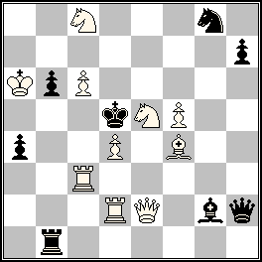  ‡2 (10+8) | 1.Se~? [2.Qe5,Qe6‡]  1… Be4 2.Qc4#  1… Re1 2.S×b6#,  but 1…Bf1!  1.Sd3? [2.Qe5‡]  1…Re1 2.Sb4‡  but 1…Be4!  1.Sc4! [2.Qe6‡]  1…Be4 2.Se3‡  1…Re1 2.S4×b6‡  (1…Qh6 2.Q×g2‡)

Answer: Yes, this example is thematic. The thematic purpose of 1.Sd3 and 1.Sc4 is obvious from the 1.Se~? and no additional proof in the solution is required by the theme definition.
Section B: Threemovers
Question: Is it allowed to have different tactical motives in different variations?
Answer: Yes, it is allowed. According to the theme definition, no comparison between variations is required to define if specific variation is thematic.

Section G: Fairies
Clarification:
1. The definition of Take&Make should include the following statement.
Pawns can never move to the first rank of their own colour.
Both Popeye and WinChloe software correctly interpret this rule. As a result, pawns cannot be placed on the first rank of their own colour in diagram position.
2. It is recommended to use move-like recoding of moves, not Circe-like recording provided by WinChloe. For example, the solutions of example G1 from the Announcement are better written in the following way.
1.Q×c8–c2 B×h2–e2 2.Kc3 B×e6–e5‡
1.Q×b8–f4 R×c1–d3+ 2.Ke5 B×h5–g7‡
Question: Are the following moves thematic (See scheme CG1): 1.K×e5–e3 or 1.Q×b4–b5? The moves 1.Ke3 and 1.Qb5 are possible on empty board but illegal in this position.
CG1 | 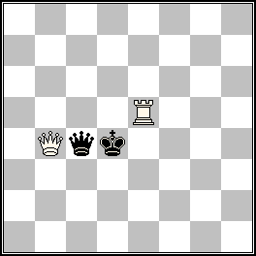

Answer: Yes, the moves like 1.K×e5–e3 and 1.Q×b4–b5 are considered thematic.
Section H: Retros
Clarification: It is allowed to have promoted pieces in diagram position (as in example H3 from the Announcement), as the play starts from initial game array and not from diagram position.
Question: Are proof games "A to B", where position A is not the initial game array, permissible?
Answer: No.

May 24, 2015
Georgy Evseev
Director of the 10th WCCT

