WCCT-9 CLARIFICATION DOCUMENT #2

Section C: Moremovers

Question 1: Is the threat allowed as a thematic variation? It is not forbidden by the theme definition, but none of the given examples shows that.

Answer: Yes, it is allowed.

Question 2: Is the front piece F of the Siers battery allowed to play any moves between White's second and final move?

Answer: Yes, it is allowed. Please refer to the improved theme definition included in the clarification document #1 of May 2011.

Question 3: At W2 move, the front piece F of a Siers battery gives a flight square to the black king by shutting off a white piece. Is it mandatory that on the mating move the piece F gives check to the black king? May the mate be given by the rear piece of the new battery that was created in the W2 move?

Answer: The checkmate may be given by the rear piece of the new battery. The theme definition requires that the mate is given by a move of the piece F; this does not necessarily mean that the piece F gives the checkmate itself.

Section D: Endgame Studies

Question: May the white queen be en prise (under attack) while playing a thematic move?

Answer: Yes, she may.

Section E: Helpmates

Question 1: Is it allowed the thematic move to be a pawn promotion?

Answer: Yes, it is allowed.

Question 2: The theme definition states that "It is not allowable to include more than one thematic move by the same piece in the same phase." In the below problem, the thematic moves are 1.S×g6 and 1.S×d7, but the thematic piece plays again in B3 (not a thematic move!)

Toma Garai  3 HM J. Neukomm-100 MT  Sakkélet 1992-94 | - Is this example thematic?  - May the thematic piece play a non-thematic move after the thematic move, or should it play a single move only in each phase?
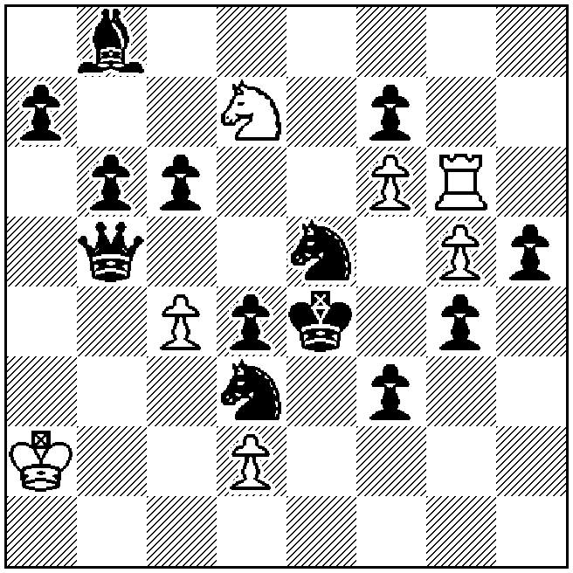
h‡3 b) c4→c3 (7+13)
a) 1.S×g6 S×b6 2.Bf4 Sc8 3.Sge5 Sd6‡
b) 1.S×d7 Rg8 2.Qf5 Rd8 3.S7e5 R×d4‡

Answer: The example is not thematic. Taking into account that the thematic move is considered equivalent to the hypothetical removal of the piece from the board, then there would be no piece to carry out the third move and block the flight square. The B1 moves would have been thematic, if the B3 moves by the thematic piece were tempo moves (in the absence of the piece, this move is simply skipped).

The thematic piece is not allowed to play a non-thematic move after the thematic move in the same phase, unless the non-thematic move is a tempo move. Obviously it may play a non-thematic move before the thematic move.

Particular attention should be also paid to the move 1.S×d7 in part (b). The theme definition states that "A black unit (pawns included) could hypothetically have been removed from the board instead of being moved to a certain square (the thematic move) and the specific solution or set line would still be successful." In part (b) if we hypothetically remove the black Se5 instead of capturing the white Sd7, the specific solution does not work. In fact, the black knight must capture on d7 in order to open in advance the line d8-d4 for the white rook. Thus the move is not thematic.

Section F: Selfmates

Question 1: In some of the examples, the thematic black moves have an additional defensive motif apart from closing a line of a black piece which gives direct mate in the threat. In F3 the move 1…Sg3 defends against the threat by also guarding e4 (2.e4+ S×e4+!), while in F4 the moves 1…Sd3 and 1…c4 defend against the threat by also closing the WQ diagonal. Furthermore 1…Sd3 also prepares for 2…Se5 after the threat move 2.Bg7+.

Is there any guideline on this issue?
Answer: It is the judging countries' duty to evaluate in each particular case if (and to what extent) there is an influence on the value of the composition.

Question 2: The theme definition states that "The piece whose line is closed has to play some role in the thematic variation(s)." Is there any restriction on what this role should be? For example, may the black piece provide a shield to its own king from check, or keep a line closed, or be used as a static block on a flight square?

Answer: There is not any restriction.

Section G: Fairies

Clarification: The usual convention that promotions to a fairy piece are allowed only if such a piece is present on the diagram is valid for this tourney.

Question: Is the following scheme thematic?
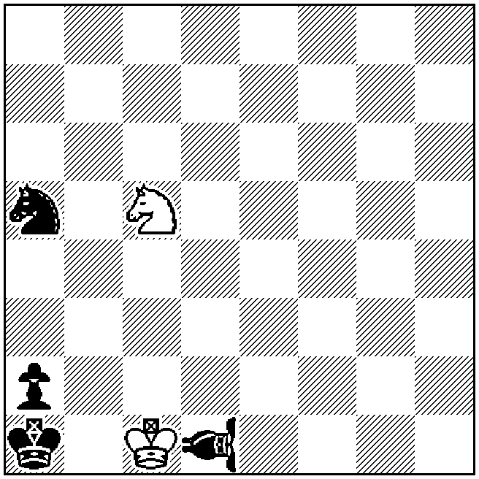
hs‡1.5 (2+4)
1…VAOa4 2. Sb3+ S×b3‡
In the final position everything looks fine: the black VAO guards squares over the black hurdle. But it is a white piece that plays first to the critical square.

Answer: The scheme is thematic. In the logical try 1…VAOc2? 2.Sb3+, the move 2…S×b3 is not mate, as the critical move for the black interference is missing. The fact that after the white move Sb3+ the WK flight squares are already guarded is only a technical detail, but not the reason for the move 1…VAOa4.

July 15, 2011
Harry Fougiaxis
Director of the 9th WCCT

