WCCT-9 CLARIFICATION DOCUMENT #1

WCCT General Rules
Paragraph #5: In the orthodox sections (A-F) (...) Promoted pieces in the diagram position are allowed only if they are substitutes for captured pieces of the same type. It should be noted that a king's bishop cannot be a substitute for a queen's bishop or vice versa.
Question: Are positions based on Chess960 (FIDE chess rules, appendix F) allowed?
Example: white pawns b2 and d2, white bishop e1. In Chess960, this bishop is not necessarily a promoted one; it can be, depending on the arrangement of the units in the diagram position. Whether in this case the bishop e1 is promoted or not, can be of significance when determining the legality of the position by the number of captures. In the above case: composer A rejects his problem with white pawns b2 & d2 and white bishop e1 as the diagram position does not allow for a promoted pawn. Composer B has the same diagram position and enters 'Chess960' under the diagram needing no promotion.
Answer: Diagram positions based on Chess960 (FIDE chess rules, appendix F) are not recognised by the WCCT rules.

Annex to General Rules
Paragraph #5: In section G (Fairies), no limitation is imposed on the number of orthodox or fairy pieces. This number has no connection with the number of pawns and no proof game is needed.
Question: Is there a maximum of 8 pawns (per side), or is the number of pawns per side also unlimited? Further, how do we interpret such a statement -- does this imply judges should not penalize for such transgressions, or does it merely specify the requirements?
Answer: The number of orthodox as well as of fairy units is unrestricted. Full freedom is allowed in this respect, thus the number of pawns for each side may exceed 8. It is the judging countries' duty to evaluate in each particular case if (and to what extent) there is an influence on the value of the composition.
Paragraph #11: The correct French notation is RDTFCP.

Section A: Twomovers
Question 1: Are dual-threats acceptable as thematic?
Answer: No. Dual-threats are not thematic.
Question 2: Are moves like Qg6-e6 and Qg4-e6 considered identical?
Answer: Yes, they are. The determinants for two moves to be considered identical are the same unit and the same arrival square. Furthermore, it is not important whether the full written form is exactly identical, for instance capture/non-capture are still the same moves.

Section C: Moremovers
Composers are urged to pay attention to the following more precise theme definition:

Theme: Based on the well-known idea of the Siers battery*, this theme may be termed an "interrupted Siers battery". It is defined as follows: A directmate in 4 to 6 moves is required, in which a white battery consisting of a rear piece and a front piece F (the latter standing on a square z) fires at the black king on move 2. By its firing move (arriving on a square x), F provides one or more flight squares for the black king, either directly (by abandoning a guard) or indirectly (by closing a white line) or both; the flight square is to be occupied immediately by the black king. The mate is given on the last move of the problem by a move of F (but not with a return to square z). Immediately before the mate, F stands on square x. No further restriction is imposed on the interval between move 2 and the mate.

* "Normal" (uninterrupted) Siers battery: The front piece, in moving away from the battery line, gives a flight; when the king moves to this flight, the original front piece moves again to give mate, but this move is not a return to its starting square.

Question 1: The theme stipulates that "In a directmate in 4 to 6 moves, the first move of a Siers battery is the second move of the problem. The second move of the Siers battery is the last (mating) move of the problem. This may be called an "interrupted" Siers battery."

May we interpret broadly the stipulation by replacing the second sentence with "The black King is mated by the front piece of the Siers battery" and drop the third sentence? The reason for the interpretation is that, after you made a first move with the front piece of the Siers battery, the battery no longer exists. In the first example, after: 1…Qe7 2.Sa4+ Kd5 (the battery is gone) 3.c4+ b×c3 e.p. 4.S×c3‡

Answer: Refer to the above improved theme definition.

Question 2: Is it required that the mating move has to be played by the same Siers battery front piece? For instance, is the following interpretation thematic? "The second move of the problem is made by the front piece of a Siers battery A. A second Siers battery B is created during the play (along the same line of battery A or a different line). Black is mated by the front piece of the Siers battery B."

Answer: No. Such an interpretation is not thematic.
Question 3: Are all kinds of battery pieces (B+S, R+S, R+P, R+B, B+R and so on) allowed? Theodor Siers considered only a knight as the front battery piece in his original definition.
Answer: Yes. There is no restriction on the combination of the front and rear battery pieces.
Question 4: Is mate with a pawn promotion considered thematic if the pawn opens the battery line in the second move of the problem?
Answer: Yes, it is thematic.
Question 5: Is it required the battery check on the second move of the problem to provide a flight to the black king, or may the flight be already available to the king before the second move? If providing the flight is required, then may it be provided indirectly by interference?
Answer: The battery check on the second move of the problem must provide a flight to the black king. The flight may be provided indirectly by interference. The flight square is to be occupied immediately by the black king.
Question 6: Is it allowed to have the white king as the thematic piece? (It can mate only by firing another battery)
Answer: Yes, it is allowed.
Question 7: Is it allowed to have the black king mated not on the square it has moved to after the battery check?
Answer: Yes, it is allowed.

A few more thematic examples:

Valentin F. Rudenko  Chervony girnik 1977 | Example C3  1.Se4! [2.Rc5+ Bd5 3.Sh6+ Ke5 4.Sf7‡  2…Rd5 3.Sgf2+ Ke5 4.Sd3‡]  1…Bd5 2.Sgf2+ Ke5 3.B×c3+ Rd4/Sd4,S×c3 4.Sd3/f4‡  1…Rd5 2.Sh6+ Ke5 3.Re8+ Be6 4.Sf7‡
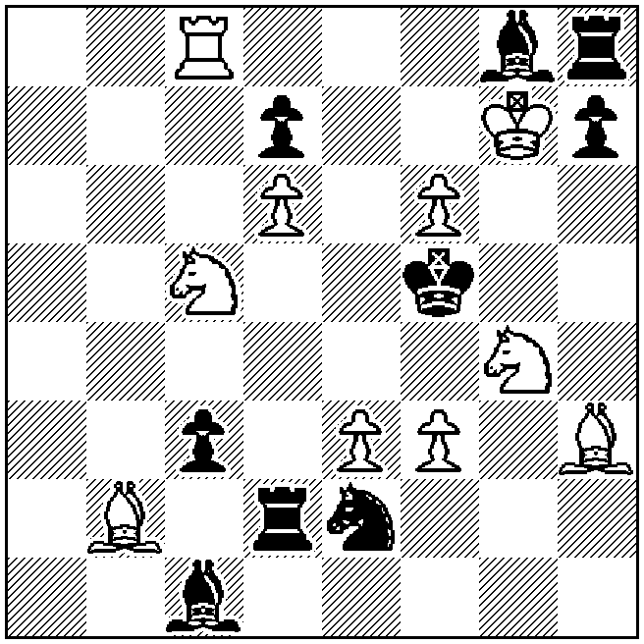
‡4 (10+9)

Ivan Soroka  1 Pr Odessa 1989 | Example C4  1.Rf6! [2.Rd5+ e×d5 3.Sa4+ K×e4 4.Sc5‡]  1…R×h5 2.Sd1+ K×e4 3.f3+ g×f3 4.Sf2‡  1…Se7 2.Sd5+ K×e4 3.R×f4+ B×f4 4.Sf6‡  1…Se3 2.Sb1+ K×e4 3.d3+ B×d3 4.Sd2‡
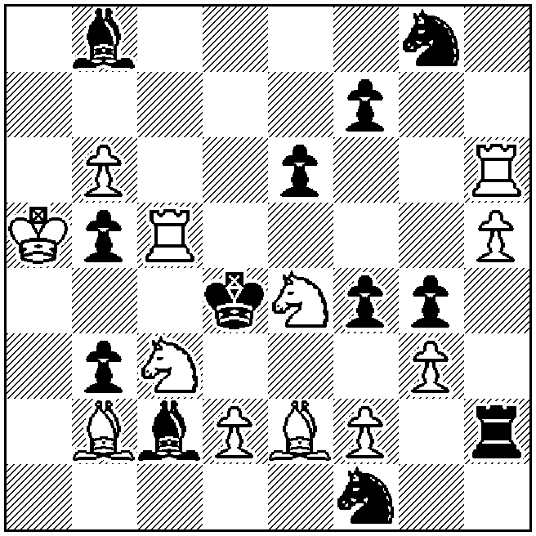
‡4 (12+12)

Anatoly Vasilenko  Die Schwalbe 1992 | Example C5  1.Kb2! [2.Rd4+ c×d4 3.Sh4+ Ke5 4.f4‡]  1…Q×b7 2.Sd4+ Ke5 3.Bf6+ Kd6 4.Sb5‡  (1…Bh5 2.Sd2+ Bf3 3.B×f3+ Ke5 4.Sc4‡  1…R×e7 2.Se1+ Re4 3.B×e4+ Ke5,Kd4 4.Sf3‡  1…S×f5 2.R×f5+ Ke4 3.Re5+ Kd3 4.Re3‡  1…c4 2.b×c4+ Q×c4 3.Sd4+ Ke5 4.Bf6‡  1…Qg6 2.Sh4+ Ke5 3.S×g6+ B×g6 4.Bf6‡  1…Qd6 2.Se1+ Ke5 3.Sd3+ Q×d3 4.Bf6‡  1…Qe6 2.Sd2+ Ke5 3.Sc4+ Q×c4 4.Bf6‡  (2…Qe4 3.B×e4+ Ke5,Kd4 4.Sf3,Bf6‡))  Note: The variations 1…Bh5 and 1…R×e7 are unthematic
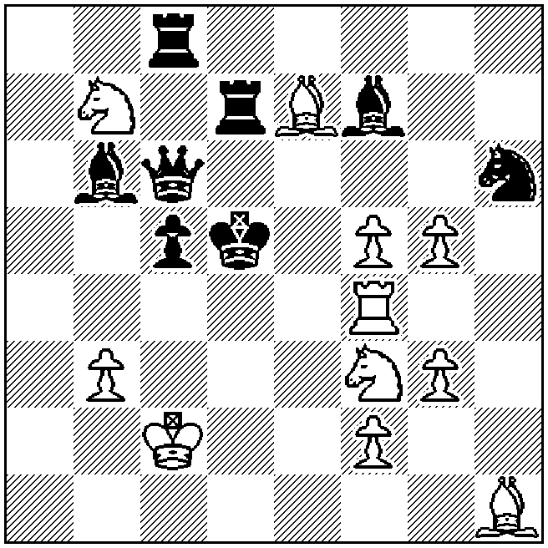
‡4 (11+8)
Sergy Ivanovich Tkachenko  2 HM U.S. Problem Bulletin 1994 | Example C6  1.Rb4! [2.Sa5+ Ke5 3.Sc6+ K×d5 4.Rd4‡]  1…Qg7 2.Sf6+ Kf4 3.Qe4+ B×e4/R×e4 4.S×h5/Sd5‡  1…Se2 2.S×d2+ Ke5 3.Re4+ R×e4/B×e4 4. S×f3/Sc4‡  (1…f2 2.Sd×e3+ d5 3.Q×d5+ Kf4 4.Sg2‡  1…Rb2 2.S×b2+ Ke5 3.Rd4 [4.Sc4‡])  Note: The variations 1…f2 and 1…Rb2 are unthematic
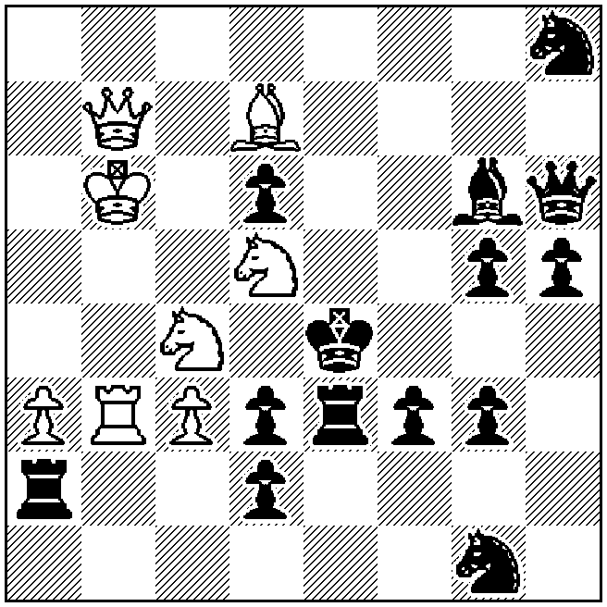
‡4 (8+14)

Yuri Marker  2 HM Probleemblad 2001 | Example C7  1.g3! [2.Rf6+ B×f6 3.Sh2+ K×e5 4.Sf3‡]  1…Sd4 2.Sf6+ K×e5 3.Rd5+ B×d5,S×d5 4.Sd7‡  1…Se4 2.Sf2+ K×e5 3.d4+ S×d4 4.Sd3‡  (1…Sd5 2.R×e7+ S×e7 3.Rf6+ Kd5 4.Rd6‡  1…Bd6+ 2.R×d6+ Ke7 3.Rd7+ Ke6/Ke8 4.Rf6/Sf6‡  1…g5 2.Sf6+,Se3+)
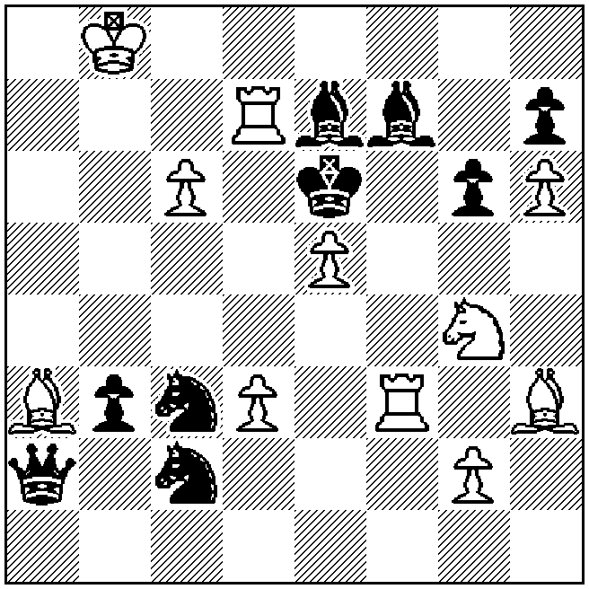
‡4 (11+9)

Michael Herzberg  1 Pr Die Schwalbe 1994 | Example C8  1.Se6! [2.Sb~‡]  1…Re×e6 2.Sc1+ Kd4 3.Rb5 Rf5 4.Be5+ Re×e5  5.Rd5+ R×d5 6.Se2‡  4…Rf×e5 5.Se2+ R×e2 6.Rd5‡  1…Rf×e6 2.Sa5+ Kd4 3.Rb5 Rd7 4.Bd6 Re×d6  5.Rd5+ R×d5 6.Sc6‡  4…Rd×d6 5.Sc6+ R×c6 6.Rd5‡
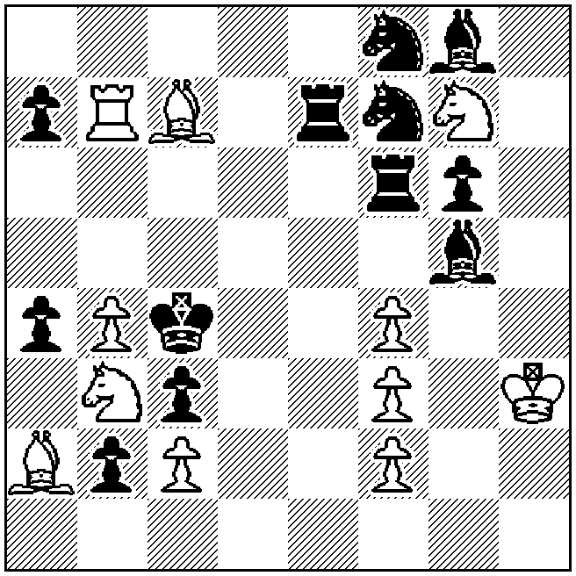
‡6 (11+12)

Section D: Endgame Studies
Example D2: The exact source is Ilham Aliev EG 1999 (after Jindřich Fritz, 1 Pr Svobodné slovo 1961), see below.

Jindřich Fritz  1 Pr Svobodné slovo 1961 | 1.Bh1! R×h1 2.a8=Q Rc1 3.Qh1 R×h1 4.a7 Rc1 5.a8=Q+ Kb4 6.Qb8+ Kc3 7.Q×h2 +- [2…Rb1 3.Qd8+ Ka4 4.Qh4+ +-]
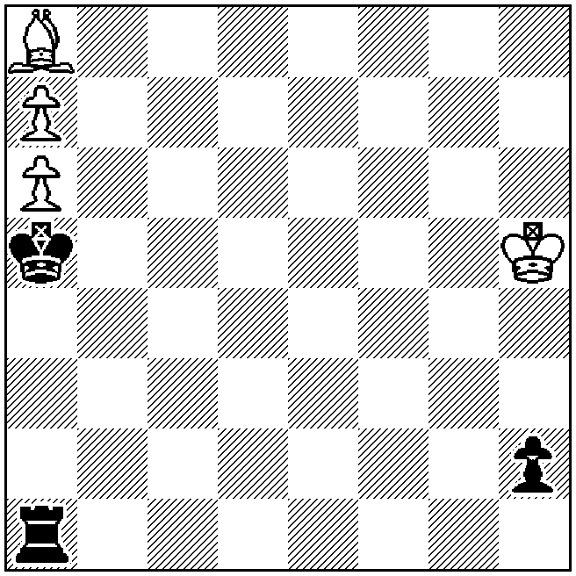
+ (4+3)

The idea was already known at that time, as the following study shows:

Paul Heuäcker  Deutsche Schachblätter 1937 | 1.Bg7 a2 2.B×h8 Re1 3.Ba1! [3.Kb4? Re7 4.Bg7 a1=Q 5.B×a1 R×h7 6.Bg7] 3…R×a1 4.h8=Q Rb1! 5.Qa1! R×a1 6.h7 Re1 7.h8=Q+ Kg1 8.Qg8+ Kf2 9.Q×a2+ +-
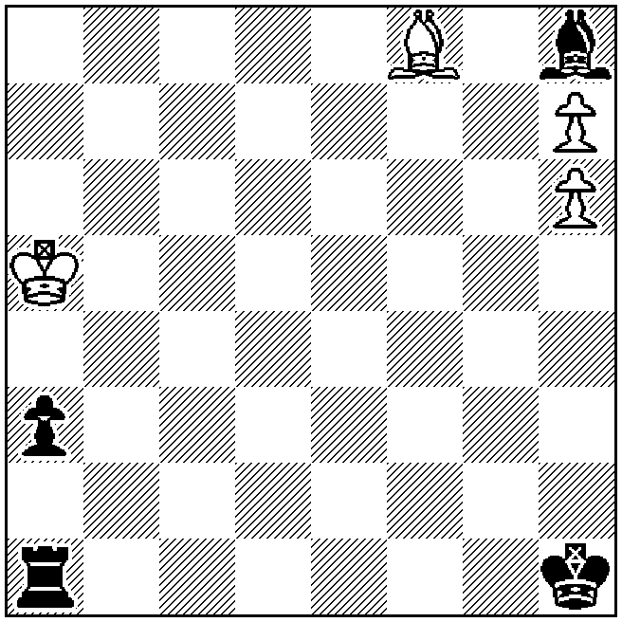
+ (4+4)

Example D4: The exact source is 1 Pr E. Böök-70 JT, Suomen Shakki 1980-81

Question: There is no mention in the announcement document concerning studies which might be found within the EGTB. Nonetheless, one example does employ 7 units total -- how should this be interpreted?
Answer: According to decisions reached at Rhodes 2007, (a) the judging countries in section D are requested to allocate points to the studies as if they had been composed in the traditional manner before the advent of the computer into compositional chess & (b) studies are not to be regarded as anticipated by any position appearing in a computer-generated database.

Section E: Helpmates and G: Fairies
Clarification: In the (not allowed) Polish-type twin, all units change colour in the twin.

Section F: Selfmates
Question: Does the phrase "The piece whose line is closed has to play some role in the thematic variation(s)" mean "in all thematic variations", or "in at least one thematic variation"?
Answer: In order for a variation to be considered thematic, the piece whose line is closed has to play some role in it. The following problem has one thematic variation (1…Sc6) and it would be legitimate for the tournament. The variations inside the parenthesis are not thematic.
Živko Janevski  StrateGems 2009 | Example F7  1.Bh4! [2.Re5+ K×e5 3.Qe4+ B×e4‡]  1…Sc6 2.R×c5+ K×c5 3.Re5+ S×e5‡  (1…Sb7 2.Rg4+ Ke5 3.R×c5+ S×c5‡  1…c6 2.Qg5+ Be5 3.R×d4+ Q×d4‡)
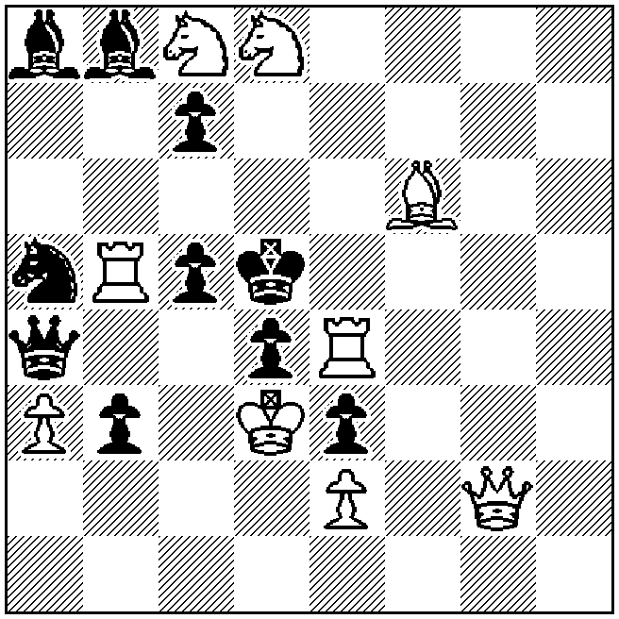
s‡3 (9+10)

May 10, 2011
Harry Fougiaxis
Director of the 9th WCCT

