WORLD FEDERATION
FOR CHESS COMPOSITION

9th WORLD CHESS
COMPOSITION TOURNAMENT

ANNOUNCEMENT

January 2011
Invitation

The World Chess Composition Tournament is a long-established team event enabling composers from all over the world to compete at international level with new chess problems and studies on set themes. Eight such tournaments have been held to date, with enthusiastic worldwide participation. The 9th WCCT is now announced, and I have pleasure in inviting all countries affiliated to FIDE to register for this competition and take part in an event which promises to be even more popular and successful than its predecessors.

Harry Fougiaxis
President of the WFCC
Introduction by the WCCT Committee

A great deal of effort has been invested in the announcement of the 9th WCCT.

Composers all over the world were asked to submit their theme proposals for the 7 traditional sections of the tourney. We were pleased to find, after extensive deliberations at times, submissions good enough to ensure themes for most sections. (In one or two cases the need arose for further investigation). Thanks to all contributors for their good will!

I hope that the themes laid before you will provide the necessary inspiration for the final result to be marvellous and to reflect the best our art can achieve.

I should like to wish all composers, judges, team leaders and of course the tournament director (our President Harry Fougiaxis) good luck and smooth working!

Uri Avner
Honorary President of the WFCC
and Spokesman of the WCCT committee

Foreword by the WCCT Director

The tournament director is Harry Fougiaxis. Registrations for the 9th WCCT should be submitted to him by May 1st, 2011, including the name, e-mail and postal address of the country's team leader.

Questions about the themes should be forwarded to the director (by the team leaders only). The director will consult the WCCT Committee and then provide answers. All team captains, please make sure that you and your country's composers are aware of the general rules of the 9th WCCT.

The closing date for entries in all sections is April 15th, 2012.

Harry Fougiaxis's email address is harryfou@ath.forthnet.gr or loyaldragon@gmail.com

Harry Fougiaxis
Director of the 9th WCCT
January 2011
WCCT General Rules

The General Rules were accepted at Pula in September 1972 by the Permanent Commission of the FIDE for Chess Composition (PCCC) and modified and added to in September 1978 in Canterbury, in August 1984 in Sarajevo, in September 1990 in Benidorm, in August 1991 in Rotterdam and in August/September 1993 in Bratislava. Further amendments have been made in the light of changes approved at Pula 2000, Wageningen 2001, Eretria 2005 and Crete 2010 (by the World Federation for Chess Composition, the follow-up organisation of the PCCC).

- The WCCT (World Chess Composition Tournament) is organised with the authority of the WFCC.

- The WCCT is open to all member federations of the FIDE (hereinafter called "participating countries"). The member federations of the FIDE are to be given adequate opportunity to notify in advance their intention to participate.

- The WCCT includes the following sections: A) Twomovers, B) Threemovers, C) Moremovers, D) Endgame studies, E) Helpmates, F) Selfmates, G) Fairies.

- The WFCC regulates the procedure for proposing and selecting themes, approves the procedure to be used for judging and appoints the Tournament Director (hereinafter called "Director"). The final choice of themes and of countries to be asked to judge each section (hereinafter called "judging countries") lies with the WFCC.

- Constructional tasks and any theme stipulating a limit to the number of pieces should be avoided. In the orthodox sections (A-F), compositions in twin or duplex form and/or with more than one solution are acceptable only if so specified in the definitions of the prescribed themes. Promoted pieces in the diagram position are allowed only if they are substitutes for captured pieces of the same type. It should be noted that a King's Bishop cannot be a substitute for a Queen's Bishop or vice versa. In section G, fairy pieces or fairy conditions which do not exactly correspond with the theme definitions will not be accepted.

- A dated announcement of the WCCT will be made, setting out the rules and providing theme definitions with diagrammed illustrations. There should be at least 10 months between the date of the announcement and the closing date for entries. The closing date is to be stated precisely in the announcement and cannot be changed.

- The official documents (announcement and award) are to be written in at least one of the official languages of the FIDE.

- Each participating country appoints a team leader. The Director cannot act as a team leader.

- The organising country may participate in the WCCT provided that its entries are sent in a sealed form by the team leader to the appointed WFCC Presidium member two weeks before the closing date.

- Three compositions in each of the seven sections are allowed from each participating country. Any one composer may participate with three compositions in each section. Joint compositions are permitted.

- Entries are to be printed or stamped on uniform diagrams with the section, the composer's name and country, and the full solution all clearly written on the same side of the paper as the diagram in each case. Algebraic notation is to be used.
- The entries are to be acknowledged by the Director, who will compile them into a document with diagrams and full solutions, but without composers' names or countries. Each diagram will bear a number for reference purposes. The document will be sent to the team leaders for checking, and the Director must be informed within three months about any misprints or claims of anticipation or unsoundness.

- The Director will inform all judging countries and team leaders of any misprints, any entries deemed to be unsound, and any claims of anticipation, so that six weeks may be given for checking these claims.

- Using a scale of 0 to 4 including half-points, each judging country will allocate points to all compositions in the section which it has agreed to judge, except for the entries of the judging country itself. Compositions which are sound, thematic and not anticipated should receive at least 0.5 points. The judging countries must explain their reason(s) for giving a score of 0 points to any composition. Comments on all compositions are welcome and are strongly recommended in the case of those with a score of 2.5 points or more.

- If a judging country does not make its award by the date prescribed in the Tournament schedule, or in the case of other irregularities, the Director may appoint some other judging country, making use in the first instance of the list of reserves drawn up by the WCCT Committee. The WFCC Presidium shall be informed.

- The Director will calculate the total points gained by each composition. If a composition has been judged by five judging countries, the Director discards the highest and the lowest scores and sums the remaining three. If a composition belongs to a judging country, he sums the two middle scores and the average of the highest and the lowest scores. If a composition has received a zero score from two or more judging countries, it is excluded from the tournament and receives no points.

- The Director will order the entries in each section on the basis of their score. In each section, only the two highest-placed entries from each participating country will be taken into consideration in calculating the country's tournament score. The overall winner of the Tournament is the country with the highest total score from all sections.

- In each section the twenty highest-placed problems (hereinafter called the “top 20”) will be printed on diagrams with full solutions in the final awards document. If several entries are ranked equally and share the 20th place, all of them will be printed on diagrams. If the third-placed entry of any country belongs to the "top 20" list, it will be printed in the final awards document, even though it does not contribute to that country’s score.

- In each section the entries scoring points for a participating country, but not belonging to the "top 20" list, will be mentioned in the final awards document only by means of their reference number, composer and country names, score and place. These compositions are to be considered as published. Any unpublished entries will be available to their composers for publication elsewhere, once the final awards document has appeared.

- The final awards document will be made available to every participating country and composer.

- The three countries with the highest total scores and the composers of the three highest-placed entries in each section will be awarded certificates of honour.

Annex to WCCT General Rules

This annex aims to provide clarification of some of the WCCT General Rules and, for the 9th WCCT in particular, is to be considered as an integral part of those Rules. The paragraph numbering corresponds to that used in the General Rules.

Paragraph #5: In section G (Fairies), no limitation is imposed on the number of orthodox or fairy pieces. This number has no connection with the number of pawns and no proof game is needed.

Paragraph #7: The announcement and the award will be written in the English language. Team leaders and judging countries are kindly asked also to use only English. Communication between the Director, the team leaders and the judging countries will be via e-mail.

Paragraph #9: The team leader of the organising country will send the entries to the appointed WFCC Presidium member in a password-protected ZIP archive. The Director will ask the team leader for the password upon receipt of the file with the entries.

Paragraph #10: Even though the submission of versions is not encouraged, it is not forbidden. Similar problems by different countries are all legitimate; they are not considered to be versions and are not subject to the procedure described below. The procedure for versions in the current tournament is as in the previous WCCT:

- Every participating country must inform the Director if it submits groups of 2 or 3 problems which are versions of each other.
- The judging countries do not receive this information. They allocate points to all the entries as if there were no versions.
- Among versions submitted by the same country only the highest-graded one is kept in the award and may score points for that country.
- After the judging countries have submitted their marks, the Director informs them of seemingly undeclared versions which he has detected among the entries submitted by any country.
- The judging countries in the relevant section must then state whether they consider these entries to be versions of each other. If there is a majority decision that an entry is a version, action is taken according paragraph (c). If there is a tie, the Director must exercise a casting vote and inform the judging countries of his decision.
Paragraph #11: The team leaders will submit the entries in electronic form. Acceptable file formats are: WinChloe, Fancy CCV, Problemiste PBM, MatPlus Librarian PBZ/PBX, Microsoft Word DOC and DOCX, OpenOffice ODT, Rich text format RTF and Adobe Acrobat PDF. For section D (Endgame studies) in particular, the entries must be submitted in PGN format. If the entries are submitted in DOC, DOCX, ODT or RTF format, team leaders must also include in these documents, or in separate plain text files, the positions in standard FEN (preferably) or algebraic notation. If the entries are submitted in PDF format, team leaders must provide the positions in separate plain text files. Acceptable notations are: FEN (KQRBNP), English (KQRBSP), French (RDTFCP), German (KDTLSB) and FIDE (KDTLSP).
Paragraph #12: The document including all the entries will be made available by the Director in PDF format. The WCCT Committee considers that no printed booklet is necessary.

Paragraph #14: Each judging country is free to determine its own judging method, whether it uses one, two or more judges. To reach the best result, it is recommended that a country's judges work in consultation with each other. The country should itself resolve any dispute among the judges; for example an appointed person in charge may make the final decision. It is not required for judges to be international FIDE judges. The judging countries are trusted to appoint their best experts to carry out the work and they are not obliged to provide the names of the persons who have made the award.
Guidelines for the allocation of points:

Points | Description
4.0 | An outstanding problem: an accurate and intensive rendering of the set theme, without blemishes in any of the main lines, and showing originality and flair. Perfect construction and economy.
3.5 | As above, but some small constructional weaknesses, and perhaps not ideally economical.
3.0 | Either: a very good problem showing the theme clearly but perhaps not intensively or very originally  Or: a task rendering of the theme which does not reach the highest artistic standard. In either case, good construction and economy.
2.5 | As above, but constructional weakness and/or less than ideal economy because of the intensive or task setting.
2.0 | A good problem, very likely worth an honourable mention or commendation in a reasonably strong tourney, but not a very intensive rendering of the theme, and perhaps not very original. Adequate to good construction and economy.
1.5 | As above, but with some artistic weakness or constructional blemish.
1.0 | A very ordinary piece of work, typical of many average columns but hardly up to award standard. Adequate construction and economy.
0.5 | As above, but with serious constructional defects.
0.0 | Unsound, unthematic or fully anticipated.

Paragraph #18: The final awards document will be made available by the Director in PDF format and as a printed booklet.

Timetable

January 15th, 2011 Announcement
May 1st, 2011 Registration
April 15th, 2012 Deadline for submitting entries
July 1st, 2012 Document with entries
October 1st, 2012 Claims
November 1st, 2012 Distribution of claims
January 1st, 2013 Replies to claims
February 1st, 2013 Distribution of replies to claims
June 1st, 2013 Judging completed
October 1st, 2013 Award booklet
WFCC Meeting, 2013 Celebration of the winners

SECTION A: TWOMOVERS

Judging countries: Germany, Serbia, Slovakia, Russia, Ukraine
Reserves: Great Britain, Slovenia

Theme: In a directmate in 2 moves, two tries have the same threat A. Another two tries have the same threat B. In the solution neither move A nor move B is a threat but both become mates in variations.

Ivan Kiss  dedicated to S. Radilova  2 Pr Thèmes-64 1983 | Example A1  1.Sb7? [2.Q×c5‡ A] but 1…Ke5! a  1.Bf1? [2.R×e4‡ B] but 1…e×d3! b  1.Rde1? [2.Bc3‡ C] but 1…S×e3! c  1.b4? [2.Q×c5‡ A] but 1…S×e3! c  1.Sf4? [2.R×e4‡ B] but 1…Ke5! a  1.Rg3? [2.Bc3‡ C] but 1…e×d3! b  1.e7! [2.Q×f6‡]  1…Ke5 a 2.Q×c5‡ A  1…e×d3 b 2.Re4‡ B  1…S×e3 c 2.Bc3‡ C  1…Sd6 2.Q×d6‡  1…Bc6 2.S×c6‡
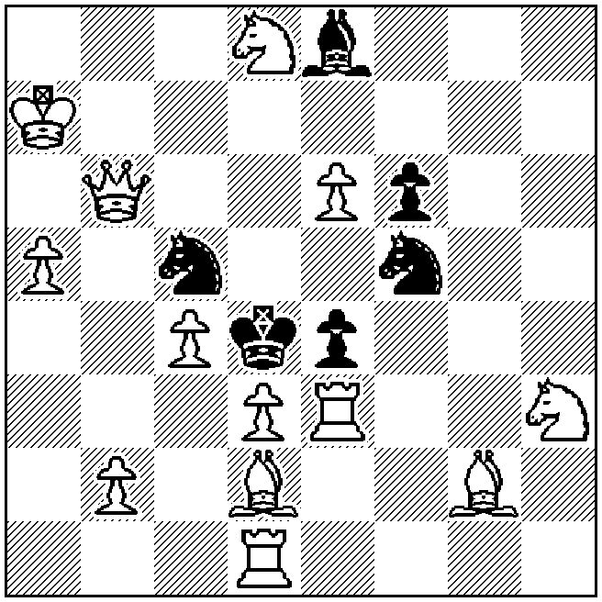
‡2 (13+6)

Valery Shanshin  Die Schwalbe 2009 | Example A2  1…Se~ 2.B×g6‡  1…Sf5! 2.Sc5‡  1.Rbd5? [2.Sc5‡ A] but 1…Bd4!  1.Rdd5? [2.Sc5‡ A] but 1…Sf5!  1.Sf~? [2.Qf4‡ B] but 1…g5!  1.S×g6? [2.Qf4‡ B] but 1…Sd5!  1.Sd5! [2.Qc2‡]  1…Kd3 2.Sc5‡ A  1…Kf5 2.Qf4‡ B  1…S×d5 2.B×g6‡  1…B×f6 2.S×f6‡
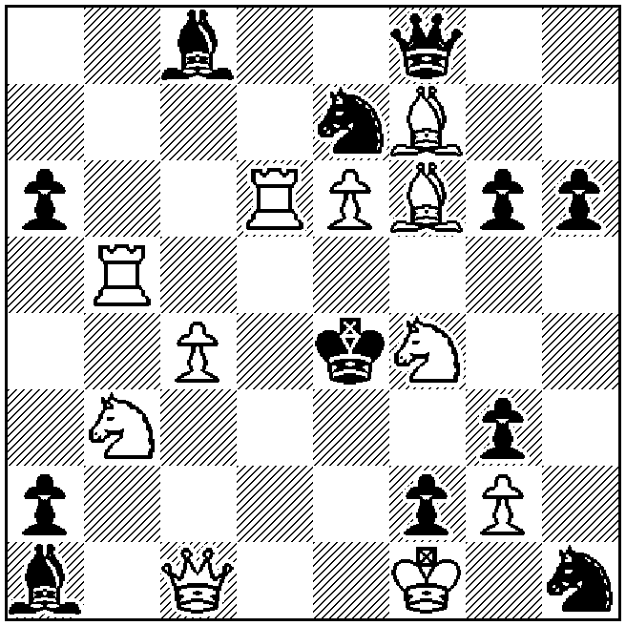
‡2 (11+12)

SECTION B: THREEMOVERS

Judging countries: France, Netherlands, Russia, Sweden, USA
Reserves: Finland

Theme: In a directmate in 3 moves, at least three thematic variations are united by manifest systems of moves (similar or different) by both Black and White. For example: moves by the same piece(s), moves to the same square, cyclic play, geometric unity, battery play and so on. The thematic elements may be shown on any move (B1 or B2 for Black, W2 or W3 for White), or as a system linking B1 and B2 or W2 and W3 in the same variation. There may be several phases (solution plus set and/or try or tries), but twinning is not allowed; however the required number of variations must appear in а single thematic phase independently of other phases. The presence of the theme in the actual solution is mandatory. The threat may be one of the thematic variations (with thematic elements for Black shown at B2).

Sergeï T. Pugachev  1 Pr M. Chigorin MT 1949 | Example B1  1.Rh2! [2.Sc2 [3.S×b4,Se1,Q×e3‡] S×c2 3.Q×c2‡]  1…e6 2.Sf3 [3.Sf4,Se5,Se1‡] e×f3 3.Bh7‡  1…Be6 2.Sb5 [3.Sf4‡] Sc2 3.Q×c2‡  1…Re6 2.Sf5 [3.Sf4‡] Sc2 3.Q×c2‡  1…Rc6 2.S×c6 [3.Sf4,Se5,S×b4‡]  Black defences on the same square at B1  White continuations by the same piece at W2
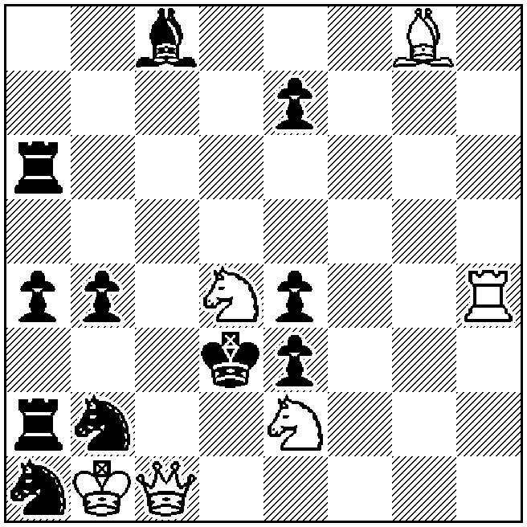
‡3 (6+11)

Eeltje Visserman  1 Pr Dutch Federation Ty 1950 | Example B2  1.Sg8! [2.Se7+ Ke6 3.Bc4‡]  1…Bb3,Ra5 2.B×c3 [3.Qd4‡] Rd2/Q×f4/b×c3/Ra8+/R×b5 3.S×e3/S×f6/S×c3/b×a8=Q/Q×b5‡  1…Be4 2.B×f6 [3.Qd4‡] Rd2/Q×f6/b3/Ra8+ 3.S×e3/S×f6/S×c3/b×a8=Q‡  1…Bd3 2.B×e3 [3.Qd4‡] Q×f4/B×e3/B×b5/b3/Ra8+ 3.S×f6/S×e3/Q×b5/S×c3/b×a8=Q‡  Black and white moves by the same pieces at B1 and W2
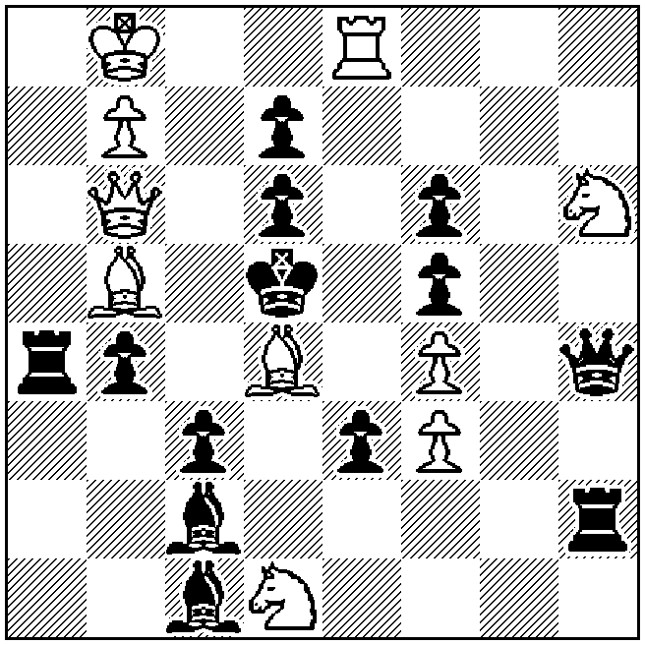
‡3 (10+13)

Viktor Kapusta  Levova dolja 1997 | Example B3  1.Qh3! [2.Qg4 [3.Be6‡] Q×e4 3.Q×e4,B×e4‡]  1…Q×e4 2.Bc8+ R×h5/Qe5/Qf5 3.Qd7/R×e5/Q×f5‡  1…Q×d3,R×d3 2.Bd7+ R×h5,K×e4 3.Qe6‡  1…Qe3 2.Be6+ K×e4 3.Qf5‡  1…h×g6 2.B×g6+ R×h5 3.Qd7‡  Black defences by the same piece at B1  Bristol manoeuvres at W2 and W3
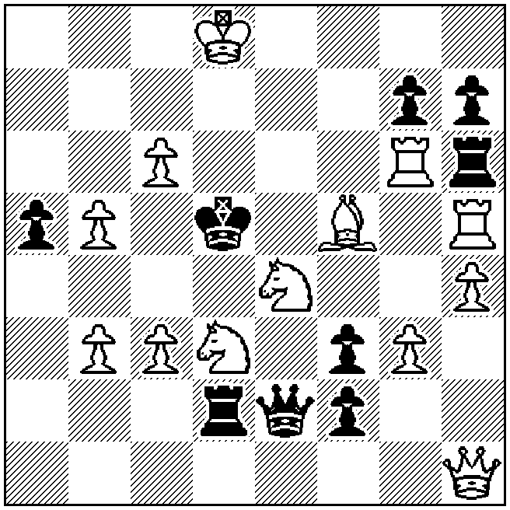
‡3 (13+9)

Aleksandr Kuzovkov  The Problemist 1997 | Example B4  1.Rff4! [2.Sf7+ Kd5,K×e6 3.Qd6‡]  1…d×c6 2.Rfe4+ Kd5/Kf6 3.Rcd4/Sh7‡  1…d×e6 2.S×f3+ Kd5 3.Rfd4‡  1…d5 2.d4+ R×d4 3.e×d4‡  1…d6 2.Qc3+ Kd5 3.Qd4‡  1…R×d3 2.Rfe4+ Kd5/Kf6 3.Q×d3/Sh7,Qf8‡  Black Pickaninny at B1  Mates on the same square at W3
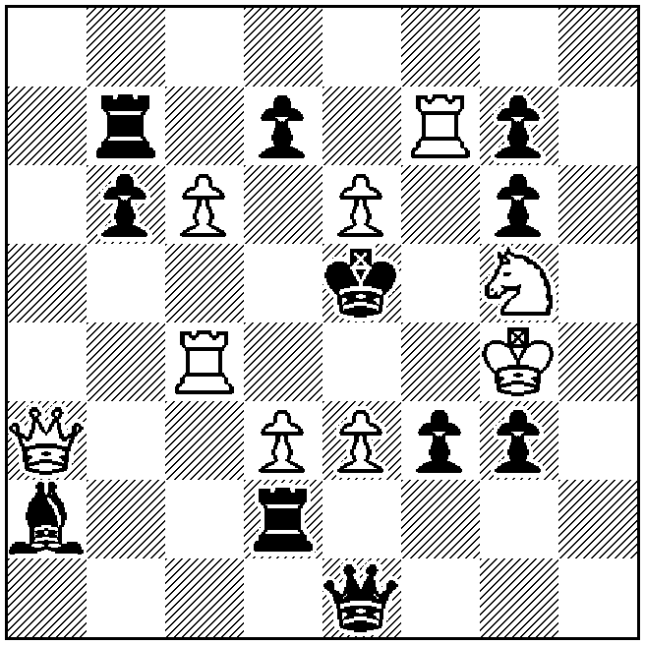
‡3 (9+11)

SECTION C: MOREMOVERS

Judging countries: Belarus, Finland, Germany, Switzerland, Ukraine
Reserves: Russia

Theme: In a directmate in 4 to 6 moves, the first move of a Siers battery is the second move of the problem. The second move of the Siers battery is the last (mating) move of the problem. This may be called an "interrupted" Siers battery.

"Normal" Siers battery: the front piece, in moving away from the battery line, gives a flight; when the king moves to this flight, the original front piece moves again to give check or mate, but this move is not a return to its starting square.

Torsten Linss  1 C East German Federation Beginners Ty 1987-88 | Example C1  1.Rc8! [2.Sa8+ Kd5 3.Sc7‡]  1…Qe7 2.Sa4+ Kd5 3.c4+ b×c3 e.p. 4.S×c3‡  1…Qg7 2.Sc4+ Kd5 3.e4+ f×e3 e.p. 4.S×e3‡
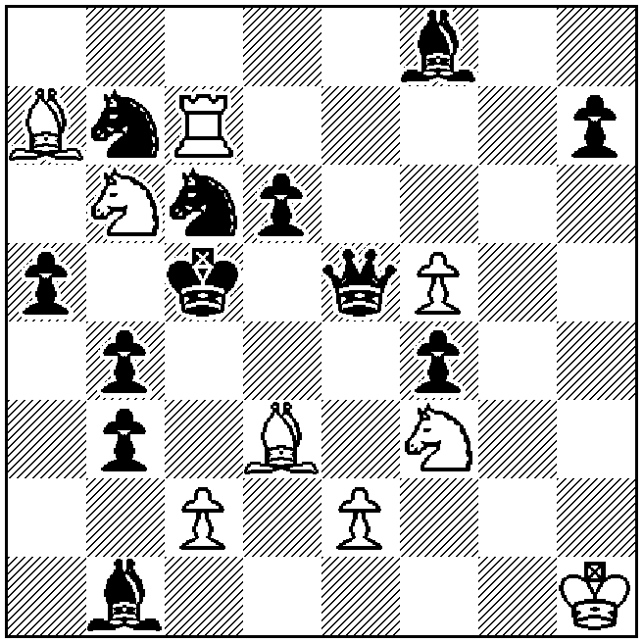
‡4 (9+12)

Anatoly Styopochkin  Vyacheslav Anufriev  1 Pr Probleemblad 1992 | Example C2  1.Qg6! [2.Qf5+ Kd4 3.c3+ b×c3 4.b×c3‡  2…Re5 3.S×c8+ Kd5 4.Se7‡  2…Be5 3.Sd7+ Kd5 4.Sf6‡]  1…Re5 2.Sa4+ Kd5 3.c4+ b×c3 e.p. 4.S×c3‡  1…Be5 2.Sc4+ Kd5 3.e4+ f×e3 e.p. 4.S×e3‡  1…Re3 2.S×c8+ Kd5 3.Qf5+ Re5,Be5 4.Se7‡  1…B×b2,Bc3 2.Sd7+ Kd5 3.Qf5+ Re5,Be5 4.Sf6‡  (1…Kd4 2.c3+ b×c3 3.b×c3+ Kc5/Ke5 4.b4/d4‡  2…Kc5 3.Sd7+,Q×g5+  1…Ra8 2.S×a8+ Kd5 3.Sc7+,Qf5+  1…Re6 2.Q×e6 [3.S~,Qc4‡] Kd4 3.e3+ f×e3/Kc5 4.Q×e3/S~,Qc4‡)
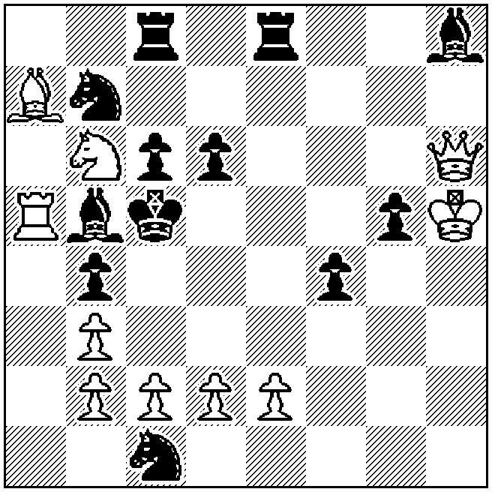
‡4 (10+12)

SECTION D: ENDGAME STUDIES

Judging countries: Azerbaijan, Finland, Georgia, Russia, Slovakia
Reserves: Belgium

Theme: In a win study, the white queen moves, without capturing, checking or refuting a check, to a square where she is not guarded by White and where she can immediately be captured by Black.

Gerhard Josten  Gert Wilhelm Hörning  Problem-Forum 2001 | Example D1  1.Qb5 Q×b5+ [1…Qa8 2.Qg5 (2.Qd7 Qa5+ 3.Kh6 Qd2+)] 2.Kh6 Qh5+ [2…Qd7 S×d7] 3.S×h5 Be4 [3…Sd4 4.g7+ Kg8 5.Sf6+ Kf7 6.g8=Q+ K×f6 7.Qg7+ Ke6 8.Q×d4] 4.g7+ Kg8 5.Sf6+ Kf7 6.S×e4 d5 [6…f2 7.S×f2] 7.Kh7 +-
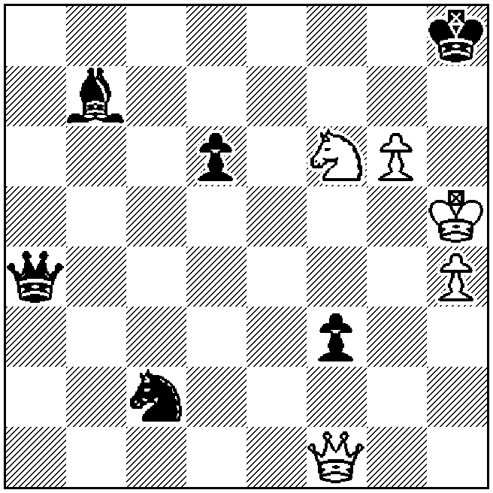
+ (5+6)

Ilham Aliev  (after Jindrich Fritz,  1 Pr Svobodné slovo 1961)  EG 1999 | Example D2  1.Qh1 [1.Qh8+ Ka2] 1…R×h1 2.a8=Q Rg1 3.Qh1 R×h1  4.a7 Rg1 5.a8=Q+ Kb2 6.Qb8+ +-
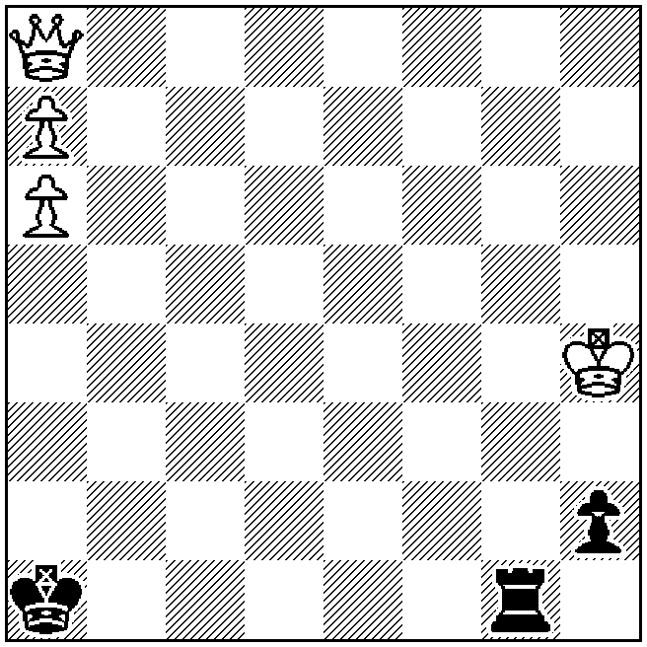
+ (4+3)

Mario Matouš  5 HM Shakhmaty v SSSR 1986 | Example D3  1.Ka2 [1.Qc2+ Kb4 2.Qd2+ Kc5 3.Qe3+ Kc6] 1…b4 [1…Qe5 2.Qd2 b4 3.Qd7+ Qb5 4.Bb3‡; 1…Qd8 2.Qe1 Qd3 3.Qh4+ b4 4.Be8+] 2.Qf4 [2.Qg3 Qh8 3.Bc4 (3.Qh4 Qc8; 3.Qh3 Qd8) 3…Qc3] 2…Qh8 [2…Qa8 3.Qf3; 2…Qc8 3.Qc7; 2…Qd8 3.Qd6] 3.Qh6 [3.Qh4 Qc8; 3.Bb3+ Kb5 4.Qc7 Qc3 5.Ba4+ Ka6; 3.Qc7 b3+ 4.B×b3+ Kb5 5.Ba4+ Kb4 6.Qb7+ Kc5 7.Qb5+ Kd6 8.Qc6+ Ke7 9.Qd7+ Kf8 10.Qe8+ Kg7] 3…Qa8 4.Qh1 Qc8 [4…Q×h1 5.Be8+] 5.Qc1 Qd7 [5…Qa8 6.Qf1 b3+ 7.B×b3+ Kb4 8.Qc4‡] 6.Qd1+ [6.Bc4 Qh3] 6…Qxd1 7.Be8+ Qd7 8.B×d7‡ +-
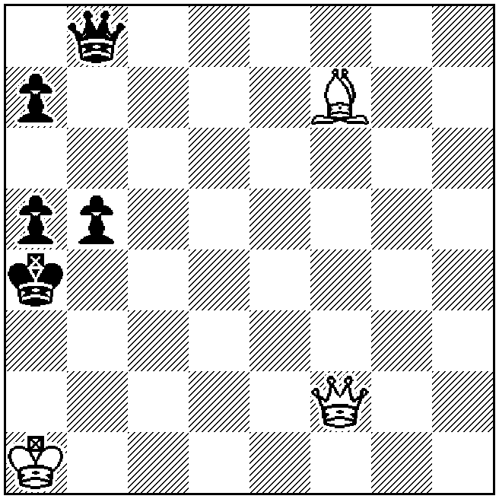
+ (3+5)

Viktor Kapusta  Lev Kapusta  1 Pr E. Böök-70 JT  Suomen Shakki 1980-81 | Example D4  1.f6+ Kh8 [1…Kg8,Kf8 2.Qh6(+)] 2.Re3 [2.g4 Bd8 3.Rh3 Kg8] 2…Bd8 [2…Q×a4 3.Re7 Qb5 4.R×f7 Rg8 5.R×h7+ K×h7 6.Qh4‡; 2…Qc8 3.Re7 R×e7 4.Qh6 Qg8 5.f×e7 Bd8 6.Qf8 B×e7 7.Q×e7; 2…Rf8 3.Re7 Qf5 4.Q×f5 g×f5 5.R×c7] 3.Qg4 Q×a4 4.b5 Q×b5 5.Qc4 Qd7 6.Qc8 Qa4 7.Qa8 Qb5 8.Q×b7 Qa4 9.Qa7 Qb5 10.Q×f7 Rg8 11.g4 [11.Re4 h5 12.g4 (12.Qe6 Qb7 13.f7 Rf8 14.Q×d6 Q×f7 15.Rf4 Bf6) 12…B×f6 13.Q×f6+ Rg7 14.Q×d6 Qd7 15.Qf8+ Kh7 16.d6 Qc6 17.f3 Qc2+; 11.Re1 g5] 11…g5 [11…Qa4 12.Q×h7+ K×h7 13.Rh3‡] 12.Re4 h6 [12…Qd3 13.Re8 Qg6 14.Q×g6 h×g6 15.f7; 12…B×f6 13.Q×f6+ Rg7 14.Qf8+ Rg8 15.Q×d6 Qb2 16.Re5] 13.Qe6 Rf8 14.Q×d6 Kg8 15.Re7 B×e7 16.f×e7 Re8 17.Qg6+ Kh8 18.Q×h6+ Kg8 19.Qg6+ Kh8 20.Q×g5 Qd7 21.Qh6+ [21.d6 Qc6+ 22.f3 Ra8] 21…Kg8 22.Qg6+ Kh8 23.d6 Qc6+ 24.f3 R×e7 25.Qh6+ Kg8 [25…Rh7 26.Qf8‡] 26.d×e7 +-
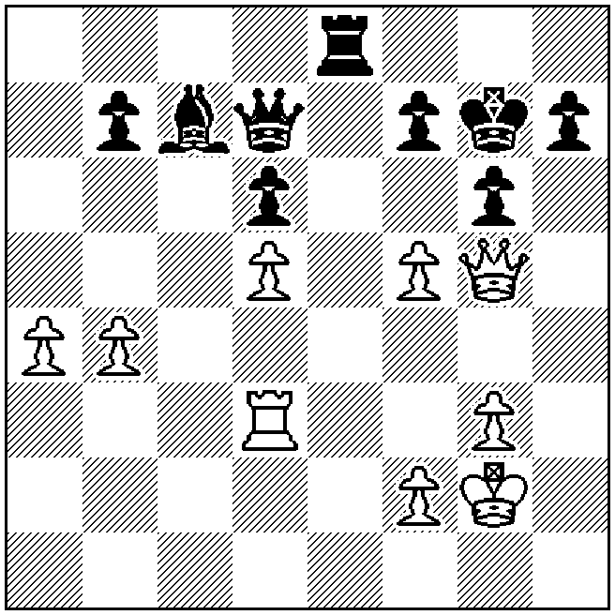
+ (9+9)
Oleg Pervakov  Pr V.A. Razumenko-70 JT  Zadachi i Etyudy 2007 | Example D5  1.Qa8 [1.Qf7 Bh4 2.B×h5+ Ke1 3.Se3 d1=Q 4.B×d1 Qg1] 1…Qh3 [1…Q×a8 2.B×h5+ Qf3 3.B×f3‡; 1…Q×f1 2.B×h5+ Qe2 3.Qa4‡] 2.Qc8 [2.Qa6 Qc3+ 3.K×a2 Bh4 4.Se3+ Kc1 5.Qf1+ Be1 6.Qb5 d1=Q 7.S×d1 K×d1] 2…Qf3 [2…Q×f1 3.B×h5+ Qe2 4.Qc2‡; 2…Q×c8 3.B×h5+ Qg4 4.B×g4‡; 2…Qc3+ 3.Q×c3 S×c3 4.B×h5+ Se2 5.Se3‡; 2…Ke2 3.Q×h3 d1=Q 4.B×h5+] 3.Qc4 Bf2 [3…Qb7+ 4.Ka1; 3…Bh4 4.B×h5 (4.Se3+ Ke1) 4…Q×h5 5.Se3+ Ke1 6.Qf1‡] 4.Se3+ [4.B×h5 B×d4+ 5.K×a2 Q×h5 6.Se3+ B×e3 7.Qf1+ Kc2 8.Qb1+ (8.Qc4+ Kd1 9.Qf1+ =) 8…Kc3 9.Qb3+ Kd4 –+] 4…B×e3 5.B×h5 B×d4+ 6.K×a2 Q×h5 7.Qf1+ Kc2 8.Qb1+ Kc3 9.Qb3‡ +-
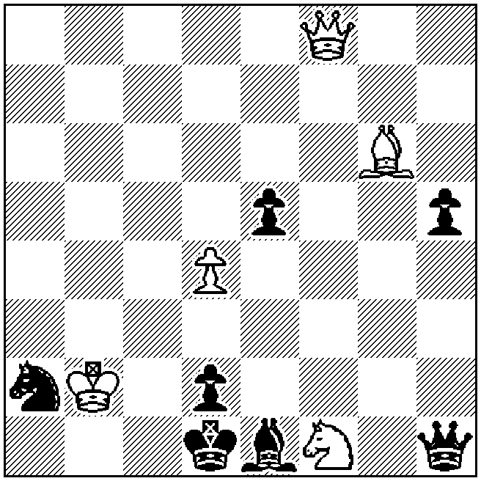
+ (5+7)
SECTION E: HELPMATES

Judging countries: Czech Republic, Israel, Italy, Macedonia, Ukraine
Reserves: Switzerland

Theme: In each line of play of a helpmate in 3 moves, a black unit (pawns included) could hypothetically have been removed from the board instead of being moved to a certain square (the thematic move) and the specific solution or set line would still be successful. The thematic move must not be the only legal move available to the piece making it. The thematic move must not be a tempo move.

If thematic moves by more than one unit are included in the same phase, each such move must meet the above conditions independently. It is not allowable to include more than one thematic move by the same piece in the same phase.
At least two lines of play are required. Set play, multi-solutions and twins are allowed, but not duplex, Polish-type twins or zero-positions.

Alois Johandl  Europe Echecs 1962 | Fadil Abdurahmanović  in memoriam P. Kniest  Pr feenschach 1994 | Gennady Kozyura  17 Pl MKD-RUS-UKR 2008-09
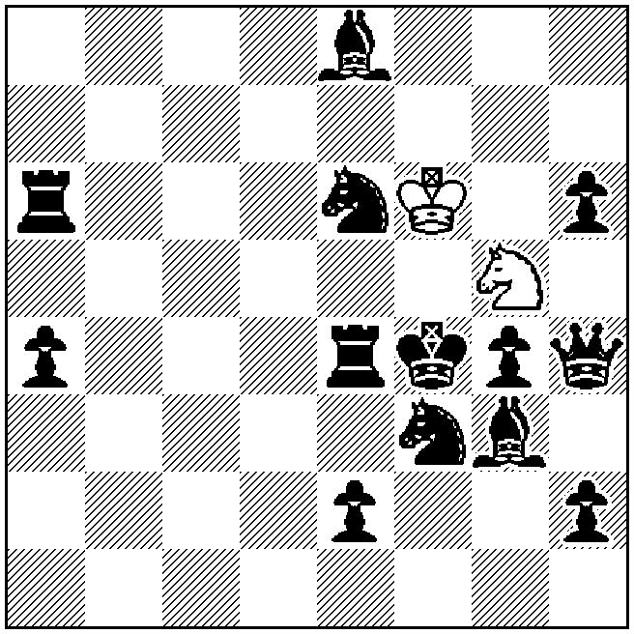 | 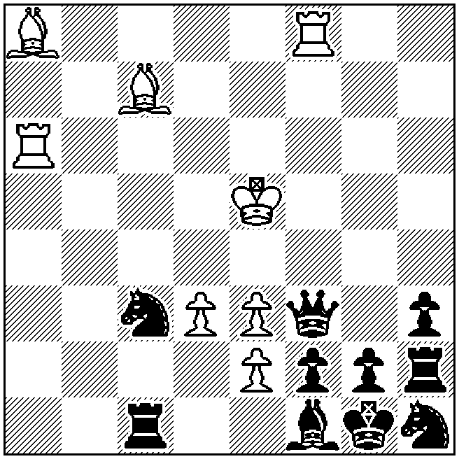 | 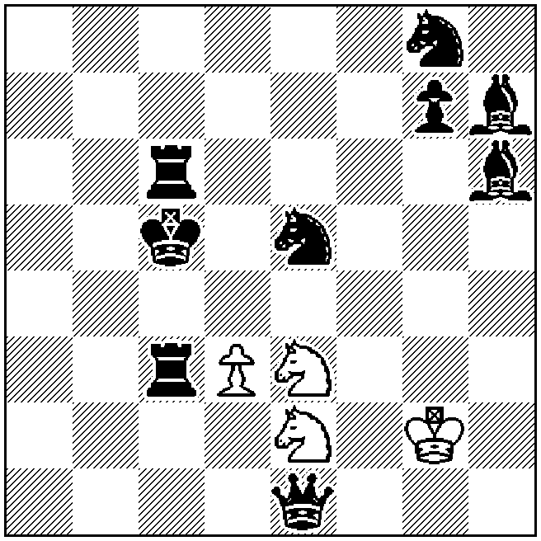
h‡3 2.1.1… (2+13) | h‡3 2.1.1… (8+10) | h‡3 2.1.1… (4+9)

Example E1 (Johandl)
1.Qh3 S×e4 2.e1=R Sc3 3.Re4 Sd5‡
1.Qh5 S×f3 2.e1=S Sh4 3.Sf3 Sg2‡

Example E2 (Abdurahmanović)
1.Q×f8 B×g2 2.K×g2 Bd8 3.Kg3 Rg6‡
1.Q×a8 R×f2 2.K×f2 Ra2 3.K×e3 Bb6‡

Example E3 (Kozyura)
1.Bf4 Sf5 2.Kd5 Kh3 3.R3c5 S×f4‡
1.Bf5 Sf4 2.Kd4 Kh2 3.R6c5 S×f5‡

Christopher J.A. Jones  Problemkiste 2005 | Chris. Feather  Probleemblad 2006 | Menachem Witztum  HM Tver Vodka  Wageningen 2001 (v)
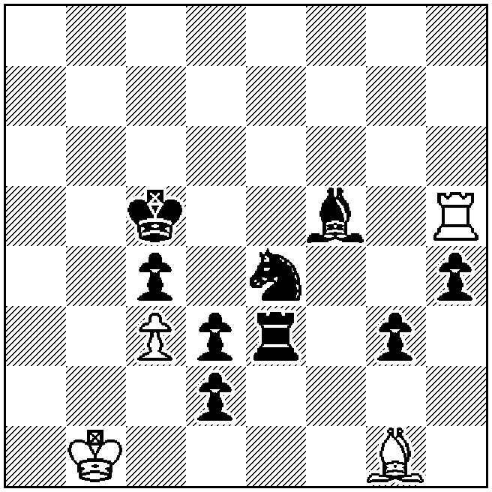 | 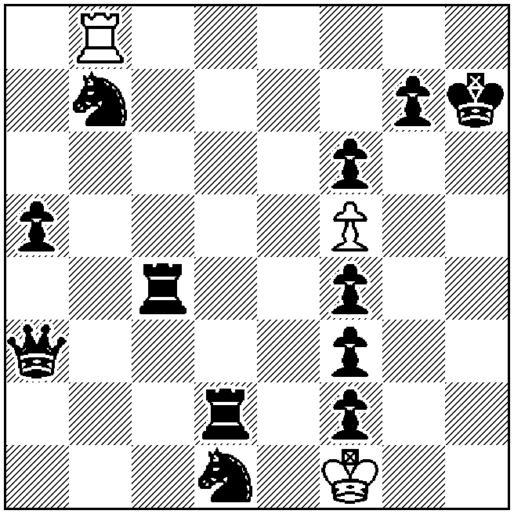 | 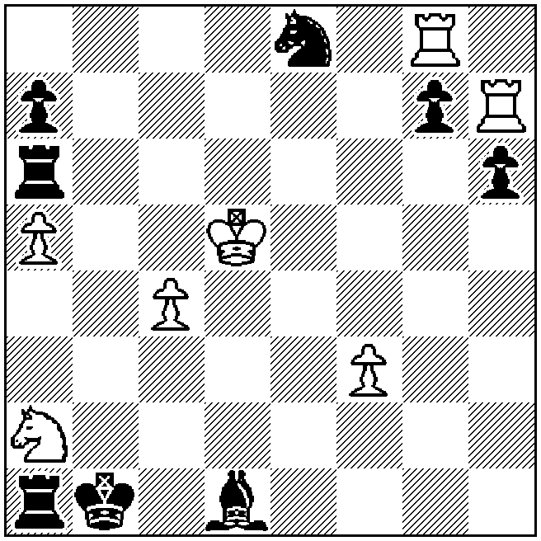
h‡3 b) g3→f6 (4+9) | h‡3 3.1.1… (3+12) | h‡3 b) g8 (7+8)

Example E4 (Jones)  a) 1.Sg5 Rh6 2.Be4 Rb6 3.Bd5 B×e3‡  b) 1.Sf2 Bh2 2.Re6 Bc7 3.Rc6 R×f5‡ | Example E5 (Feather)  1.Sc5 Rb2 2.Rd8 R×f2 3.Rg8 Rh2‡  1.Sd8 Rb3 2.Qf8 R×f3 3.Qg8 Rh3‡  1.Sd6 Rb4 2.Rc8 R×f4 3.Rg8 Rh4‡
Example E6 (Witztum)
a) 1.Re6 Rg×g7 2.Re4 Rg2 3.B×f3 Rb7‡
b) 1.Ba4 R×g7 2.Bb5 Rg2 3.R×a5 Bh7‡

Christopher J.A. Jones  1 Pr Problem-Forum 2005 | Marko Ylijoki  Springaren 2000 | Viktor Chepizhny  2 Pr Shakhmatnaya Poeziya 2007
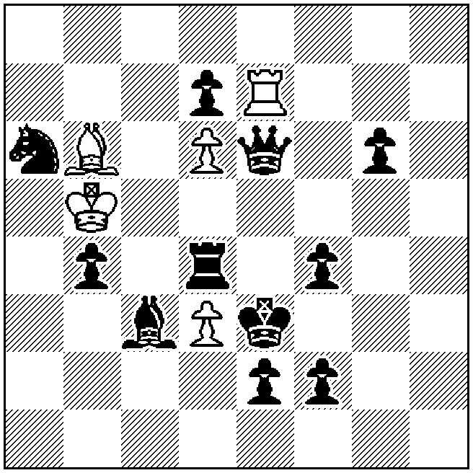 | 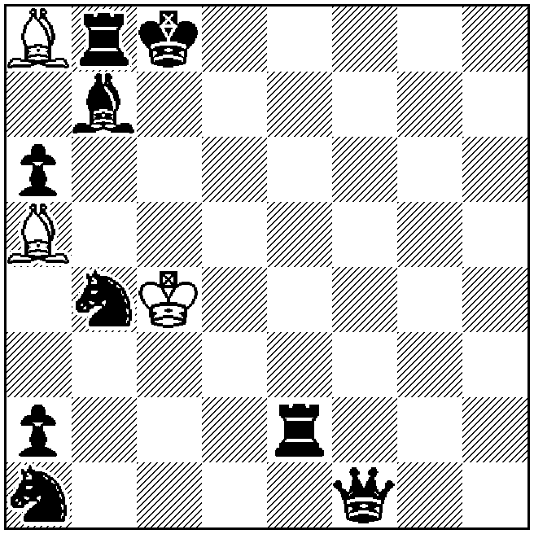 | 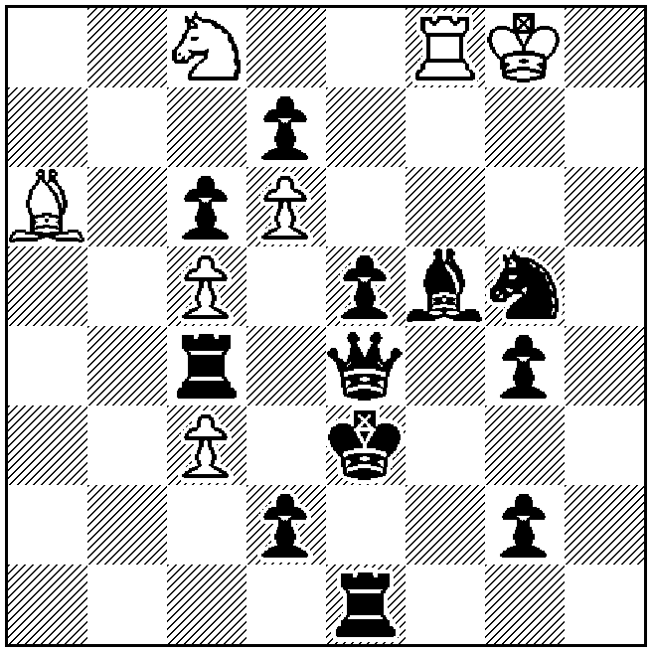
h‡3 b) -f4 (5+11) | h‡3 2.1.1… (3+9) | h‡3 b) g4→c2 (7+12)

Example E7 (Jones)  a) 1.f3 Bd8 2.R×d6 R×d7 3.Rc6 Bg5‡  b) 1.Bd2 Rh7 2.Q×d6 Bc7 3.Qe7 Rh3‡ | Example E8 (Ylijoki)  1.Bh1 Bg2 2.Rb2+ B×f1 3.Bb7 Bh3‡  1.Bg2 Bf3 2.Qh1 B×e2 3.Bb7 Bg4‡
Example E9 (Chepizhny)
a) 1.Qb1 Se7 2.Bc2 Rf1 3.Re4 Sf5‡
b) 1.Qh4 Sb6 2.Rg4 Bf1 3.Be4 Sc4‡
SECTION F: SELFMATES

Judging countries: Belarus, Bulgaria, Germany, Israel, Switzerland
Reserves: Slovakia

Theme: In a selfmate in 3 to 5 moves, Black defends against the threat by closing a line of a black piece which gives direct mate in the threat. The closure may be anticipatory or masked. The thematic line can be either a line along which the black piece moves, or a line along which it attacks the white king. The piece whose line is closed has to play some role in the thematic variation(s).

Aleksandr Bakharev  1 Pr S. Ilyasov MT  Molodoï 2006 | Živko Janevski  8 Pl 7th WCCT 2003-04 | Živko Janevski  1 C Die Schwalbe 2008
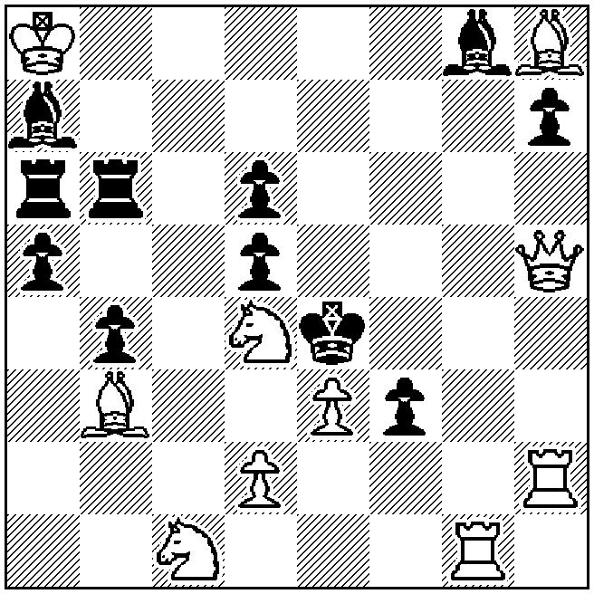 | 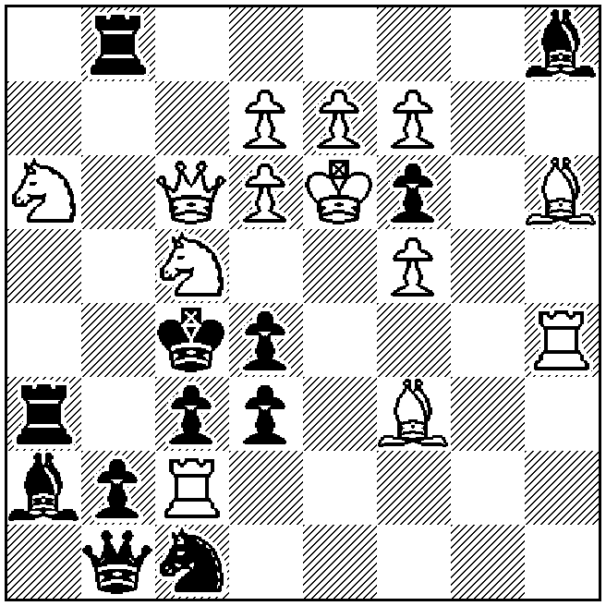 | 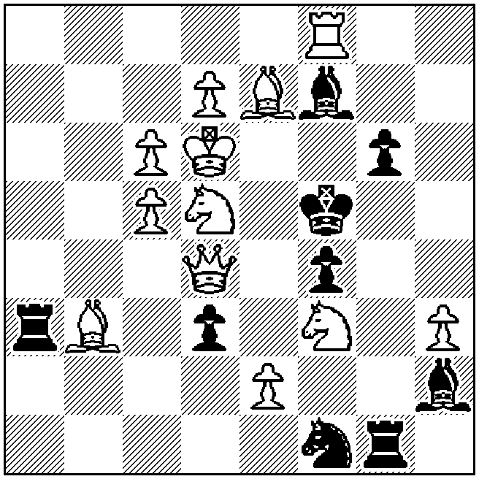
s‡3 (10+11) | s‡3 (13+12) | s‡3 (12+9)

Example F1 (Bakharev)
1.Sde2! [2.Q×f3+ K×f3 3.B×d5+ B×d5‡]
1…Rc6 2.Q×d5+ B×d5 3.Bc2+ R×c2‡
1…Rb7 2.B×d5+ B×d5 3.Q×h7+ R×h7‡
1…Rb5 2.Qh4+ Kf5 3.Sd4+ B×d4‡

Example F2 (Janevski)
1.Bd1! [2.R×d4+ K×d4+ 3.Qd5+ B×d5‡]
1…Sb3 2.R×c3+ K×c3 3.Sb7+ Sc5‡
1…Rab3 2.S×b3+ K×b3 3.Qa4+ K×a4‡
1…Rbb3 2.S×d3+ K×d3 3.Qb5+ R×b5‡

Example F3 (Janevski)
1.Sg5! [2.e4+ f×e3 e.p.+ 3.Qe5+ B×e5‡]
1…Rg3 2.Q×d3+ R×d3 3.e4+ f×e3 e.p.‡
1…Sg3 2.Se3+ f×e3 3.Qe4+ S×e4‡
1…Sd2,Se3 2.S(×)e3+ f×e3+ 3.Qe5+ B×e5‡
1…d×e2 2.Bc2+ Rd3 3.Q×f4+ B×f4‡

Živko Janevski  2 HM PCCC-50 JT 2010 (v) | Example F4  1.Rg~? [2.Bg7+ Ke3 3.Qe2+ B×e2‡]  but 1…Sd3!  1.Rd7? [2.Bg7+ Ke3 3.Qe2+ B×e2‡]  but 1…c4!  1.Rg6! [2.Bg7+ Ke3 3.Qe2+ B×e2‡]  1…Sd3 2.R×d6+ S×d6 3.Q×c5+ S×c5‡  1…c4 2.Qe5+ d×e5 3.Sb3+ c×b3‡  1…Sf3,Sg2 2.Sb3+ Ke4 3.Qc4+ B×c4‡
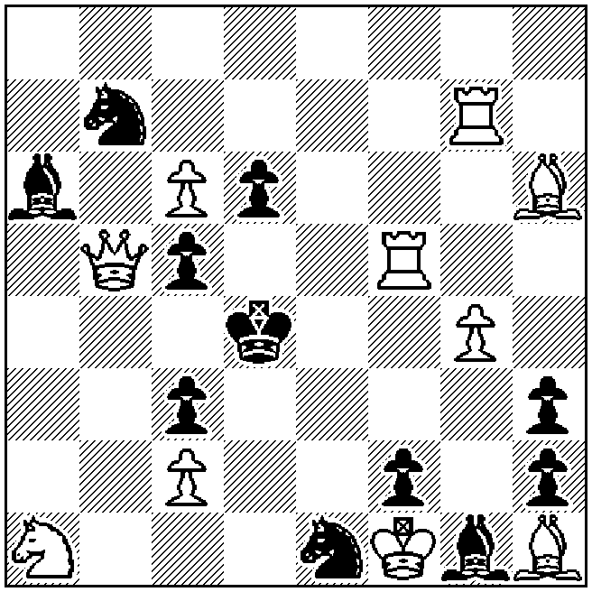
s‡3 (10+11)

Andreï Selivanov  3 Pr A. Azhusin-55 JT  Uralsky Problemist 2006 | Example F5  1.Rf5! [2.R×d4+ K×d4 3.Rd5+ Q×d5‡]  1…Sf3 2.Rf4+ K×f4 3.R×d4+ S×d4‡  1…Rg2 2.Re5+ Kf4 3.Sg6+ R×g6‡  1…R×e2 2.Rc3+ d3 3.Rf4+ K×f4‡
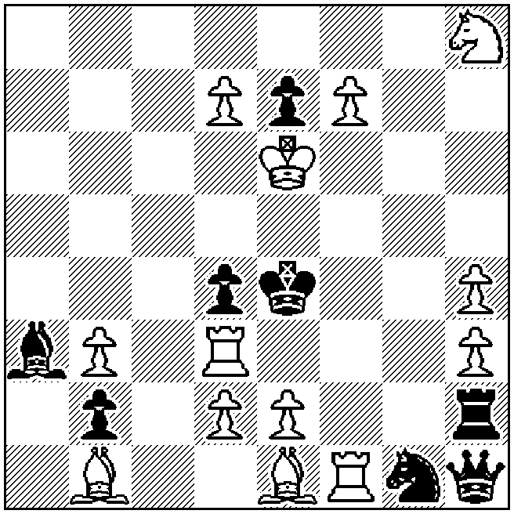
s‡3 (13+8)

Aleksandr Azhusin  Andreï Selivanov  2 Pr Uralsky Problemist 2002 | Example F6  1.Qb4! [2.Sb2+ Ke3 3.Sd1+ Q×d1 4.Qd4+ Q×d4‡]  1…Bg4 2.Sb6+ Ke3 3.S×d5+ e×d5 4.Qf4+ g×f4‡  1…g4 2.Sa3+ Ke3 3.Qf4+ S×f4 4.Sc2+ B×c2‡  1…Qe2+ 2.Se3+ K×e3 3.Bd2+ Q×d2 4.Qd4+ Q×d4‡
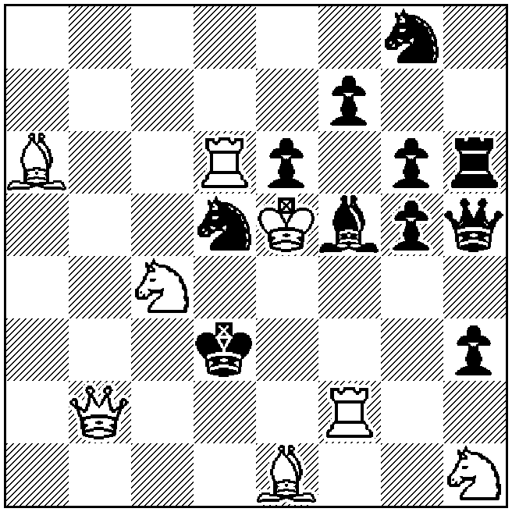
s‡4 (8+11)

SECTION G: FAIRIES

Judging countries: Bulgaria, Czech Republic, Japan, Slovenia, Sweden
Reserves: Croatia

Theme: In a helpselfmate in 2 to 4 moves, anti-battery critical moves by Chinese pieces (LEO, PAO, VAO, NAO) have to be shown. Set play, multi-solutions and twins are allowed, but not duplex, Polish-type twins or zero-positions. By General Rules, point 5, no other fairy pieces or conditions are allowed.
Definitions
- In a helpselfmate in n moves (denoted hs‡n), White starts and Black collaborates with White for n-1 moves, in order to reach a position where White forces a s‡1 (selfmate in one move) at move n. In hs‡n.5 problems (hs‡2.5 and hs‡3.5 are allowed), Black starts.

- Anti-battery critical move of a Chinese piece: A Chinese piece A moves without capture along a critical line crossing (but not starting from) a critical square x. After it, another piece B of the same colour as A plays to square x with a positive line effect along the critical line (allowing piece A to check, guard, capture, pin and so on).

LEO (): the Chinese Queen, which moves like a normal Queen, but captures by moving along Queen-lines over another unit (the hurdle) of either colour to any number of squares beyond the hurdle, provided that the line is free.

PAO (): the Chinese Rook, which moves like a normal Rook, but captures by moving along Rook-lines over another unit (the hurdle) of either colour to any number of squares beyond the hurdle, provided that the line is free.

VAO (☹): the Chinese Bishop, which moves like a normal Bishop, but captures by moving along Bishop-lines over another unit (the hurdle) of either colour to any number of squares beyond the hurdle, provided that the line is free.

NAO (): the Chinese Nightrider, which moves like a normal Nightrider (a Rider along a straight line of squares lying a Knight's move away from each other), but captures by moving along Nightrider-lines over another unit (the hurdle) of either colour to any number of squares beyond the hurdle, provided that the line is free.

Hans Peter Rehm  Scheme 1, original 2010 | Hans Peter Rehm  Scheme 2, original 2010 | Hans Peter Rehm  Scheme 3, original 2010
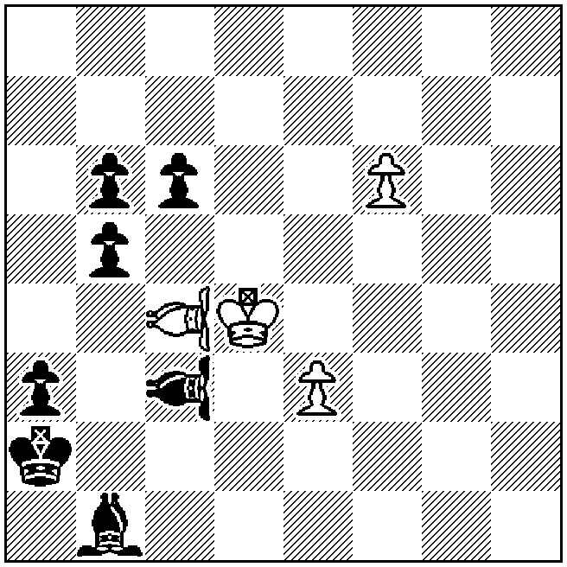 | 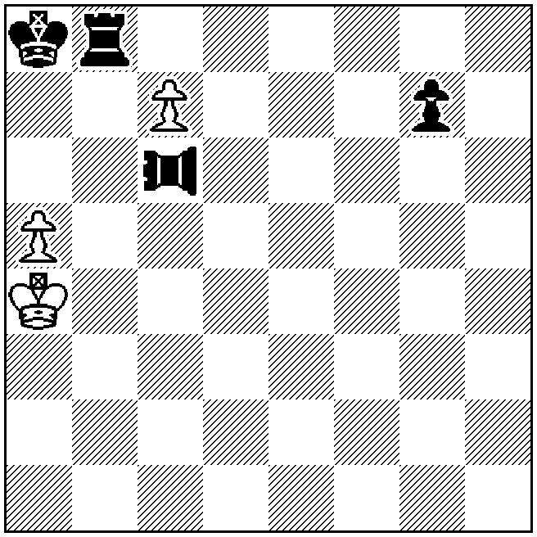 | 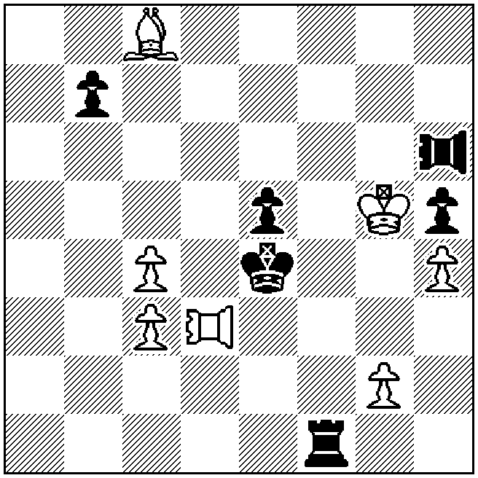
hs‡2 (4+7) | hs‡2.5 (3+4) | hs‡3 (7+6)
Example G1: 1.VAOg8 VAOa1 2.f7+ Kb2‡
Critical move by White 1.VAOg8, critical line a2-g8, critical square f7.
Critical move by Black 1…VAOa1, critical line h8-a1, critical square b2.
Anti-battery check and mate.

Example G2: 1…PAOh6 2.c8=Q g6 3.Qa6+ PAO×a6‡
Anti-battery critical move 1…PAOh6 in order to capture.

Example G3: 1.PAOh3 PAOa6 2.g3 b6 3.Bf5+ R×f5‡
Critical moves of white and black PAOs with indirect anti-batteries.

Petko A. Petkov  ANDA 2003 | Example G4  1.d8=R Ra4 2.PAOa7 Bd4 3.Ke4+ Ke7 4.VAOd7+ B×a7‡  1.d8=B Bc5 2.VAOa4 Rd4 3.Ke3+ Ke8 4.PAOed7+ R×a4‡  White anti-battery critical moves PAOa7 and VAOa4  with anti-battery checks on W4.  The black moves 1…Ra4 and 1…Bc5 are normal critical moves, which are not thematic.
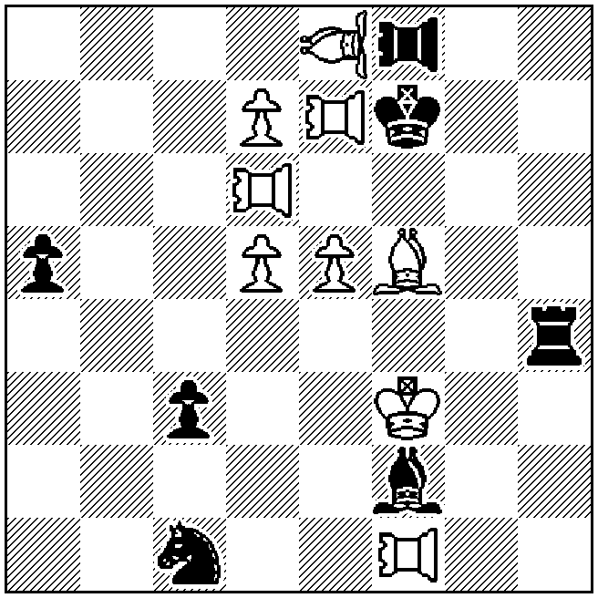
hs‡4 211… (9+7)

Editors of chess magazines are asked not to publish originals with themes of this tournament before the award of the WCCT is printed

