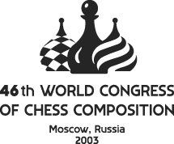 |  | Application Form
Surname:
First name:
Date of birth: ( dd.mm.yy )
Place of birth: |  |  |  |  | Citizenship:
Address:
City: |  |  |  | Country:
Tel: |  |  |  | Fax:
E-mail:
I will apply for entry visa in (city):
Arriving from:
Passport Number:
Please return this application form to the organizing committee
Vladimirov Jakov, Petrozavodskaya str. 17 korp.2 kv. 157, 125 502 Moscow, Russia
Tel / fax: 007 095 2923165
e-mail: seliv@rol.ru

