PCCC 50 JT - section helpmates
Judge: Michal Dragoun (Czech Republic)

Pins and/or unpins were frequently used in helpmate compositions, and surely they will do so in the future too. For this reason I did not expect some extraordinary new concepts and in the preparing of the award I had often to ask (and answer) the question, if partly new problem deserves recognition and where is already limit for saying „it is not original enough“. My decisions in such cases (as the decisions of every judge) are surely subjective.
I received from Dmitrij Baibikov as director of the whole tourney 92 anonymized entries. The number was quite high and their quality was satisfactory, however after seeing the problems for the first time, I had a lot of candidates for commendations, but quite a few compositions attracted me to give them prizes. I eliminated one cooked problems and few, which were not thematic (without pinning or unpinning move - the move on the pinline is for me no one of them). In some compositions was pin created on one line, but in such cases the pin was usually not necessary and sometimes better economy without such two (ore at least one) pieces can be achieved (Nos. 11, 41, 46, 51, 68, 87). Problems with clear symmetry or weak economy of the mating side had not the chance to be in the award too.
Before the award itself few notes to some problems not included:
2: Economical extension of problem sent for comparison, but I dislike different motivation for B2 and repeated move d4.
3: Construction with a lot of white pawns shows difficulty of the idea, but I like more final direct unpinning in P0521725 (all problems given for comparison are quoted under their number in PDB).
4 and 78: Combination of black and white halfpin, but the solutions are not homogenous enough.
9: Unpin of black pieces with following blocks are used in the same pattern eg. in P0525929. Because of another geometry of the wQ pin twinning is necessary.
10: Author(s) probably intended mates from square vacated in B1, but I like P0578345 more.
15: Interesting idea, but the same first move in all positions are too disturbing for me.
20: 2.Sf5 interferes black Queen too.
25: The play reminds P0540741.
31: Difficult idea, but first white move is not interesting and motivation for B3 is too different.
33: The content is in my eyes not so special for two bQ.
34, 42 and 54: Unpin-selfpin-unpin sequence with not absolutely homogenous motivation (usually black block in one position is added).
40: Unpin of both white pieces, but I like much more different moves by black, as eg. in P0526373.
44 and 58: Good economy, but main interest of the play I see only in duplex form.
59: Unpin of the white pieces are not relevant for the content and first white move in combination with twinning is not very homogenous.
61: Antidual motivation of the first black move is not homogenous and reminds partly to P1014070.
67: Two black underpromotions with white fuctions exchange, but as whole too simple.
69: Better construction in comparison to the quoted problem of J. Simadhinata, but not new enough.
74: Known selfpins in B2 were already shown in better content, here especially first white move is not interesting.
83: Richer motivation with similar white play (without twin) has P1006525.
86: Anticipated by P0547149 or P0563604.

My ranking is as follows:

Ricardo de Mattos Vieira (Brazil)
1st Prize – No. 88.
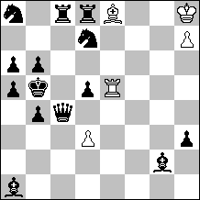
C+ 5+14
h#3 b) bPa5→a4

Rich play with Holzhausen interferences, unpin of white and black pieces, interferences and hideaways with a lot of reciprocal effects between four pairs of pieces.

Aleksandr Semenenko & Valery Semenenko (Ukraine)
2nd Prize – No. 23.
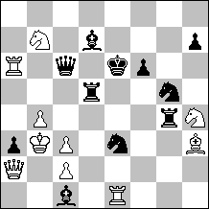
C+ 10+11
h#2 b) Sb7→a7
c) Sb7→h8

Black Rook standing on the line of white masked battery is pinned on three different lines and allow mates by sacrifices of unpinned black pieces. First white move homogeneously guards black King squares - one would wish more interesting motivation, but it is hardly possible in this pattern.
Jorge Lois & Jorge Kapros (Argentina)
3rd Prize – No. 26.
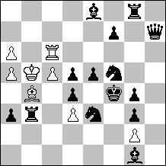
C+ 8+15
h#3 b) Pg2→h4

Freeing of white mating lines and interferences of bB and bQ respectively add new elements to the partly known play (especially concerning unpin of white piece by move of own King, move of unpinned piece and Grimshaw on the Kings initial square in B3).

Francesco Simoni (Italy)
4th Prize – No. 43.
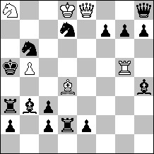
C+ 6+15
h#2 2 solutions

Interesting combination: first black move unpins one of the white pieces and pins wB, white ambush follows and antidual unpin of wB in B2 has antidual effect for choose of the mating move too. However, this play is not absolutely pure: move of bSd7 opens line for guarding of b5 (but its position on d7 is important because of soundness too) and possible mating squares are guarded once directly and once by line opening (but it is not so important). But finally I appreciated more richness of the play than mentioned weaknesses.
Živko Janevski (Macedonia)
1st Hon. Mention – No. 37.
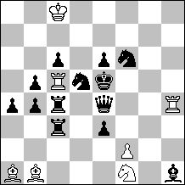
C+ 7+13
h#2 2 solutions

Unpin of one black piece is combined with newly created pin of the black Queen on two lines. Function exchange of two pairs of white pieces and unpinning tries by bS and bR, but first white move is not very interesting.

Shaul Shamir & Paz Einat (Israel)
2nd Hon. Mention – No. 89.
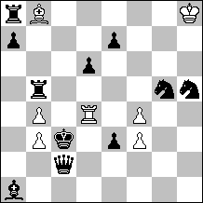
C+ 7+11
h#3 b) bKc3→c8

White unpin and black pin with function exchange between three pairs of pieces. It is a pity that W1 looks as artificial prolongation.
Januarta Simadhinata (Indonesia)
3rd Hon. Mention – No. 22.
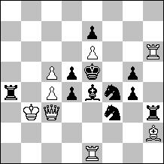
C+ 8+11
h#2 2 solutions

Pin-unpin combination of white Queen is combined with her Pelle moves and line opening for mates.

Ricardo de Mattos Vieira (Brazil)
4th Hon. Mention – No. 80.
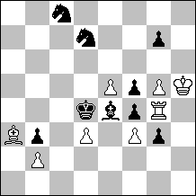
C+ 8+9
h#3 2 solutions

Reciprocal temporary pin between black Bishop and white Rook has unifying effect in opening of lines for wR and blocks by bB and bS.
Ljubomir Branković & Nikola Predrag (Croatia)
5th Hon. Mention – No. 14.
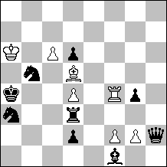
C+ 7+9
h#2 2 solutions
b) Ka4→h1

Captures of white pawns allow 2x2 mates by doublecheck, second black moves have to block Kings square (Sb3, Qg1) or cannot close white line. Very similar No. 27 is maybe a little bit purer in motivation, but I prefer No. 14 with three pieces less.

Almiro Zarur (Brazil)
6th Hon. Mention – No. 75.
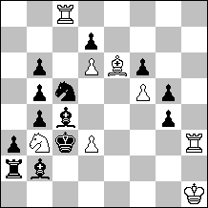
C+ 8+13
h#2 2 solutions

Tempo selfpin by black pieces could be new in combination with activation of white battery created from black halfpin.
Živko Janevski (Macedonia)
1st Commendation – No. 24.
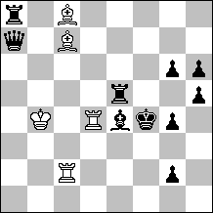
C+ 5+10
h#2 2 solutions

Reciprocal function exchange between three pairs of pieces is surely next step in development of already known idea (and partly even pattern), see P0538578 and P1006565.

Jorge Lois & Jorge Kapros (Argentina)
2nd Commendation – No. 91.
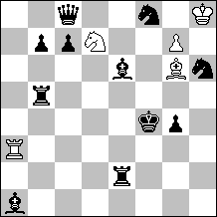
C+ 5+11
h#2 2 solutions

Unpin-selfpin-unpin combination with two white underpromotions and antidual in B2.
Ricardo de Mattos Vieira (Brazil)
3rd Commendation – No. 71.
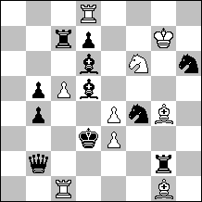
C+ 9+11
h#2 b) Pc5→c6

Again unpin-selfpin-unpin sequence with block in B1 and additional activation of white thirdpin. Unfortunately twinning is not nice.

Julio Pancaldo & Jorge Kapros (Argentina)
4th Commendation – No. 48.
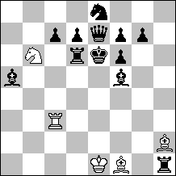
C+ 5+12
h#2 2 solutions

Unpin of white pieces and pin of the black with good use of the whole chessboard and reciprocal function exchange of two pairs of white pieces.
Mikhail Gershinskij (Ukraine) & Alexandr Pankratjev (Russia)
5th Commendation – No. 66.
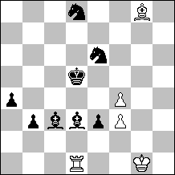
C+ 5+8
h#3 b) e3→c6

Rich content concerning unpins and pins, but mates by double check are quite known and twinning is not ideal.

Valerio Agostini & Antonio Garofalo (Italy)
6th Commendation – No. 1.
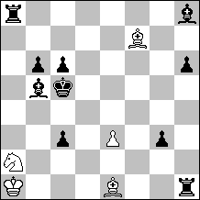
C+ 5+10
h#2 2 solutions

Unpin-selfpin-unpin sequence for the third time, this one deserves distinction because of antiduals in black unpinning moves.
Abdelaziz Onkoud (Morocco)
7th Commendation – No. 62.
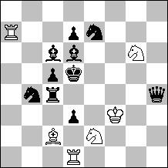
C+ 6+10
h#2 2 solutions

Holzhausen interferences with Zilahi and added second pin in W1.

Živko Janevski (Macedonia) & Abdelaziz Onkoud (Morocco)
8th Commendation – No. 49.
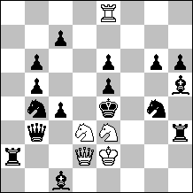
C+ 5+16
h#2 2 solutions

Unpins of white Queen combined with unguard of mating squares in B1 are new in comparison with P0535482.
Commendation without order:

Sven Trommler (Germany)
Commendation – No. 8.
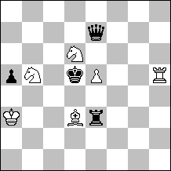
C+ 6+4
h#2 2 solutions

Very light setting with selfpin and unpin of black pieces, freeing fifth rank and blocking e6. Formal addition are three halfmoves on the same squares. I am little bit afraid of originality, but I am not able to claim the anticipation.

Jorge Lois & Jorge Kapros (Argentina)
Commendation – No. 13.
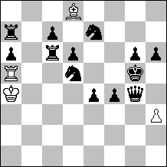
C+ 4+13
h#3 2 solutions

Transfer of both pinned Knights closer to the black King, thus resulting in squareblock. Openings of the bRa7 lines make the difference in comparison with P0506194.
Aleksandr Semenenko (Ukraine)
Commendation – No. 30.
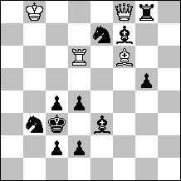
C+ 4+11
h#2 b) Kc3→d3

Combined black-white opening of the lines for the white Queen are combined with known black selfpin after sacrifices of white pieces with their function exchange.

Menachem Witztum (Israel)
Commendation – No. 39.
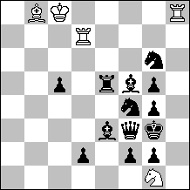
C+ 5+13
h#2 b) Pg5→d4

Unpinned white Rook pins two different black pieces. Plus point are unpinning tries by bB and bS, but twinning detracts overall impression.
Abdelaziz Onkoud (Morocco)
Commendation – No. 45.
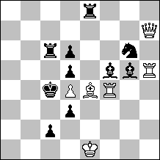
C+ 6+10
h#2 b) –Pd4

Function exchange of two white pieces (pin-mate) with bB standing on the crossing of their lines.

Nikolai Kolesnik & Valery Semenenko (Ukraine)
Commendation – No. 50.
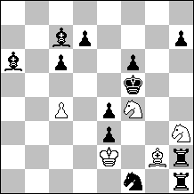
C+ 5+12
h#3 b) Kf5→d6

Zilahi with blocks. Unfortunately in A there are blocks by both Bishops, in B only by one Rook. Despite twinning by move of black King quite economical.
Ricardo de Mattos Vieira (Brazil)
Commendation – No. 65.
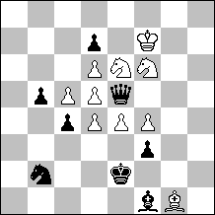
C+ 10+8
h#3 b) Ke2→c3

Temporary pin of both Knights determine white move order. Function exchange between both white Knights.

Abdelaziz Onkoud (Morocco)
Commendation – No. 79.
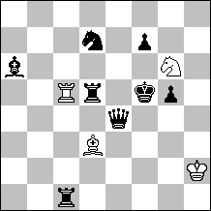
C+ 4+8
h#2 2 solutions

Economical change of pinning units and interference of black lines.

Michal Dragoun
Prague, 19th September 2010

Ricardo de Mattos Vieira (Brazil)
1st Prize – No. 88.
C+ 5+14
h#3 b) bPa5→a4
a) 1.Tc5 Kg7 2.d4 Td5 3.Tb8 L:d7#

b) 1.Dc6 Kg8 2.Sf8 Ld7 3.Lf1 T:d5#

Aleksandr Semenenko & Valery Semenenko (Ukraine)
2nd Prize – No. 23.
C+ 10+11
h#2 b) Sb7→a7
c) Sb7→h8
a) 1.Tf5 Sg6 2.T:b4+ K:b4#
b) 1.Te5 Sc8 2.S:c2 K:c2#
c) 1.Td6 S8g6 2.D:c3+ K:c3#

Jorge Lois & Jorge Kapros (Argentina)
3rd Prize – No. 26.
C+ 8+15
h#3 b) Pg2→h4
a) 1.Sd1 Kb6 (unpin) 2.Sf2 Tf6 A (pin) 3.Lb5 (unpin) Ld2 B #

b) 1.Se7 Ka4 (unpin) 2.Sg6 Ld2 B (pin) 3.Tb5 (unpin) Tf6 A #

Reversal 2nd and 3rd white moves

Francesco Simoni (Italy)
4th Prize – No. 43.
C+ 6+15
h#2 2 solutions
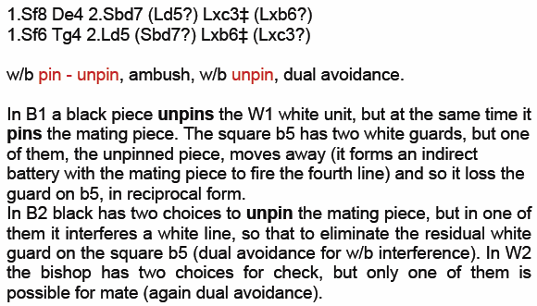

Živko Janevski (Macedonia)
1st Hon. Mention – No. 37.
C+ 7+13
h#2 2 solutions
1.Kd4 Tb5: 2.Sc7 (2.Sf4?) fe3#
1.Kf5 Tg4 2.Tc1 (2.Tc2?) Se3:#

Double black transferred pin with self-unpin/self-pin by the BK and a la Schiffmann thematic try by the black unpinned piece in the each phase! Mates on a same square.

Shaul Shamir & Paz Einat (Israel)
2nd Hon. Mention – No. 89.
C+ 7+11
h#3 b) bKc3→c8
a) 1.Qd3 Rxd6 2.Rd5 Rd8 3.Kd4 Be5#

b) 1.Rb7 Bxd6 2.Qc7 Be5 3.Kb8 Rd8#

Januarta Simadhinata (Indonesia)
3rd Hon. Mention – No. 22.
C+ 8+11
h#2 2 solutions
1. Sxe1 Qf3 2. Bd3 Qxd5#

1. Sxh2 Qe3 2. Sd3 Qxg5#

Ricardo de Mattos Vieira (Brazil)
4th Hon. Mention – No. 80.
C+ 8+9
h#3 2 solutions
1.L:f3 Lb4 2.Ld5 T:g3 3.Sc5 Lc3#

1.S:e5 T:f4 2.Sc4 T:f5 3.L:d3 Lc5#

Ljubomir Branković & Nikola Predrag (Croatia)
5th Hon. Mention – No. 14.
C+ 7+9
h#2 2 solutions
b) Ka4→h1
a) 1.Txd4 Le4! 2.Td5! Lc2#
1.Sxd4 Lc4! 2.Sb3! Lb5#

b) 1.Lxg2 Te4! 2.Lh3! Te1#
1.Dxg2 Tf3! 2.Dg1! Th3#

Necessary selfblock in 2 phases and avoidance of line-interfering switchback in other 2 phases eliminate duals.

Almiro Zarur (Brazil)
6th Hon. Mention – No. 75.
C+ 8+13
h#2 2 solutions
1.Sxd3 Sc5 2.Lb3 Sxb3#

1.Lxd3 Lc4 2.Se6 Lxe6#

Živko Janevski (Macedonia)
1st Commendation – No. 24.
C+ 5+10
h#2 2 solutions
1.Kf3 Lb7(a) 2.Tc5(B) Td3#
1.Kg5 Tc5(b) 2.Lb7(A) Ld8#

An original setting of reciprocal changed squares (b7 & c5) of pining of black piece and black masked interference with reciprocal changed functions of two pairs white line pieces Lc7/Td4, Lc8/Tc2 and black pieces: Te5/Le4.

Jorge Lois & Jorge Kapros (Argentina)
2nd Commendation – No. 91.
C+ 5+11
h#2 2 solutions
1.Tbb2 (unpin) gxf8=L (self-pin) 2.Lg8 (unpin) Lxh6#
1.Teb2 (unpin) gxf8=S (self-pin) 2.Sg8 (unpin) Sxe6#

Ricardo de Mattos Vieira (Brazil)
3rd Commendation – No. 71.
C+ 9+11
h#2 b) Pc5→c6
a) 1.Td2 L:d7 2.Le7! (Lf7?) L:b5#

b) 1.Dd2 S:d7 2.Lf7! (Le7?) Sc5#

Julio Pancaldo & Jorge Kapros (Argentina)
4th Commendation – No. 48.
C+ 5+12
h#2 2 solutions
1.Lxb6 (unpin) Tc6 (pin) 2.Lg1 (unpin) Lc4#
1.Txh2 (unpin) Lh3 (pin) 2.Thd2 (unpin) Te3#

Mikhail Gershinskij (Ukraine) & Alexandr Pankratjev (Russia)
5th Commendation – No. 66.
C+ 5+8
h#3 b) e3→c6
a) 1.Ld4 (развязывание) Lh7(развязывание)
2.Lc4 (связывание) Ld3 (развязывание)
3.Lc5 Le4#

b) 1.Sf7 (развязывание) Te1(развязывание)
2.Sd4 (связывание) Te6 (развязывание)
3.Sd6 Te5#

Valerio Agostini & Antonio Garofalo (Italy)
6th Commendation – No. 1.
C+ 5+10
h#2 2 solutions
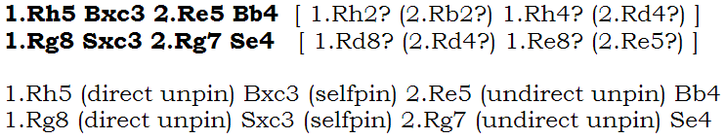

Abdelaziz Onkoud (Morocco)
7th Commendation – No. 62.
C+ 6+10
h#2 2 solutions
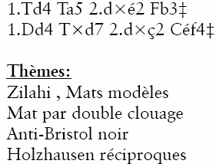

Živko Janevski (Macedonia) & Abdelaziz Onkoud (Morocco)
8th Commendation – No. 49.
C+ 5+16
h#2 2 solutions
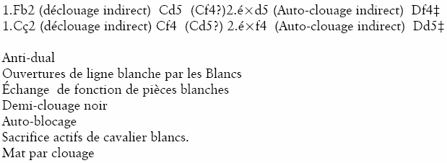

Sven Trommler (Germany)
Commendation – No. 8.
C+ 6+4
h#2 2 solutions
1.Q:e5 Nf5 2.Qe6 Ne7#
1.R:e5 Bf5 2.Re6 Be4#

Jorge Lois & Jorge Kapros (Argentina)
Commendation – No. 13.
C+ 4+13
h#3 2 solutions
1.Dh4 Lxc7 (unpin) 2.Sg8 Ld8+ 3.Sgf6 (self-pin) Txd5#
1.Dh5 Txa6 (unpin) 2.Se3 Ta5+ 3.S3f5 (self-pin) Lxe7#

Switchbacks (Lxc7/Ld8 & Txa6/Ta5)
The black Ss change the square but not the line where they are pinned.

Aleksandr Semenenko (Ukraine)
Commendation – No. 30.
C+ 4+11
h#2 b) Kc3→d3
a) 1.Sc8 T:d4 2.S:d4 Da3#

b) 1.Le8 L:d4 2.L:d4 Df3#

Menachem Witztum (Israel)
Commendation – No. 39.
C+ 5+13
h#2 b) Pg5→d4
a) 1.Sf4-e6 Rd7-d3 2.Be3-d4 (Be3>f4?) Sg1-e2#

b) 1.Re5-e6 Rd7-g7 2.Sg6-f8 (Sg6>e5?) Rh8-h3#

Abdelaziz Onkoud (Morocco)
Commendation – No. 45.
C+ 6+10
h#2 b) –Pd4
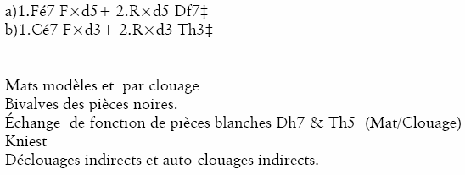

Nikolai Kolesnik & Valery Semenenko (Ukraine)
Commendation – No. 50.
C+ 5+12
h#3 b) Kf5→d6
a) 1.L:c4+ Sd3 2.Le6 Sf2 3.Le5 L:e4#

b) 1.T:g2+ Sf2 2.Tg7 Sd3 3.Te7 c5#

Ricardo de Mattos Vieira (Brazil)
Commendation – No. 65.
C+ 10+8
h#3 b) Ke2→c3
a) 1. D:f4 Lf2 2. D:e4 S:e4 3. Sd1 Sf4#

b) 1. D:d5 Le3 2. D:d4 S:d4 3. Ld3 Sd5#

Abdelaziz Onkoud (Morocco)
Commendation – No. 79.
C+ 4+8
h#2 2 solutions
