PCCC 50th Anniversary Composing Festival
Selfmates
Award
Surprisingly, only 13 entries were submitted to the selfmate section of this prestigious tournament. Fresh ideas or complex combinations of pinning and unpinning effects were scarce. It is not satisfactory if an unpin takes place which plays no role in the sequel, or if just one of three main variations shows pin/unpin play.
In a considerable number of cases, the construction was obviously unpolished (possible improvements of economy being easily seen, in two cases there was a simply superfluous pawn), making a distinction questionable, even more if there were further weak points. My ranking is as follows:

Frank Richter (Germany) & Dieter Werner (Switzerland)
1st Prize – No. 11.
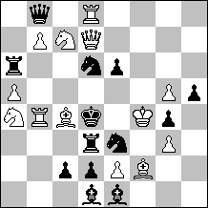
s#3 C+ 13+13
In both variations first unpin, then pin of a black knight by means of matching white battery play, and consecutive Umnov effects. It is a pity that a bPe6 (captured in the key) had to be used to prevent 1.Qe7. The try 1.Qh7? is thematically more interesting than 1.Qc6? because it provides a neat change of White’s 3rd move (after 1. – B:f2) with respect to the solution. This is certainly the most ambitious and satisfying contribution to the tournament.
Frank Richter (Germany)
2nd Prize – No. 9.
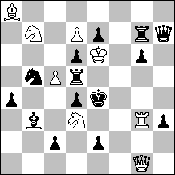
s#5 C+ 8+14
The general logical structure is rather elementary and clear-cut: The first two moves have the aim to shift wSb7 to c6, leaving the position otherwise untouched, which is the decisive preparation for the final combination (moves 3-5). The threat 3.Qd4:+ is introduced by the unpin of bRd5, forcing 2. – Sb5. But in the last move, the very motive of this defense (guard of d4) is exploited, forcing the bS to mate on d4 after the pin move 5.Sd4+. The result is a very clever combination of the theme stipulation and inversion of motives, with a fine change of the whole scenery by the bK’s move to f3. The construction is excellent.

Dieter Werner (Switzerland)
1st Hon. Mention – No. 1.
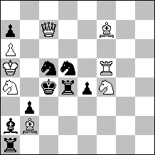
s#5 C+ 8+9
White wants to play 1.Bd5:+ Rd5: 2.Qc5:+, but both the ambushing wRf5 and wSa4 are obstacles. It is easy to get the knight pinned by 1.Qc8 Bb1, but 2.Rf6 “unfortunately” guards b6, hence allows the unpin 2. – Ba2. Now 3.Be6 renews the initial threat, so forces the pin move 3. – Bb1 again. But now the two obstacles are out of the way and the conclusion may follow. A nice and well constructed sequence of pins and unpins in a logical (pendulum) setting. The fact, however, that the threat after 2.Rf6 coincides with the final combination is a drawback as it means that this threat is only put off, not prevented by Black.

Živko Janevski (Macedonia)
2nd Hon. Mention – No. 10.
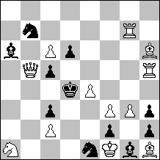
s#3 C+ 12+11
The Dentist mechanism is well known, but here we see an interesting combination with white correction: After an arbitrary move of wRg7, the Dentist variation 1. – c4 works, but 1. – Sd3! is sufficient. Now the correction 1.Rd7!? takes care of the latter – but inadvertently bPd6 is pinned so that 1. – c4! is now successful. White must avoid this pin, hence 1.Rg6!, and both (delayed) Dentist variations run smoothly. This clever presentation of an unwanted pin effect in a white correction try would deserve a higher ranking if the construction had been worked out more carefully. A simple modification (wRh5→f5, wPg3→g4, –wPf3,e4) would suffice to save two white pawns and give work and freedom to the incarcerated wBh1.

Gennady Kozjura (Ukraine)
Commendation – No. 12.
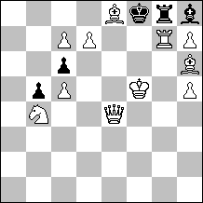
s#4 C+ 11+5
A most elegant two-fold battery construction problem in which the black rook and bishop exchange their roles. First a pin on g7 takes place, followed by an unpin by the black king move. Both variations make full use of the white forces. Still the ranking cannot be high in view of the “close relative” by G. Kozyura and V. Kopyl, Jub. Gershinsky – 70 (Problemist Ukraїni 2006), 3. prize, Kf3, Qf1, Rc5, Rh5, Bc4, Bh4, Se2, Sg5, Pc2, c3, d4, d6, e4, f7, h3 – Kf6, Rg6, Bh6, Pc6, g7, s#5. 1.Sg1 Bg5:/Rg5: 2.e5/Ke3+ Kf5/Kg6 3.Kg3/f8S+ Ke4/Kh5: 4.Ld3/Le2+ Ke3/Kh4: 5.Df4/Df2+. – Furthermore, there is no need for a wQ: a wRe4 is sufficient.

Kronshagen, September 10, 2010
Hartmut Laue

Comments, not part of the award

no. 2: Pd6 superfluous, threat is “unreal” as each black move is a defence

no. 3: removing the units at a3, a4, b6, d1, d3, shifting bQa5→a3, and adding bBa2, bRb3 reduces the number of units from 25 to 22. The contents is certainly of interest, but the threat is very similar to one of the two main variations, and the main mechanism has essentially been shown many years ago by different authors. An example from the past which could easily have competed in this theme tourney is the following: V. Nikoletic, Probleemblad 1990, Ke4, Qc8, Ra4, Rh6, Bf8, Bg8, Sb3, Se8, Pb6, d3, e7, f3, f4, g4 – Ke6, Qg1, Rh4, Rh7, Ba2, Bf2, Sd7, Sf7, Pb7, g3, g6, s#3. 1.Rd4. – A large part of the contents (and the theme matrix) is contained in: Ž. Janevski, TT Liga Problemista 2007, 9. pl., Kc4, Qg5, Rb8, Rf6, Be8, Bf8, Sa8, Sg6, Pb3, d3, d4, e4 – Kc6, Qf2, Rc2, Rh4, Bc3, Sd7, Pa5, a6, b4, c7, e6, h3, h5, s#3. 1.Qf4.

no. 7: Ph6 superfluous, and by canceling this pawn, the move 1. – f5 would become indeed a real defence (while in the submitted position, by contrast, it is just the only possible black move!),

no. 8: bBh1→g2, –bPb4, wPd2→b4 not only saves one unit but also improves the key (then 1.Rd2).

