Studies Award
General introduction
First of all I would like to congratulate all composers with the 50th Anniversary of the PCCC. Secondly, I was really honoured to be invited by PCCC-president Uri Avner to judge this important formal theme tourney.
Personally, I find it difficult to judge a theme tourney. Although I am well aware that a set theme can be very inspiring, the main disadvantage is that comparing an excellent study in which also the set theme occurs almost coincidentally with a relative poor study with an excellent presentation of the required theme. And what about tasks (the only focus is a multiple theme expression)?
Obviously, all of this is not a problem when a couple of excellent studies are submitted which also show an excellent expression of the theme, but, as always, that was not the case here.
The theme was not defined in great detail, and as a consequence I took a very liberal approach, e.g. allowing self-pins as pinning moves in response to a check. But I considered the following cases as not being thematic: a move by a pinning piece only maintaining the pin is not a pinning move.
Also I consider the case where a pinned piece brutaly captures the pinning piece, not as an unpinning move.
I received 29 anonimized studies for judging. All the studies were checked by me for both soundness (two proved to be incorrect, and five studies had duals or cooks due to the presentation of the solution).
Two studies were fully anticipated. Just to give an impression of the time a judge has to invest to produce an award: it took me about 15 hours of time.
I consider the level of the tourney as average; no masterpieces.
dr. Harold van der Heijden, FIDE judge for endgame studies, Deventer 10-08-28

nr | K-pos | correct | thematic | points | award | anticipations
1 | a1d3 | yes | yes | 2 |  | Kubbel d6d8 shows one of the stalemating combinations as a black defence in a win study, and also part of the introduction.
2 | a3a1 | yes | yes | 2,5 | 3.hm
3 | a3e5 | yes | yes | 2 |  | Carlsson & Mugnos f7g2, f6f3, g6g2, f7f3
4 | a7f6 | no | yes | 0
5 | a8c2 | yes (after move 11 duals) | yes | 1 |  | Kalandadze a8c1
6 | b1b4 | yes | yes | 1,5 |  | Neistadt e1c4, e1c4
7 | b8a1 | (yes) | yes | 1 |  | Kraemer g6b1, Glushakov b8h1 (S-prom!), v. Holzhausen g8a1, Aizikowicz f5b1
8 | b8c3 | yes | yes | 1,5
9 | c3a2 | no | yes | 0
10 | c8f7 | yes | yes | 2
11 | d1a1 | yes | yes | 1 |  | Liburkin c3h1
12 | d1a5 | yes | yes | 2,5 | 3.c
13 | d4b7 | yes | yes | 1,5
14 | d8d6 | yes | yes | 1,5
15 | e1h7 | yes | yes | 2,5 | 1.c | Chodera f8c4, Tamburini h5b8
16 | e7c6 | yes | yes | 3 | Spec.p
17 | e8f5 | yes | yes | 3 | 1.hm | Matous & Polasek f7h8
18 | f4f7 | yes | yes | 1 |  | Becker f4f7
19 | f7e4 | yes? | no | 0
20 | f8h8 | yes | yes | 2
21 | g2a1 | yes | yes | 2,5 | 4.c
22 | g6e7 | yes | yes | 3 | 2.hm
23 | g8e8 | yes | yes | 2,5 | 2.c
24 | h1e1 | yes | yes | 3,5 | 2.p
25 | h1g3 | yes | yes | 2
26 | h1h3 | yes | yes | 1,5
27 | h1h8 | (yes) | no | 0
28 | h5h8 | (yes) | yes | 1
29 | h6f2 | yes | yes | 4 | 1.p

1) The thematic tries/main line with multiple pinning unpinning moves make a pleasant impression (including the echoing discovered checks by the bK and stalemates). It is a pity that the introduction is too violent, and also the study starts BTM.
2) Q-staircase manoeuvres show the required pinning and unpinning moves. Here we have a double Q-staircase, but with a beautiful sacrificial B-manoeuvre in between, forcing the wQ back. Surprisingly, it seems to be original. It is a pity that the study has BTM, especially since this is not necessary at all! I would prefer the setting with wRc8 instead of wRe8 and WTM (1.Qh3). The extra black move is hardly interesting.
3) Surprisingly, the pinning and unpinning moves are original in this setting. Carlsson & Mugnos published a series of studies with a similar combination, but without the pinning move. The introduction is too violent, although the B-sac is ok.
4) incorrect: 5.Sc7 Rxf7 6.Bxf7 Sxc7 and now 7.Bxe3 with a won ending: Sb5+ 8.Kb8 (also 8.Ka8) 8…Bf5 9.Bc4 Sd6 10.Bd5 Kd7 11.Bf4 Sc8 12.b7 Sb6 13.Ka7 Sc8+ 14.Ka6, or 11…Se4 12.Ka7 Sc5 13.Be3 Be6 14.Be4 wins.
5) Fully anticipated by Kalandadze a8c1.
6) The thematic pinning/unpinning is largely anticipated by Neistadt (with a much heavier setting).
7) This is a well-known K-staircase. The merit is that wK travels a relative large distance. There duals; e.g. 5.Ke4+ Sb2 = main line, as 5…Kb1 6.Kf4+! Kc1 7.Ba1 wins.
8) Mechanical play. Many, many (3-fold) position repetitions which makes the study very boring (another presentation of the solution should be considered). However, nice echoing K-moves 31.Kc7! and 57.Ka5!
9) Not all indicated pinning moves are thematic. Cooked by 12.Kd2 Qb3 13.Se3 Qb4+ and now 14.Ke2 and Black cannot make progress.
10) A pair of self-pinning echoing crosschecks. Nice idea, but with a very heavy setting. A lot of lines, but e.g. the difference between Sd7+/Sg4+ is not explained.
11) Well-known multiple S-promotion study. The whole idea, including the unpinning S-move and the double-check mate was already shown by Liburkin (with an horizontal RS/K battery).
12) The pinning/unpinning is connected with a an interesting reciprocal zz.
13) A lot of pinning/unpinning, but the artistic value is not high (e.g. thematic try and disappointing final).
14) Not all indicated pinning moves are thematic. Low artistic content.
15) The composer indicated that 4.Rb7 is both a pinning and an unpinning move, which is not correct. Nice study, the B/R-combination is partly anticipated.
16) Excellent study. Good introduction. Nice rook-sac. Nice thematic try (unpinning move). And… fully original!
An anticipation was informed after the publication of the award: Piedro Rossi, Die Schwalbe 2001, Kh8 Rb5 e5 pg4 – Kh6 Qc3 Bd5, =, 1.Rb6+ Bc6 2.Rxc6+! Qxc6 3.g5+ Kh5! (3...Kg6 4.Re6+! Qxe6 stalemate) 4.g6+ Kh6 5.g7 Qf6! 6.Re7! with: 6...Kg6 7.Re6!=, or also 7…Qxe7 7.g8N+!=.
It is unfortunate that I overlooked the anticipation, although it lacks the thematic try of the awarded study. Therefore my decision is to award this study a special prize for adding the thematic try to a known idea.
17) Task (Matous & Polasek also show a lot of pinned pieces); the author correctly claims that almost all pieces (n=6) that are present in the initial position (except wPf4 and the kings of course) are pinned. The first main line (1…Sc7+) is not very interesting. Two correct pawn sacs, but the author forgets to explain (4...Sd4 5.Rd1!), BTM. Points awarded for the task, the study lacks artistic value.
18) Would have gained a high score (nice thematic try based on reciprocal zz, nice thematic subline with stalemate), but is fully (self?)-anticipated by Becker.
19) There is a problem. The stipulation is wrong, because it clearly is a draw study. However, move 20…Qd6+? Is a blunder as 21.Kc8 wins. But many other Black moves draw (in fact Black is unable to win). We could skip the move, but then there is no unpinning!
20) Double Q-staircase with good introduction and still interesting finish.
21) Study with nice stalemate/mate points, with a couple of thematic pins/unpins.
22) Systematic manoeuvre by wRs, bQ and bK involving pinning and unpinning. The finish of the study is unsatisfactorily.
23) Very good tactical study with excellent introduction involving many sacrifices by both White and Black, also related to pinning (2…Qxb3) and unpinning (3.Rb8+). Then an original reciprocal zugzwang position occurs after a festina lente move (6.f3), also related to pinning since bQ cannot play and keep the pin on wpf7. The final play is crowned with a sacrifice of the wS with an unpinning pointe (13.Se7+). The only serious drawback is the capturing key move.
24) An excellent study involving three stalemates (and another one in a sub-subline) and a positional draw based on a systematic manoeuvre involving pinning and unpinning, although the line ends abruptly. Also, the pinning/unpinning moves feel a bit coincidental. The composer compensated for this by adding an introduction also involving the thematic pinning and a B-sac. An almost perfect achievement.
25) A minimal study, still involving two stalemate lines with pinning/unpinning. As always, BTM only for an extra ply, is a draw-back.
26) Technically speaking the play is ok. Also the fact that no captures or checks occur in the main line is ok. But the artistic content is low. The composer also confuses "thematic try" with "another try" because there is no thematic content at all. Main line A1 is by far the most interesting of the three, perhaps even some aspects are study-like here. The pinning/unpinning moves almost escape the attention (even from the composer as he does not mention that 13.Bc1 is unpinning move; perhaps even the best one of all.
27) The solution should end with 4.Bxg6+ "and wins, e.g. Kxg6 5.Rxc8", because 5.Rg1+ also wins. I do not consider the unpinning move thematic (the pinned piece brutaly captures the pinning piece). Apart from the thematic worries, this is a very poor endgame study.
28) Nice unpinning move, which, curiously, is fully original. After the wQ-staircase (albeit without pinning here!), the wQ-sac with a S-promotion point is interesting as the play continues. Unfortunately, White also wins by 18.Qf6+, instead of the two-move mate. Although the finish is well-known, saving the study by ending the solution with 17.h8Q+ "and wins, e.g. Kg7 19.Qd8+ Ke6 19.Qd6 mate" deprives the second phase of the study by an appropriate finish.
29) An excellent thematic study. The thematic tries (except for the one on the first move, which is only a try in this particular tourney) are really excellent because the pinning/unpinning moves are a real festival including halfpins both as "pinning" and unpinning moves. Also in the main line 7.d6 is an unpinning move, but also a halfpin, and 8.d7 is a selfpin, with 8...Ke6 as an unpinning move. All of it is crowned by a very natural excelsior. It must be said, however, that this study lacks surprise, a prerequisite of studies in non-thematic tourneys. But here I do not care.

János Mikitovics (Hungary)
1st Prize − No. 29.
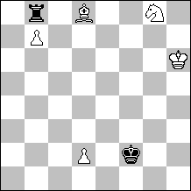
5+2
Win
1.Ba5!!
Thematic try 1.Sf6!? Rxd8= (1...Ke2? 2.Ba5! (2.d4? Rxd8= (2...Kd3? 3.Bc7! Rxb7 4.Be5 Rb4 5.d5+-) ) 2...Rxb7 3.d4!+- main line)
1...Rxb7
1...Rxg8 2.Bc7+-
2.Sf6 Ke2 3.d4 Ra7
3...Kd3 4.d5 Kc4 5.d6 Kb5 6.Bd8! Kc6 7.Be7 Rb1 8.d7 Rd1 9.d8Q (or d8R) +-, Excelsior
4.Bd8!
Thematic try 4.Bb6!? Ra6 Halfpin 5.Sd5 (5.Sd7 Kd2 6.Kg5 Kc3 7.Bc5 Ra4 8.d5 Kc4=) 5...Kf3 (5...Kd3? 6.Sb4++-) 6.Kg6 Ke4 7.Sf6+ Kd3 8.Bc5 Kc4 9.Kf5 Ra5! Pin 10.Sd7 Kd5! Unpin 11.Sf6+ Kc4 Pin 12.Sd7 Kd5 Unpin, positional draw.
4...Ke3 5.d5
5.Bb6? Ra6= Halfpin (5...Rb7? 6.Bc5 Kd3 7.Kg5 Kc4 8.Kf4! Rb5 9.Se4+-)
5...Ra6! Pin
5...Kf4 6.Kg6 Ke5 7.Bb6 Rb7 (7...Ra6 8.Bc7+ Kd4 9.d6+-) 8.Ba5! Kd6 9.Bd2! Ke5 10.Bc3+ Kd6 11.Kf5+-
6.Be7!
6.Kg5? Kd4!= thr. 7...Rxf6=
6...Kf4 7.d6 Halfpin
7.Kg6? Ke5!= thr. 8...Rxf6=
7...Ke5 8.d7!
Thematic try 8.Se8? Rb6 (Rc6)! Pin 9.Kg6 Ke6! Unpin (9...Rb7? Unpin 10.Kf7! Rd7 Pin 11.Kf8! Ke6 12.Sc7+ Ke5 13.Sb5! Ke6 14.Ke8+-)
8...Ke6 Unpin 9.d8Q! wins, Excelsior
9.Sg8? Kxd7+=;
9.d8R? Kxe7= Pin

Anatoliy Skripnik (Russia) & Sergiy Didukh (Ukraine)
2nd Prize − No. 24.
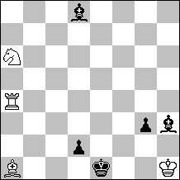
4+5
Draw
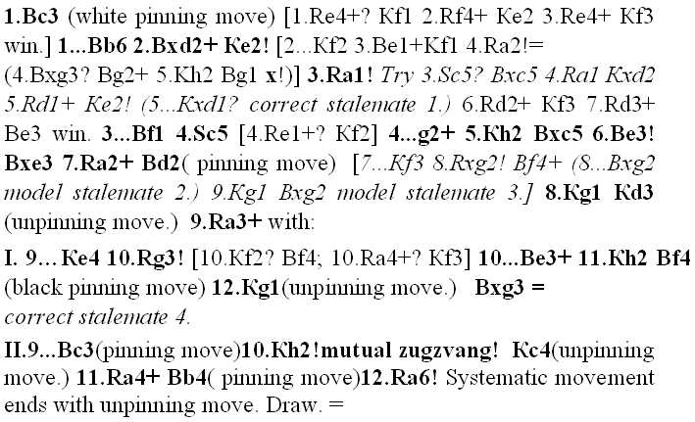

Yochanan Afek (The Netherlands/Israel)
Special Prize − No. 16.
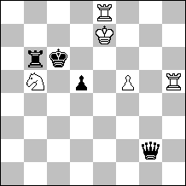
5+4
Draw
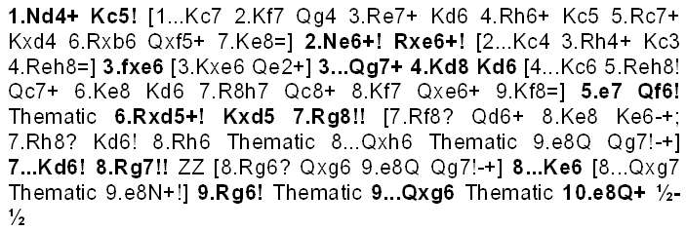

János Mikitovics (Hungary) & Iuri Akobia (Georgia)
1st Hon. Mention − No. 17.
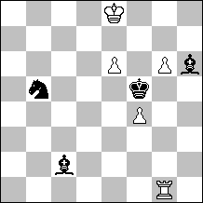
5+4
Black to move, White draws
As is known KBBN against of KR wins without problems. However, here White have “indemnification” - three pawns. But, except one they are not protected and besides, the white king has not so good position. Also turn of a move of the black. It gives them the initiative. Black have two strongest continuations here 1...Sc7+ and 1...Kf6 .
In the first variant we are quickly convinced - white have a draw faster:
1...Sc7+ 2.Kf7!
2.Ke7? Sxe6 3.Rh1 Bxf4–+
2...Bb3! Pin 3.Kg8!! Selfpin
3.g7? Bxe6+ 4.Kf8 Selfpin Kf6–+
3...Sxe6 4.Kh7 Bg7 5.Rb1 Bc2 6.Rb7 Bf6 7.Kh6 and white draws.
It appears, that it is necessary for white to work much more after the second possibility of the black:
1...Kf6 2.g7!
Try 2.e7? Sd4! 3.Ra1! Bd3! (3...Bxg6+? 4.Kd7 Bf5+ 5.Kd6 Bxf4+ 6.Kd5 Se6 7.e8S+!!=) 4.Ra5! (4.Kd7 Bb5+–+) 4...Sc6 5.g7 (5.Rd5 Bxg6+ 6.Kd7 Sxe7 7.Rd6+ Kf7–+) 5...Sxe7 6.Rd5 Bg6+–+ (6...Bc4? 7.Rd6+ Be6 Selfpin 8.f5!=);
2...Bxg7 3.f5! Bxf5 4.e7 Bh6 5.Rf1! Pin
Try 5.Kd8? Be3 6.Rf1 Pin (6.e8S+ Kf7 7.Rg7+ Kf8–+; 6.e8Q Bb6#) 6...Bb6+ 7.Ke8 Sd4 8.Kf8 Bc5!–+ Pin;
5...Sd4 6.Rd1 Unpin and with the lines:
A) - 6...Be3 7.Rf1 Pin Bg5 (also 7...Bh6 8.Rd1 Unpin Se6 9.Rf1= Pin, draws as in Main B)
8.Kf8 Bh6+ 9.Ke8 Bd2 10.Rd1 Unpin
10.Kf8? Bb4!–+ Pin
10...Bc3 11.Rc1
11.Kf8? Se6+–+;
11.Rf1? Pin Bb4–+
11...Ba5 12.Rc5 Bb6 (also 12...Bd2 13.Rd5 Be3 14.Rd6+ Be6 Selfpin 15.Kd8=)
13.Rd5 Be6 (also 13...Ke6 14.Kf8! Kxd5 15.e8Q=)
14.Rd6 Pin Bc5 15.Kd8! Bxd6 16.e8Q=
16.e8S+? Ke5–+
B) - 6...Se6 7.Rf1! Pin
Try 7.Rd6? Pin Bc2 8.Ra6 Pin (8.Rc6 Pin Ba4–+ Pin) 8...Bd3 9.Rb6 Pin (9.Rc6 Pin Bb5–+ Pin) 9...Be3 10.Rc6 Pin Bb5–+ Pin; 7.Rd5? Bg4! (7...Sc7+? 8.Kd8 Sxd5 9.e8Q Bg5 10.Qh5! (10.Qg8? Be6 11.Qh7 Ke5+ 12.Ke8 Sf6+–+) 10...Be6 11.Ke8!=) 8.Rd6 Pin Ke5 9.Kd7 Sd4+! 10.Kc7 Sb5+–+
B1) - 7...Sf4 Selfunpin/Halfpin 8.Kd8!=
(8.Rf3!? Bg5! (8...Ke6? 9.Kd8 Kd6 10.e8S+=) 9.Rxf4 Pin 9...Bxf4 10.Kd8 Be3 11.e8Q Bb6#)
B2) - 7...Bf4! Selfunpin/Halfpin
8.Rf2!! Halfpin Bd3 Selfpin 9.Rb2! Unpin Bc1 10.Rf2+ Bf4 Selfpin 11.Rb2 Unpin/Positional draw, or 11...Be5 12.Rf2+ Bf4 Selfpin 13.Rb2 Unpin/Positional draw, or Sg7+
13...Sg5 14.Rb4= e.g. 14...Bd6 15.Rb6!= Pin
14.Kd8
14.Kf8? Bd6!–+ Pin
14...Bg6 15.Rb6+
15.Rf2? Pin
15...Kf5–+ Selfpin
15...Kf5 16.Rxg6 draws.

All Black & White men get a pin in the play at least one times with the exception of the f4wP.

Siegfried Hornecker & Martin Minski (Germany)
2nd Hon. Mention – No. 22.
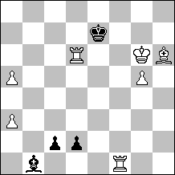
7+4
Win
contents: theme: pinning and unpinning moves.
Systematic manoeuvre by white Rooks, black Queen and black King.

1.Rb6! [1.Rff6? c1Q+ 2.Kg7 Qc3 3.a6 Ba2 4.Kh7 Qc4=;
1.Rxd2?? c1Q+–+; 1.Bf8+? Ke8 2.Rb6 d1Q 3.Rb8+ Kd7=]
1...d1Q [1...c1Q+ 2.Rxb1+-]
2.Rf7+! [2.Rxd1? cxd1Q+]
2...Ke8 3.Rb8+ [3.Kg7? Qd4+ 4.Kg8 c1Q=]
3...Qd8 self-pin 4.Rf8+ [4.Rxd8+? Kxd8=]
4...Ke7 unpin 5.Rb7+!
[5.Rfxd8? c1Q+ 6.Kg7 (6.Kh5 Qh1+=) 6...Qc3+ 7.Kg8 Qc4+ 8.Kh8 Qc3+ 9.Bg7 Qh3+ 10.Bh6 Qc3+=]
5...Qd7 self-pin [5...Ke6 6.Rxd8 c1Q+ 7.Kg7 Qc3+ 8.Kg8+-]
6.Rf7+ Ke6 unpin
[6...Ke8 7.Rbxd7! (7.Rfxd7? c1Q+ 8.Kg7 Qc3+ 9.Kg8 Ba2+ 10.Rf7 Bxf7+ 11.Rxf7 Qxa3=) 7...c1Q+ 8.Kg7 Qc3+ 9.Kg8+-]
7.Rb6+! [7.Rfxd7? c1Q+ 8.Kg7 Qc3+ 9.Kg8 Qc8+ 10.Bf8 Qxd7 11.Rxd7 Kxd7=]
7...Qd6 self-pin
8.Rf6+ Ke5 unpin 9.Rb5+! [9.Rfxd6? c1Q+ 10.Kf7 Qc7+ 11.Ke8 Qxd6 12.Bg7+ Kd5 13.Rxd6+ Kxd6 14.Kd8 Kc6 15.Kc8 Kb5 16.Bc3 Ka6=]
9...Qd5 self-pin [9...Ke4 10.Rxd6+-]
10.Rf5+ Ke6 unpin 11.Rbxd5! [11.Rfxd5? c1Q+ 12.Kh5 Qh1+ 13.Kg4 Qxd5 14.Rxd5 Kxd5=; 11.Rb6+? Qd6 12.Rf6+ Ke5]
11...c1Q pin 12.Rde5+ Kd7 [12...Kd6 13.Kg7 Qc3 14.Kg8 Qb3+ 15.Kh8 Bxf5 16.Rxf5+-] 13.Kg7 unpin
[13.Kf7? Bxf5 14.Rd5+ Kc8 15.Rxf5 Qc2 16.Rf6 Qh7+ 17.Kf8 Qh8+ 18.Ke7 Qh7+ 19.Rf7 Qd3 20.Kf8 Qxa3+ 21.Kg7 Qxa5= EGTB; 13.a6? Qxa3 14.Kg7 Bxf5 15.Rxf5 Qxa6= EGTB]
13...Bxf5 [13...Qc3 14.Rf7+ Kd6 15.Rfe7 Qxe5+ 16.Rxe5 Kxe5 17.a6 Be4 18.a7 Kd6 19.Kf6 Kc7 20.Ke5+-]
14.Rxf5 Qc3+ 15.Kg8 Qxa3
[15...Qc2 16.Rf6+-; 15...Qc8+ 16.Rf8 (or 16.Bf8+- ) 16...Qa6 (16...Qc2 17.Rf6+-) 17.Kh7 Qxa5 18.g6 Qxa3 19.g7 Qd3+ 20.Kh8+- EGTB]
16.g6 Qh3 17.Rf7++-

Luis Miguel González (Spain)
3rd Hon. Mention – No. 2.
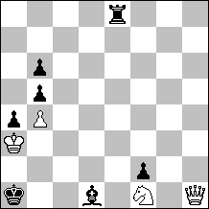
4+7
Black to move, White wins
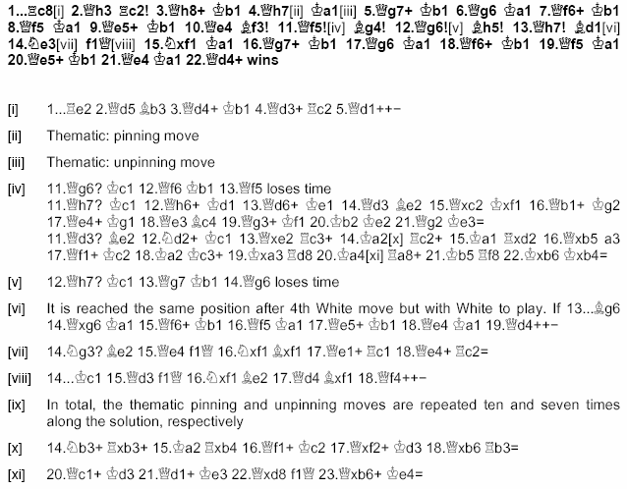

Jan Timman (The Netherlands)
1st Commendation – No. 15.
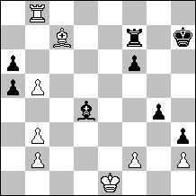
8+8
Win
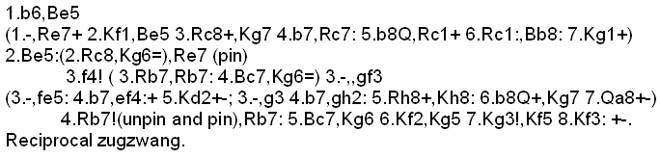

Guy Sobrecases (France)
2nd Commendation – No. 23.
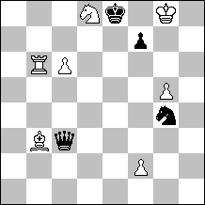
7+4
Win
1.Nxf7!! threats 2.Rb8+ Ke7 3.Rb7+ Ke8 4.Nd6+ Kd8 5.Rd7
[1.Rb8? / 1.Nb7? 1…Nf6+ 2.gxf6 Qg3+!=;
1.c7? Qxc7 2.Rb7 Qf4 (2...Qxd8?? 3.Bxf7#) 3.Nxf7 Nf6+ 4.gxf6 (4.Kg7 Nd7 5.g6 Qf6+ 6.Kh6 (6.Kg8?? Qxg6+ 7.Kh8 Kf8-+) 6...Qh4+=) 4...Qg3+ 5.Kh7 Qg7+!!=]

1...Nf6+!? [1...Qc5? 2.Rb8+ Ke7 3.Rb7+ Ke8 4.Ba4 Nf6+ 5.Kg7! (5.gxf6? Qf8+! 6.Kh7 Qg7+=) 5...Nh5+ (5...Qf8+ 6.Kxf6 Qg7+ 7.Kf5+-) 6.Kh6+-]
2.gxf6 [2.Kg7? Nd5+ 3.Kg8 Ne7+ 4.Kh7 Qd3+ 5.Kh8 Qd4+ 6.Kh7 Qxb6-+]

2...Qxb3!? [2...Qg3+? 3.Kh7! Qh4+ a) 3...Qg7+?? 4.fxg7+-; b) 3...Qd3+ 4.Kh6! Qh3+ 5.Kg6! Qd3+ 6.Kg5! Qd2+ 7.f4 Qg2+ (7...Qa5+ 8.Ne5 Qxb6 9.f7++-) 8.Kh6 Qh3+ 9.Kg7 Qg2+ 10.Ng5+-; 4.Nh6+-]

3.Rb8+!! The WR sacrifices to unpin the WSf7 and prevents Qg3+
[3.Rb7? guards theWSf7 and threats 4.Re7#; but 3…Qg3+!=]

3…Qxb8 4.c7!! [4.Ne5? Kd8 5.f4 (5.c7+ Kxc7+!=) 5...Kc7+ 6.Kg7 Qb4 7.f7 Qxf4 8.f8Q Qxe5+=]

4...Qxc7 5.Ne5!! [5.Nd6+? Kd7 6.f7 Qxd6 7.f8Q Qxf8+=]

5...Qb8!? [5...Qxe5 6.f7++-; 5...Qc8 6.Kg7! Qb7+ 7.f7+! Kd8 8.f4!! ZZ(8.f3? Kc8!! ZZ 9.f4 Qa7 10.f5 Qb7 11.f6 Kb8! (11...Qc7? 12.Kg8!+-; 11...Qa7? 12.Kh8!!+- Qa3 13.Ng6 Qh3+ 14.Kg7 Qd7 15.Ne7++-; 11...Kd8? 12.Nc6+! Kc8 13.Ne7+!+-) 12.Nc6+ Ka8! 13.Ne7 Qg2+! 14.Ng6 Qb7! The BQ can now keep the pinning on the 7th rank, as the WNe7 would not check anymore 15.Kg8 Qb3 diagonal pinning 16.Kg7 Qb7!=)]

6.f3!! ZZ [6.f4? Qa8! 7.Kg7 Qg2+-+; 6.Kg7? Qxe5!-+ pins the WP]

6...Qa8 7.Kg7! threats 8.f7+ Ke7 9.Ng6+ +-

7...Qb7+ [7...Kd8 8.f7]

8.f7+ self pinning

8...Kd8 9.f4!! ZZ, the BQ cannot find another square on the 7th rank to keep the WPc7 pinned. The BK is forced to play on c8 where it will be immobilized by the WNc6, and then will be checked by the WNe7, unpinning the WPf7 at the end of the line.

9...Kc8 [9...Qg2+ 10.Kf6+-; 9...Qa7?? 10.Nc6+!+-; 9...Qe7?? 10.Nc6+!+-; 9...Qc7 10.Kg8!+- unpinning the WPf7 10...Qc4?? the only possible square for the BQ to keep the WPf7 pinned is now guarded.]

10.f5!! ZZ 10...Qa7 [10...Kb8 11.Kg6! unpinning the WP 11...Qb6+ 12.Kh5! The BQ cannot check on the h file 12...Qd6 13.f8Q+! (13.Nd7+? Kc7 14.f8Q Qh2+ 15.Kg6 Qg2+ 16.Kf7 Qd5+ 17.Kg7 Qg2+ 18.Kh7 Qh3+ 19.Kg8 Qg4+ 20.Qg7 Qxf5=) 13...Qxf8 14.Nd7++-]

11.f6! Qb7 [11...Qg1+ 12.Ng6 Qa7 pinning 13.Ne7+ checks and unpins]

12.Nc6!! The BKc8 cannot escape from the check to come from the WNe7, as it would unpin the WPf7 if it plays on the 7th rank. The WN sacrifices to close the line b7-g2, and its capture by the BQ would unpin the WPf7. [12.Ng6? Kb8 13.Ne7 Qg2+ 14.Ng6 Qb7! 15.Kg8 Qb3= 16.Ne5 Qg3+ 17.Kh7 Qh4+ 18.Kg7 Qg3+! 19.Ng6 Qc7! pinning]

12...Qc7 13.Ne7+!+-

A tempo-duel, justified by the pinning / unpinning of the WPf7 by the BQ.
Perpetual pinning avoidance.
Stalemate avoidance.
All White officers sacrifices.
Meredith.

Iuri Akobia (Georgia)
3rd Commendation – No. 12.
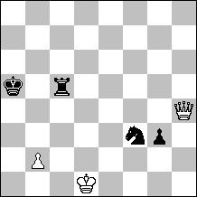
3+4
Win
1.Qd8+!
try 1.Qe4!? g2! (not 1...Ng5? 2.Qb7! Rb5 3.Qc7+ Ka6 4.Qc6+ Rb6 5.Qa8+ Kb5 6.Qd5++-) 2.b4+ Kb5 3.Qb7+ Ka4 (Kc4)=;
try 1.Qg4!? Rd5+! (not 1...g2? 2.b4+ Kb5 3.Qxg2 Rc3 4.Qg4+-) 2.Ke2 Nd4+=;
1.Qe7!? Rd5+ 2.Kc1 g2=
1...Kb4 2.Qb8+!
Thematic try 2.Qb6+!? Kc4 3.b3+ Kd5! (not 3...Kd4? selfpin 4.b4+-) 4.Qb7+ (4.b4 Rc3!=) 4...Rc6 selfpin 5.Qb5+ unpin 5...Rc5 selfpin 6.Qb7+ Rc6 selfpin - positional draw, or 7.Qf7+ (7.Qb5+ unpin 7...Rc5 8.Qd7+ unpin 8...Ke5 draw; 7.Qd7+ unpin 7...Rd6 selfpin - draw) 7...Ke4=
2...Kc4 3.b3+
3.Qf4+? Nd4 selfpin - draws.;
3.Qg8+? Rd5+ selfpin 4.Ke2 Nd4+ draws.
3...Kd5!
3...Kd4 4.Qf4+ Kd5 5.Qxf3++-
4.Qg8+!
4.Qb7+!? and play is same as 2Qb6!? line 4...Rc6 5.Qb5+ etc – draws;
4...Kd4 5.Qg4+!
Thematic try 5.Qxg3!? Ke3! zz - selfpin 6.Qh3 Rc6! zz 7.Qg3 Rc5 zz - positional draw, or 8.Qd6 Rf5! 9.Qe7+ (9.Qe6+ Kf4=; 9.b4 Nd4! 10.Qe7+ Kd3=) 9...Re5 10.Qd6 (10.Qa7+ Nd4 selfpin =) 10...Rf5 positional draw;
5...Ke3 6.Qxg3 zz - pin Rc3
6...Rf5 7.Kc2 Rg5 8.Qh3+-;
6...Rg5 7.Qh3! Rg1+ 8.Kc2+-
7.Qb8! unpin
Try 7.Qg8!? Rd3+ 8.Kc1 Nd4 9.Qg5+ Ke4 10.Qg6+ Ke3 11.Qg3+ Ke4 positional draw(11...Ke2 12.Qe5+ Kf3 13.b4+-)
7...Rd3+ 8.Kc1!
8.Kc2? Nd4+=
A) - 8...Nd4 9.Qe5+!
9.Qg3+ Ke4 10.Qg6+ Ke3 11.Qg5+ Ke4 positional draw
9...Kf3 10.b4+-;
B) - 8...Rd5 9.Qg3 pin Rg5 10.Qh3 wins.

Sergiy Didukh (Ukraine) & Anatoliy Skripnik (Russia)
4th Commendation – No. 21.
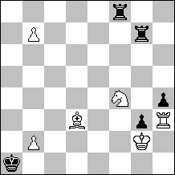
6+5
Win
