PCCC-50

Moremove Section

Award by Hans Peter Rehm, Pfinztal

It must be said that the result of this tournament section was disappointing.
Only 18 entries. Not one of them comes near in quality to the better works of the past, and modern themes were absent. For comparison I cite here examples from the FIDE ALBUMs (FA). The Pin/unpins of white pieces sent were little impressive (good examples are e.g. FA 59-61, 406, p.94, the idea dates back to 1912 with many good examples, or FA 1992-94, C107, p.223).
Maybe the time was too short for authors to develop deeper concepts.

In my opinion, only used pins/unpins can hope to be thematically impressive.
So the pin of a black piece should be followed by, say, a pin mate, or a situation where it is essential that the pinned piece is not free to move. Similarly an unpinned black piece should defend against the threat.
Almost all entries with more than 4 moves suffered from a weakly used kind of pin/unpin.
I cite here some examples in the FIDE ALBUMs without those defects:
FA 1945-55, 1108, p.213 (correction Be3 ton f4),
FA 59-61, 410, p.95,
FA 86-88, C105, p.206,
FA 1992-94 , C71, p.209.

FA 1945-55, 1175 p.224, by Josef Halumbirek contains a record. If I count correctly, more than 100 pins and unpins of the weak, not really used type (I believe that Halumbirek would have objected to classify his problem as a pinning problem). Of course much less interesting problems with this type of pins/unpins could not make it into this award.
Also a pin which is already in the diagram and stays unchanged is not very impressive.

So this award contains only commendations. Strangely all of them show reciprocal moves (ABBA) or Zigzag which are not exactly modern themes.
Don Smedley and Christopher Reeves (United Kingdom)
1st Commendation – No. 12.
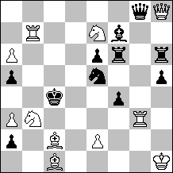
#4 C+ 11+11

Good key and changed anticipatory pin/unpin with reciprocal moves. But threat and only 1 thematical variation is a relatively small contents for a modern #4. The byplay is not interesting.

Eugene Fomichev (Russia)
2nd Commendation – No. 16.
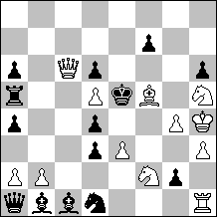
#5 C+ 12+14

Again ABBA with a simple mechanism and many pieces. Good pinning/unpinning but the key is not good and the problem is very easy to solve. Cf. FA 1986-88, C43, p.186.
Mikhail Marandyuk (Ukraine)
3rd Commendation – No. 3.
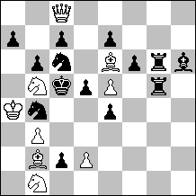
#5 C+ 9+14

Interesting double pinning. But the unpinning on move 4 suffers from the fact that white has the same answer if the unpinned piece moves or does not move.

Mikhail Marandyuk (Ukraine)
4th Commendation – No. 1.
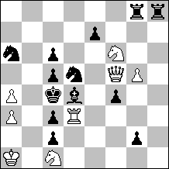
#4 C+ 8+13

Zigzag theme with pins. The unpinning is again (like in the 3rd commendation) not used by black.

Don Smedley and Christopher Reeves (United Kingdom)
1st Commendation – No. 12.
#4 C+ 11+11
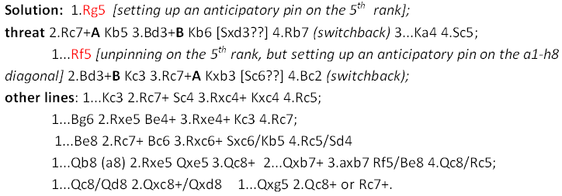

Eugene Fomichev (Russia)
2nd Commendation – No. 16.
#5 C+ 12+14
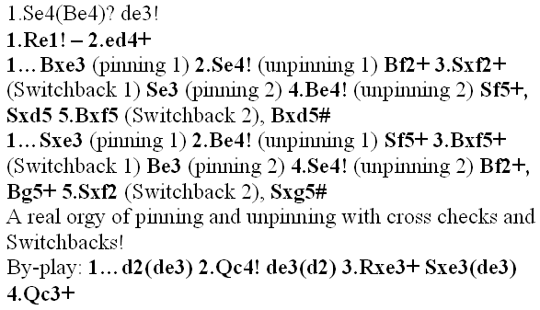

Mikhail Marandyuk (Ukraine)
3rd Commendation – No. 3.
#5 C+ 9+14
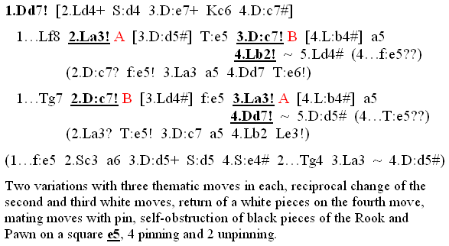

Mikhail Marandyuk (Ukraine)
4th Commendation – No. 1.
#4 C+ 8+13
