PCCC 50 ANNIVERSARY TOURNEY 3-mover award
by Don Smedley
17 problems were received for this tourney. No.15 had to be excluded as unthematic, since there was no actual unpin in the play. The best entries were well-crafted problems with interesting pinning-unpinning play of a traditional nature; disappointingly, no entry managed successfully to combine pins-unpins with modern ideas. In the end, despite some worthwhile and enjoyable problems, I thought none really stood out from the field.
Mikhail Marandyuk (Ukraine)
1 Hon.Men.
No.13
1.Qe1? (>2.Qd2) 1...Ba5! 1.Qg2? (>2.Be4) 1...Rxe5!
1.Qf1! (>2.Sxf4+ Kc3 3.Qe1)
1...Bxg5 2.Qe1 (>3.Qd2A) Sxc1 3.Be4B 1...Rf8 2.Qg2 (3.Be4B) Sc3 3.Qd2A
Direct attacks on d2/e4 fail, so W must first pin the BS. When the BR/BB are lured away from their good defences, the WQ unpins the S which has bad defences leading to a pseudo-leGrand. A harmonious and attractive Roman.
Henk le Grand (The Netherlands)
2 Hon.Men.
No.11
1.Sxg4+? Qe3! 1.Sxd5+? Re3! 1.Rhh5! (>2.Re5+ fxe5 3.Rxe5)
1...Sd3 2.Sxg4+ Re3 3.Sxf6 1...Sf3 2.Sxd5+ Qe3 3.Sxf6 1...cxd6 2.Sc4+ R,Qe3 3.Sxd6
A nice example of Beugung. When the BS interferes on the third rank, W must choose the pin that B is immediately forced to abandon.
Mikhail Marandyuk (Ukraine)
3 Hon.Men.
No.1
1.Qb3? (>2.Sb6) 1...Rxb7! 1.Qd3? (>2.Sc3) 1...Qxd2! 1.Qf3! (>2.Se7+ Ke5 3.Re6)
1...Re8 2.Qb3 3.Sb6 1...Qh4 2.Qd3 ~/Se2 3.Sc3/Qxe4
The only problem which has 3 potential pin-lines. W must choose the pin which gives a full-length threat, then revert to the other two pins when B abandons potential guards. A well-executed logical problem, though the composer must have regretted the WRc7.
Mikhail Marandyuk (Ukraine)
4 Hon.Men.
No.16
1.Rb5 (>2.Rxd7+ Kc6 3.Sa7)
1...Be8 2.Qc2 ~/Sd6 3.Qxe4/Sb6 1...dxe6 2.Rb6 ~/Sb3 3.Rd6/Bxe6
I particularly like the post-key play in this traditional problem. There is a double-pin in the threat, and 2 quiet unpinning moves leading to pin-mates. Sb3 is a further unpinning defence. The key is undeniably thematic, but hideously strong. Unfortunately, if a non-pinning key were chosen, the problem would not be thematic!

Stanislav Vokál (Slovakia)
1 commend
No. 12
1.Qb3 (>2.Qb4+ Kd5 3.Qxd6)
1...Bf5 2.d4+ Bxd4 3.Se4 1...Sd5 2.Bxd6+ Bxd6 3.Qb4
1...Se8 2.Bxd6+ Sxd6 3.Rxe5 1...Be4 2.Sxe4+ Kd4 3.dxe3
This is one of several problems exploiting a well-known idea: a B piece plays on to a pin-line, whereupon one or both of the half-pinned pieces moves away, leaving the other pinned. The unpin-repin sequences work very smoothly, an extra feature is the self-blocks on d4 and d5, and there is some by-play.
Januarta Simadhinata (Indonesia)
2 commend
No.9
1.Qf3 (>2.Rxf4+ Rxf4/Ke5 3.Qxf4/Re4,Qe4,Re6)
1...Kc4 2.Qe4+ Sd4 3.Bb5 1...Ke5 2.Bxc3+ Sd4 3.Re6
Very intensive pinning and unpinning play. In two crisp variations, existing pin-lines are destroyed and replaced by new pins of the BS on d4. Meanwhile, the BK has unpinned W pieces which will mate on the 3rd move. As a bonus, the key gives a second flight, but the triple mate in the threat is unfortunate.
Alexandr Pankratjev (Russia)
3 commend
No. 5
Set 1...Sxe4 2.Sg4+A Kxd5 3.Qc6 1...Qxe4 2.Sxf7+B Kxd5 3.Qc6
1.Qc6 (>2.Bxd4+ Kxd4 3.Qc3)
1...Sxe4 2.Sxf7+B Qxf7/Bxf7 3.Rxe4/Sg4A 1...Qxe4 2.Sg4+A Sxg4/Bxg4 3.Rxe4/Sxf7B
1...Sxd5 2.Sg4+ Bxg4 3.Qxd5
Reciprocal change of W 2nd move after captures on e4. A good key and threat, though the WQ en prise is a strong pointer. However, the pin after 1...Sxd4 is entirely spurious.
Janne Syväniemi (Finland)
4 commend
No.3
1.Ba6 (>2.Se2) 1...Sd4 2.Rh3+ Sf3,Re3 2.Se2 1...Bd4 2.Sb4 ~/B~/Re2 3.Rc2/Se2/Rc7
1...Sg3 2.Bd3 3.Rc2
Showing the same idea as the 1st commend, this scores for its light and open construction, and for the key – the unwary solver might reject it, since 1.Bb5? appears to work just as well; but 1...Bd4! 2.Sb4 Ra8+. However, the two variations are not well-matched, the Bd4 line being much more interesting than the Sd4 line.

Mikhail Marandyuk (Ukraine)
1st Hon. Mention – No. 13
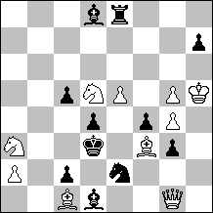
#3 C+ 10+11
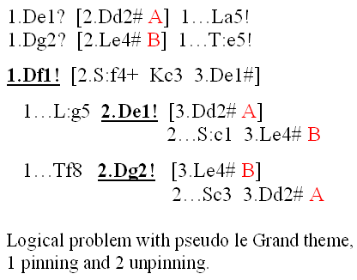

Henk le Grand (The Netherlands)
2nd Hon. Mention – No. 11
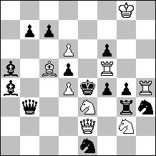
#3 C+ 9+13
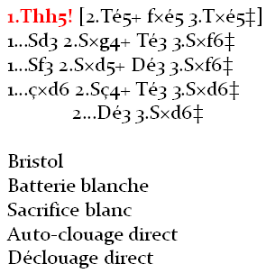

Mikhail Marandyuk (Ukraine)
3rd Hon. Mention – No. 1
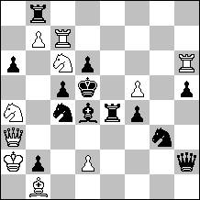
#3 C+ 10+13
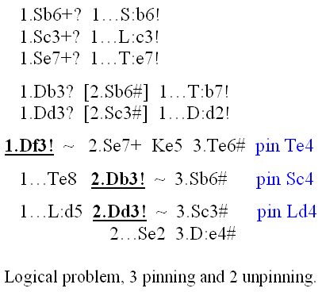

Mikhail Marandyuk (Ukraine)
4th Hon. Mention – No. 16
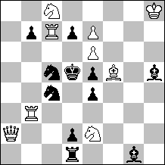
#3 C+ 9+11
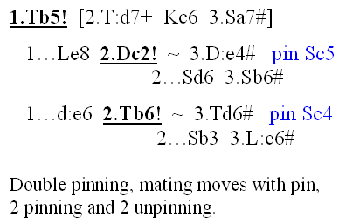

Stanislav Vokál (Slovakia)
1st Commendation – No. 12
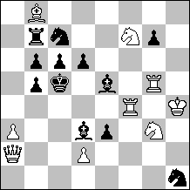
#3 C+ 9+12
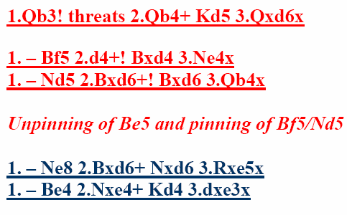

Januarta Simadhinata (Indonesia)
2nd Commendation – No. 9
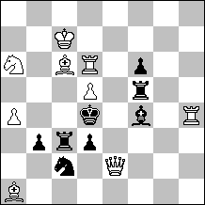
#3 C+ 9+8
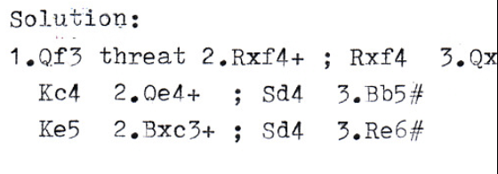

Alexandr Pankratjev (Russia)
3rd Commendation – No. 5
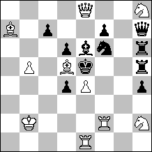
#3 C+ 10+11
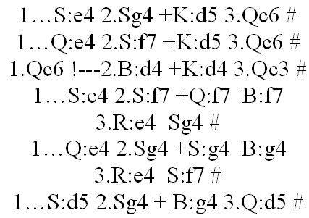

Janne Syväniemi (Finland)
4th Commendation – No. 3
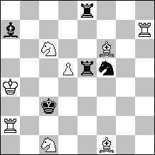
#3 C+ 8+5
Solution:
1.Bb5 ? threat: 2.Se2 #
1...Sd4 (unpin Re5)
2.Rh3 +
2...Sf3/Re3 (pin Re5/Sd4) 3.Se2 #
1...Sg3
2.Bd3 threat: 3.Rc2 #
but
1...Bd4!
1.Ba6 ! threat: 2.Se2 #
1...Sd4 (unpin Re5)
2.Rh3 +
2...Sf3/Re3 (pin Re5/Sd4) 3. Se2#
1...Bd4 (unpin Re5)
2.Sb4 threat: 3.Rc2 #
2...Bd4~ (pin Re5) / Se3
3.Se2 #
2...Re2 (pin Bd4)
3.Rc7 #
1...Sg3
2.Bd3 threat: 3.Rc2 #

