PCCC 50th Anniversary Composing Festival
Section: Twomovers
Award

I found the tourney theme highly appealing, as it provided an opportunity for synthesizing unfading, brilliant combinations of the Good Companions style with modern themes. And I want to thank Uri Avner for inviting me to judge this tourney. I am also grateful to Udo Degener for his search for anticipations.
A total of 66 entries from 30 authors were received. Most of the problems appearing in the ranking are original not only in terms of their construction but conceptually as well.
The award is as follows.

Vasyl Dyachuk (Ukraine)
1st Prize – No. 42.
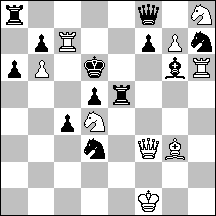
#2 C+ 9+12

1...Sf4 2.Qa3#, 1...Sf6 2.Qxf6#, 1...Qc8 2.Sxf7#.
1.Qxf7! ~ 2.Sf5#, 1...Sf4 2.Qd7#, 1...Sf6 2.Qf6#, 1...Qc8 2.Qe7# (1...Qxf7+2.Sxf7#).

The white queen is self-pinned by the key. In two variations, Black defends by unpinning his pieces. This, however, unpins the white queen as well, i.e. the combinations of defensive and weakening effects are the same. The third, uncomplicated variation features direct unpinning of the white queen. All three thematic mates are changed in relation to set play. The latter is sufficiently motivated.

Rainer Paslack (Germany)
2nd Prize – No. 50.
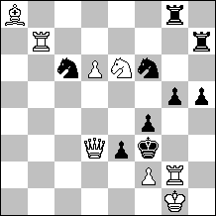
#2vv C+ 8+9

1.Rg7? ~ 2.Sd4, Sxg5#, but 1...Se4!, 1.Rb2? ~ 2.Sd4#, 1...Se4 2.Qe2#,
1...Sd5 2.Qxd5#, but 1...Rb7!
1.Rf7! ~ 2.Sd4#, 1...Se4 2.Qxe3#, 1...Sd5 2.Rg3#.

Choice of the key: an attempt with two threats; a try and a key with two thematic defenses featuring changed mates. The post-key play presents a relationship between combinations of defensive and weakening effects of a “form-antiform” type, i.e. pinning-unpinning. Another fine point of the problem consists in the thematic refutations involving black piece unpinning.
Nicely constructed.

Vasyl Dyachuk & Valery Kopyl (Ukraine)
3rd Prize – No. 25.
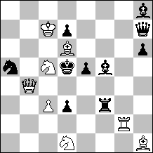
#2 C+ 8+10

1.Rg7? ~ 2.Se3#, 1...e4 2.Qd4#, but 1...Be4! 1.Rg6? ~ 2.Se3#, 1...Be4 2.Qxe4#,
but 1...e4! 1.Rg5! ~ 2.Se3#, 1...e4 2.Qxe4#, 1...Be4 2.Qd4# (1...Sc4 2.Qb7#).

Choice of the key with distribution of two thematic mates across two tries, the latter presenting, in association with post-key play, a reciprocal change of mates. The problem’s integrity is also emphasized by the fact that the refutations of the tries become the thematic defenses after the key. Similar to problem No. 50, there is a “form-antiform” relationship between combinations of defensive and weakening effects (black piece unpinning – black piece pinning). The concept is strongly anticipated by a problem using a different matrix.

Yosi Retter (Israel)
4th Prize – No. 64.
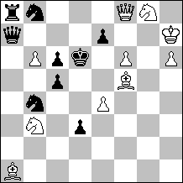
#2 C+ 10+9

1...Sd7, Qxb6, Qxa1 2.Qxe7#. 1.fe7? ~ 2.Qf6#, 1...Sd7, Qxb6 2.e8S#, 1...Qxa1
2.e8Q#, but 1...Qd7! 1.Sxe7! ~ 2.e5#, 1...Sd7 2.Sc8#, 1...Qxb6 2.Sd5#, 1...Qxa1
2.Sg6# (1…Qxe7+ 2.Qxe7#).

Choice of the white piece to be pinned and then thrice unpinned. Change of three mates. All the thematic variations end in battery mates (totaling five: three in post-key play and two in the try).

Emanuel Navon (Israel)
1st Hon. Mention – No. 27.
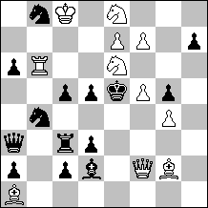
#2 C+ 11+14

1.Qxc5? ~ 2.Qc7#, 1...S8c6 2.Qd6#, 1...S4c6 2.Qxd5#, but 1...Qb2! 1.Sf8?
~ 2.Re6# 1...S8c6 2.Sd7#, but 1...S4c6! 1.Sf4? S4c6 2.Sxd3#, but 1...S8c6!
1.Sxc5! ~ 2.Re6#, 1...S8c6 2.Sd7#, 1...S4c6 2.Sxd3# (1...Be3 2.Qxe3#).

Self-pinning of the white queen by the first move of the try and of a white knight by the key; their unpinning in two variations; change of two mates. There are also two additional tries, each of them being refuted by one of the thematic defenses and forming, in association with post-key play, a second, parallel “storyline” of the problem. A rich content; however, the problem has 25 pieces, among them six pawns of a purely technical nature: two white and four black ones.

Alexandr Pankratyev (Russia)
2nd Hon. Mention – No. 40.
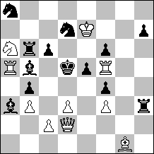
#2 C+ 10+13

1.c4+? bc! e.p. 1.Qxf4? ~ 2.Qc4, Qd4, Qe4#, but 1...Rh4! 1.Qe2? ~ 2.Qe4#, but
1...Sc5!
1.Qf2? ~ 2.Qd4#, but 1...c5!
1.Qxb4! ~ 2.c4#, 1...Sc5 2.Qd4#, 1...c5 2.Qe4# (1...Bxb4+ 2.Sxb4#).

Choice of the key. The first attempt has three threats, two of which appear as thematic mates in post-key play. Two more attempts present, in association with post-key play, the Hannelius theme. The white queen is pinned by the key and then twice unpinned by Black. The combinations of defensive and weakening effects are the same. The problem could have even become a prize-winner – without its technical flaw, the miserable role of the white rook on f5.

Self-anticipation was informed after the publication of the award:
Aleksandr N. Pankratjev, Sachova Sklabda X/1995, 1.-2. Pr.: Kf7 Qe2 Ra5 g5 Bh1 Nb5 pc3 d2 e3 g3 – Ke5 Ba2 c5 Ne7 f8 pc4 c6 d6 f5 g4 g6 h5 (10+12), #2. 1.Qg2? (2.Qe4#) 1.- d5!; 1.Qf2? (2.Qf4#) 1.- Nd5!; 1.Qc4! (2.d4#) 1.- d5/Nd5 2.Qf4/Qe4#.
Aleksandr N. Pankratjev, Probleemblad May-June 1994: Kh2 Qc1 Rc6 h5 Nf3 g6 pb5 d3 e2 – Kd5 Rf8 Bd6 Nf7 g5 pa4 b4 b6 c2 e6 f4 (9+11), 2#. 1.Qc2? (2.Qc4#) 1.- Ne5!; 1.Qg1? (2.Qd4#) 1.- e5!; 1.Df4! (2.e4#) 1.- Ne5/e5 2.Qd4/Qc4#.
I certainly agree that the problem should be excluded. Accordingly, all HMs, except the first, should be ranked one step higher.

Rainer Paslack (Germany)
2nd Hon. Mention – No. 59.
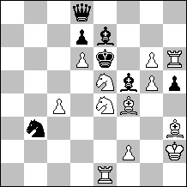
#2 v C+ 12+7

1.S5~? ~ 2.S4~#, 1...Qa8 2.Sc5#, but 1...Bxg5! 1.Sg4! ~ 2.Sc5#, 1...Bxg4 2.Sg3#,
1...Bxe4 2.Sf6# (2.Se3, Se5?), 1...Bxg6 2.Se5#.

Three self-pinnings of a black bishop followed by battery mates; White Correction; and a key which unpins Black’s main thematic piece. This entry is anticipated by several problems, but in a partial way, for example Comins Mansfield, AF 1914-1944, #342. The main differences from the anticipation problems are White Correction and thematic key.

Rainer Paslack (Germany)
3rd Hon. Mention – No. 48.
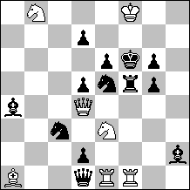
#2 C+ 7+13

1.Qb6! ~ 2.Qd8#, 1...Se~ 2.Sxd5#, 1...Sc6 2.Sxd7#, 1...Sf3 2.Sg4#

An emerging threat mechanism (Black Correction); three thematic variations; a thematic key unpinning a black piece; self-unpinning of black pieces in two variations; black halfpin play.

Zoltán Labai (Slovakia)
4th Hon. Mention – No. 60.
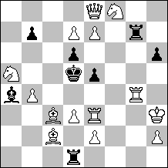
#2 C+ 14+8

1.d8Q? ~ 2.Rxe5#, 1...Bd7 (A) 2.Bb3#, 1...Rxd3 (B) 2.Rxd3#, 1...Rg5 (C) 2.Qf7#,
but 1...Rxe7! 1.Qh5 ~ 2.Rd4#, 1...Bxd7 (B) 2.Bb3#, 1...Rxd3 (C) 2.Rxd3#,
1...Rg5 (A) 2.Qf7#. A – unpin; B – pin; C – direct defense.

The combinations of black moves’ defensive effects are changed between the try and the post-key play displaying a cyclic ABC-BCA pattern. Mlynka theme.

Valery Kopyl (Ukraine)
1st Commendation – No. 56.
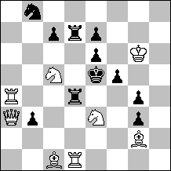
#2 C+ 8+11

1.Bb2? ~ 2.Sd3# (2.Sc4?), 1...Kd6! 2.Sc4# (2.Sd3? Rb4!), but 1...Kf4!
1.Qb2 ~ 2.Sc4# (2.Sd3?), 1...Kf4! 2.Sd3# (2.Sc4? Rd2!) 1...Kd6! 2.Qxd4#.

A two-phase problem with Royal Schiffmann, the same black rook being unpinned and pinned; Sushkov and pseudo Le Grand themes, Dombrovskis paradoxes, albeit with repetition of set play variations.

Rainer Paslack (Germany)
2nd Commendation – No. 15.
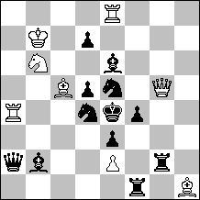
#2 C+ 8+12

1.Bd6 ~ 2.Qxe5#, 1...Se~ 2.Qg6#, 1...Sc4 2.Qxd5#, 1...Sf3 2.Qxf4#
(1...Bf5 2.Rxe5#)

A single-phase problem; three thematic variations; mechanism of emerging threat (Black Correction) in which the latter emerges as a result of black halfpin play and the defenses are moves unpinning two black pieces. The problem is similar to No. 48, but there is no key unpinning Black’s thematic piece.

Yosi Retter (Israel)
3rd Commendation – No. 47.
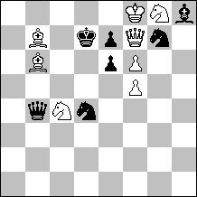
#2 C+ 8+7

1...Qxb6, Qxc4 2.Qxe7#. 1.Sxe7? ~ 2.Bc8#, 1...Qxb6 2.Sc6#, 1...Qxc4 2.Sc8#,
but 1...Qc5!
1.fe7! ~ 2.Sf6#, 1...Qxb6 2.e8Q#, 1...Qxc4 2.e8S#, 1...Qxe7+ 2.Qxe7#
(1...Sh5 2.Qe8#).

The problem is very similar to No. 64, being devoid of the third post-key variation. Unfortunately, in the try 1.Sxe7? the white king’s role is of a purely representative nature. For example he could be shifted to h7 and the whole thematic play would be preserved, but with no unpinning.

Rainer Paslack (Germany)
4th Commendation – No. 14.
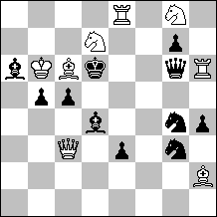
#2 * C+ 8+11

1...Be5, Bf6 2.Qxc5#.
1.Sxc5! ~ 2.Qxd4#, 1...Bxc3 2.Se4#, 1...Be5 2.Rd8# (2.Se4?), 1...Bf6
2.Re6# (2.Se4?), 1...Bxc5+ 2.Qxc5#.

A white knight is self-pinned by the key and then thrice unpinned by the black bishop. However, the knight mates only once. The unpinning of two black pieces is used as an additional defense for the purpose of dual avoidance – to prevent mate by the unpinned white knight.

Rainer Paslack (Germany)
5th Commendation – No. 13.
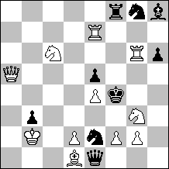
#2 vvv C+ 11+9

1.f3? ~ 2.Rg4, Sh5#, 1...Sf6 2.Qxe5#, but 1...Qxg3! 1.Sxe5!? ~ 2.Rg4#, 1...Sf6
2.Sd3#, 1...Be5+ 2.Qxe5#, but 1...h5! 1.Rxe5!?~ 2.Sh5#, 1...Sf6 2.Rf5#,
1...Bxe5+ 2.Qxe5#, but 1...Rf5! 1.Sd4! ~ 2.Se6#, 1...ed4 2.Sh5#, 1...Sxd4 2.Rg4#,
1...Rf6 2.Qxe5# (1...Qxd2+ 2.Qxd2#).

The tries present the Barnes theme with one mate changed. After the key, the threats from the tries become mates in two variations. Unfortunately, one of the main post-key variations 1…Sxd4 2.Rg4# is imported from set play and so there is no element of change here.

Anatoly Skripnik (Russia)
6th Commendation – No. 3.
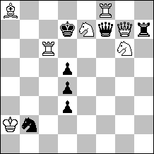
#2 C+ 7+7

1...Qxe7 2.Se5#. 1.Sc8? ~ 2.Sb6, Se5#, but 1...Sc4! 1.Sg8? ~ 2.Sf6, Se5#, but
1...Qxg7! 1.Sxd5! ~ 2.Se5#, 1...Sc4 2.Sf6#, 1...Qxg7 2.Sb6# (1...Rh5 2.Qxf7#).

There is thematic play after the key only (white knight being pinned by the key and unpinned in two variations). Nicely constructed. This entry is conceptually anticipated by many problems which have a more homogeneous play.

Yakov Rossomakho,
tourney section judge

