ISC 2007

Problem 4, Moxon 1952
Kh5, Rg8, Nf4, Ph6
Kh1, Bd6, Nc5, Pd4, h7
+; 4+5

Analysis by Henry Tanner, Finland, with Fritz 8 and Nalimov database of 6-man endings

Composer’s solution 1.Rg4!

I have examined this variation: 1.Kg4 d3 2.Nd5 (or, 1.Nd5 d3 2.Kg4) d2 3.Ne3

and now either 3...Nd7 or 3...Ne4 or 3...Nd3:

a) 3...Nd7 4.Rg7

and now either 4...Nf8 or 4...Nf6+ or 4...Ne5+ or 4...Bc5

I) 4...Nf8 5.Ra7 Bc5 6.Ra1+ Kh2 7.Nf1+ Kg2 8.Nxd2;

II) 4...Nf6+ 5.Kf5 Bf4 6.Nd1 Bxh6 7.Ra7 Ng8 8.Rxh7 Kg2 9.Rh8 Kf3 10.Rxg8 Ke2 11.Rg1 wins (diagram A);

III) 4...Ne5+ 5.Kf5 Nc4 6.Nd1 Bc5 7.Ke4 (but not 7.Ke6? Ne3 8.Nf2+ Kh2 9.Rxh7 Bf8 10.Rg7 Bxg7 11.hxg7 draw (diagram B)) Ne3 8.Nf2+ (also 8.Nc3 d1-Q 9.Nxd1 Nxd1 10.Rxh7 – Nalimov: Black to move loses in 21, e.g. 10…Bf8 11.Rg7 Nb2 12.Ke5 Nd3+ 13.Ke6 Nf4+ 14. Kf7 etc.) Kh2 9.Rxh7 d1-Q 10.Nxd1 Nxd1; Nalimov: White to move, win in 14, e.g. 11.Rc7 Nc3+ 12.Ke5 etc.)

IV) 4...Bc5 5.Nd1 Nf8 6.Rg5 Bb6 7.Rd5;

b) 3...Ne4 4.Kf3 Bc5 5.Nd1 Nf6 6.Rg5 Bd4 7.Rg2 and 8.Rxd2 wins;

c) 3...Nd3 4.Nd1 and now either 4...Bc5 or 4...Ne5+

I) 4...Bc5 5.Kf3 Ne5+ 6.Ke2 Ng6 7.Rg7 Nf8 8.Kxd2 Kh2 9.Nc3 Kh3 10.Ne4 Bb4+ 11.Ke3 Ba3 12.Kf4 Bc1+ 13.Kf5 Bxh6 (bad, but what else?) 14.Nf2+ Kh4 15.Rg4+ Kh5 16.Ne4 Bc1 17.Nf6+ (or 17.Rg1 at once) 17...Kh6 18.Rg1; or 14... Kh2 15.Ng4+; or 5...Nf2 (?!) 6.Nxf2+ Bxf2 7.Ke2 Be3 8.Rg7;

II) 4...Ne5+ 5.Kh3!

(5.Kf5 probably wins too, but is less clear: 5...Ng6 (or 5...Nf7 6.Ke4 Nxh6 7.Rg5 Nf7 8.Rg7 Nh6 9.Kf3 Kh2 10.Nf2 d1Q+ 11.Nxd1 Nf5 12.Rxh7+ Kg1; Nalimov: white to move, win in 32) 6.Rd8 Bf8 7.Rd7 Ne7+ 8.Ke6 Kg2 (8...Ng8 9.Rd8) 9.Rxe7)

5...Bc5 6.Rg7 Nf3 7.Kg3; or 5...Ng6 6.Rg7 Bf8 7.Rf7 Kg1 8.Ne3 d1Q 9.Nxd1 Bxh6 10.Rxh7; Nalimov: black to move, loses in 24, e.g. 10...Bc1 11.Rg7; 10...Bf8 11.Rf7 Bc5 12.Nc3 Bf2 13.Rg7; 11...Bh6 12.Rf6 Nf4+ 13.Kg4.

A B

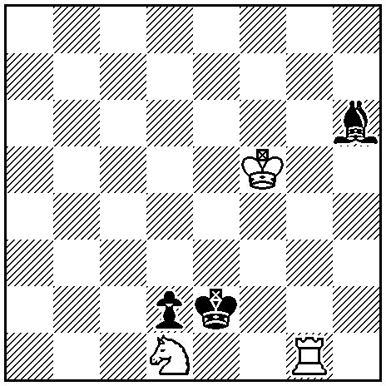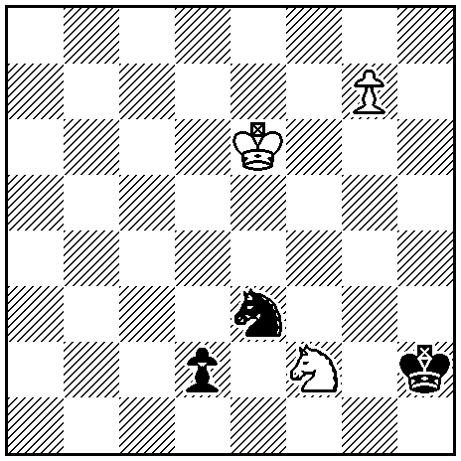

1…? 1…?

Nalimov:

A: black to move loses in 26

1...Kd3 2.Rh1 Bg7 3.Kf4 Bf8 4.Kf3 Bd6 5.Rh4 Bc5 6.Rh5 Bb6 7.Rd5+ Bd4 8.Rd8 Kc4 9.Ke4 etc.

B: black to move, draw

1...Kg2 (Kg1) 2.Nd1 Nxd1 3.g8-Q Kf2 (Kf1/Kf3) 4.Qg5 (or 4.Qg4 Nc3/Ne3 =; 4.Qd8 Ke3/Ke2 =) Ne3 =

* * * * *

