G-1
Section: Fairies
Suggested by: Bernd Ellinghoven
Theme:
Rückstellkonflikt:
In Anticirce dient ein und dasselbe Feld als Rückstellfeld für zwei Steine verschiedener Farbe. Durch Rückstellen eines dieser Steine wird ein Schlagzug des anderen Steines illegal oder ein Schach aufgehoben. Gefordert sind Aufgaben, in denen dieser Rückstellkonflikt genutzt wird.

Clash of Rebirth:
In Anticirce the same square is a rebirth square for two pieces of different colours. By a capture, one of the pieces is reborn on this square such that a capture by the other piece becomes illegal or a check is no longer effective.

Required are Anti-circe direct #2 problems

The following are the permitted groups of pieces. Only one of these groups can be exploited, and at least one piece-type belonging to the selected group must be used.
Group 1: Grasshopper, Nightrider
Group 2: Grasshopper, Rook-hopper, Bishop-hopper
Group 3: Lion, Rook-Lion, Bishop-Lion
Group 4: Leo, Pao, Vao

Example
Hans-Peter Rehm
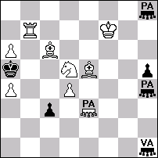
#2 AntiCirce (9+6)
Pao e3, h4, h8
Vao h1

1.Rb5+?
But: 1...PAh4xa4[bPAa4->a1]!

1.Bc7+?
But: 1...VAh1xc6[bVAc6->c1]!

1.Bb8! threat: 2.PAe3-e5#
1...VAh1-e4 2.Rb5#
1...PAh4-e4 2.Bc7#
G-2
Section: Fairies
Suggested by: Georgy Evseev
Theme:
In a Helpmate in 2, a single fairy condition from the following list is allowed:
Patrol chess, Isardam, Anticirce, Madrasi, Superpins
The theme is evident in the final position of each part of the problem. This mating position is one in which, according to the normal rules of chess, the black king is attacked two or more times. However, because of the fairy condition some of these apparent checks are not actual ones. In the mating position Black has a specific defensive move which nullifies any active check. But this defensive attempt does not protect against mate, as it activates another attack on the black king.
Duplex and zeroposition settings are not allowed. Set play, multiple solutions and twins, including ones with change of fairy condition, are allowed.

Examples:

1. Georgy Evseev
Original, sent to Probleemblad 2005.
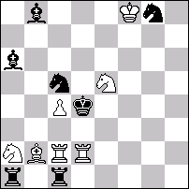
h‡2* Anticirce type Cheylan (7+7) C+
1…Re2 2.Rxa2(Ra8) Re4# (Ra1??)
1.Se4 Ba3 2.Rxc2(Ra8) Bc5# (Rc1??)

2. Hans-Peter Reich & Manfred Rittirsch
Europa Rochade 1988
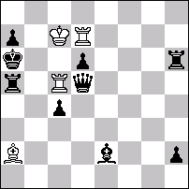
h‡2 Madrasi 2.1.1.1 (4+9) C+
1.Bg4 Rxd6 2.Qf3 Bxc4# (Be6??)
1.Rh3 Bxc4 2.Qh5 Rxd6# (Rd3??)
G-3
Section: Fairies
Suggested by: Chris Feather
Theme:
The stated objective that a theme suitable for the WCCT "should be ... not so hard as to discourage less talented composers" is almost impossible to achieve in this section, because a period of practice (say a year at least) is essential before one can really master any worthwhile fairy type, and so even those composers with some talent but no habituation are at a great disadvantage. This effectively reduces the section to a contest between existing experts. The solution applied last time (having a fairy section that was hardly unorthodox at all) may or may not have been successful, but must surely not be made into a general principle by being repeated this time!?

Consequently my suggestion is that a fairy type be chosen which is resolutely out of fashion, perhaps a type which found some attention from now-dead composers but has fallen out of use, or one which never attracted much attention in the first place. This would ensure that everyone started on an equal footing. I would suggest choosing a fairy piece rather than a condition this time. The old 'Fairy Chess Review' is full of suitable candidates, such as the squirrel, the tank or the cowboy. The proof that such "old" pieces are not without possibilities is given by the recent popularity of the kangaroo (invented 65 years ago by the same person who thought of the cowboy).

I would go so far as to suggest that the example "problem(s)" be not compositions at all but simply diagrams exemplifying the moves of the piece selected. To keep things simple I would restrict the possible stipulation types to two: 1/ directmate or selfmate in n & 2/ helpmate or helpstalemate in n.

I realise that it will be hard to get such a suggestion accepted, because everyone will want their own pet type to be chosen. However, selecting something fashionable such as Anticirce will serve only to give further reinforcement to the notion of fairy composers as a select group which discourages outsiders. The real fairy experts ought to have the LEAST say in the choice of type because they ought to be able to cope with anything! I shall not be popular for that statement, but it is true.
G-4
Section: Fairies
Suggested by: Bedrich Formanek & Ladislav Salai sr.
Theme:
Twomover (Mate in two) with the condition of basic SAT. Any other fairy conditions as well as fairy units or fairy boards are not permitted. Twins permitted but not zero-positions.
Definition of basic SAT: If the King can move (under the orthodox rules), it is in check, if there is no defence against check, it is mate; if there is no check or mate but no legal move exists, it is stalemate.

Examples:
1. Bela Majoros
Umenie 64 2001
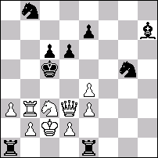
#2 SAT (9+9)
1.e5! thr. 2.Qc4#
1...Bg8 2.Rb6#
1...Se4 2.Sb5#
1...d5 2.e6#

2. Ladislav Salai jr.
Com Martin – Žilina 2000-2001
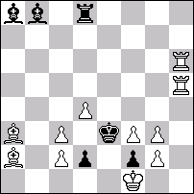
#2 SAT (11+6)
1.Bd6? thr. 2.c4# A 1...R:d6 2.g4# B 1...Ba7!
1.Rd6? thr. 2.g4# B 1...B:d6 2.c4# A 1...Rf8!
1.Bd5? thr. 2.c4# A 1...R:d5 2.f4# C 1...Be5!
1.Rd5? thr. 2.f4# C 1...B:d5 2.c4# A 1...Re8!
1.d5! thr. 2.c4# A, f4# C
1...B:d5, R:d5 2.c4# A, f4# C
G-5
Section: Fairies
Suggested by: Peter Gvozdják
Theme:
Reflexmate in 2 without predetermined theme. At least one type of the following fairy units must be used: Lion, Rook-Lion, Bishop-Lion, Nightrider-Lion, Rose-Lion.
Fairy conditions are not allowed.
Examples:

1. Maryan Kerhuel  1 Pr diagrammes 1990 (v)  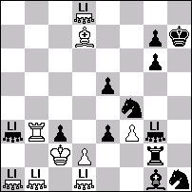  r‡2 (9+12) C+  Lions  1.Bf5! [2.LIc1 R×d2‡]  1…Bf2 2.d×e3 B×e3‡  1…e2 2.d×c3 e1=LI‡  1…Sf2 2.d4 S2d3‡  1…Se2 2.d3 LIc7‡  (1…c×d2, e×d2 2.LIe1 d×e1=LI‡  1…R×d2+ 2.Kc1 Se2‡  1…Sd5 2.LI8d3 LIc7‡  1…Sd3 2.Bd7 R×d2‡) | Emil Klemanic  Pat a Mat 2005  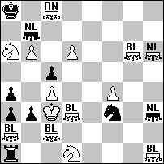  r‡2 (14+9) C+  Nightrider-Lion b7, h3, h6  Rose-Lion c8  Bishop-Lion a2, c2, d3, g6, h1  1.f5! zugzwang.  1...Rb1 2.NLh6xb3 Rxb3#  1...Rc1 (Rxa2) 2.RNc8-e3 Rxc2#  1...Rxd1 2.f6 Rxd3#  (1...b2 2.BLd3-b5 b1=S#  1...bxa2 2.BLd3-b1 axb1=S#  1...bxc2 2.RNc8-e3 c1=Q/R#)

Three good reasons (says Gvozdjak) why to choose this theme:
1. Reflexmate. Makes the combination possible on White and/or Black side.
2. Lion-Family units. Proved element for interesting themes.
3. Combination. The “added” Nightrider- and Rose-Lions much increase these possibilities.
G-6
Section: Fairies
Suggested by: Marko Klasinc
Theme:
Helpmates in any number of moves – Royal Dynasty Chess
Definition:
In a dynasty there are many royalties and it is not determined who is the master until the last one remains alive. This rule holds for a chess dynasty, too.
(1) Each side may have more kings on the chessboard.
A total number of pawns, kings and other promoted pieces are max. 9 for one side.
(2) Promotion to a king is allowed.
(3) If more than one king of one side is present at the same time no king possesses the royal nature. It means that there is no check or mate. Capturing of king(s) but the last one is allowed. The way of moving is unchanged for all kings.
(4) When one side after capturing remains with only one king his royal nature is returned no matter if he results from promotion or not. Castling is a move of royal nature and is allowed with only one king present (if a rook hasn't moved at all and if a king hasn't moved after he remains the only king of his side).

Examples (computer tested by Thomas Maeder, who upgraded Popeye for Royal Dynasty):
1. Janez Nastran  203v Šahovska misel 6/2005  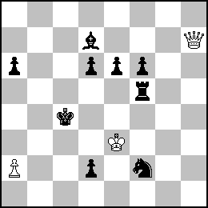  h#2 Royal Dynasty 2.1.1.1 (3+9)  1.Tc5 Db1 2.d1T Db3#  (2…~? Db3+ 3.d1K !!)  1.Lb5 Da7 2.d1L Dd4#  (2…~? Dd4+ 3.d1K !!) | 2. Janez Nastran  204v Šahovska misel 6/2005  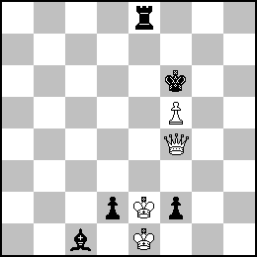  h#2 Royal Dynasty 2.1.1.1 (4+5)  1.d1K Dxf2 2.Kxf5 Dxf5# (1.Kxf5??)  1.f1K Dxd2 2.Kg5 Dxg5# (1.Kg5??)
3. Janez Nastran  205 Šahovska misel 6/2005  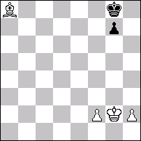  h#5 Royal Dynasty (4+2)  1.g5 f4 2.g4 f5 3.g3 f6 4.gxh2 f7+ 5.h1K+ fxg8K# | 4. Marko Klasinc  206 Šahovska misel 6/2005  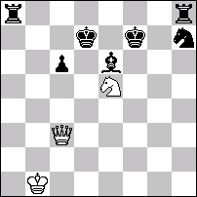  h#2 Royal Dynasty 2.1.1.1 (3+7)  1.Kfe8 Sxd7 2.0-0-0 Dxc6#  1.Kde8 Sxf7 2.0-0 Sh6#
G-7
Section: Fairies
Suggested by: Paul Raican
Theme:
Strong King.
A King is in check when (a) he is attacked by an enemy unit and (b) the King's rebirth square is not occupied (by a piece of either colour). He is checkmated if this square can't be occupied before the enemy's next move.

Here is an example of Strong King in association with Circe Strict:
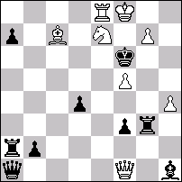
#2 Strong King + Circe Strict (8+9)
1.Rb8! [2.Rb6#]
1...Qb1 2.g8S#
1...Qc1 2.Be5#
1...Qd1 2.Qa6#
1...Qe1 2.Kf7#
1...Qxf1(Qd1) 2.Qxd4(pd7)#
1...f2 2.Sg8#
G-8
Section: Fairies
Suggested by: John Rice
Theme:
In the course of the play of a helpmate in any number of moves* using Isardam, a black unit becomes spiked, so that it is unable to prevent the mate by placing a guard on the black King.
*Obviously the number of moves could be specified if we prefer.

A simple example
by John Rice – unpublished but will appear in Supplement
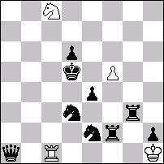
H#2 Isardam 2 solutions
1.Qd4 Rc2 2.Se5 Se7; 1.Qe5 Rc3 2.Sd4 Sb6.
G-9
Section: Fairies
Suggested by: Ukraine
Fairy type:
In the initial game array (and hence in the problem diagram), all pawns are substituted for by fairy pieces, so-called combi-pawns. The combi-pawn has all the features of the ordinary pawn plus an extra one: it controls squares adjacent to it on the row it occupies (on the left and on the right) and it can capture sideways on such a square.
Subsection:
Direct mate in 2 moves.
Theme:
No less than 2 variations presenting changed mates in response to the same moves by black. At least one variation in each phase should use the “horizontal” property of combi-pawns.

V. Rudenko
Shakhova Kompozytsiya Ukrainy, 2001
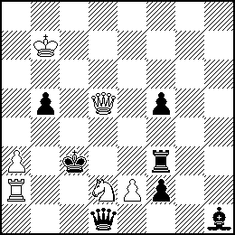
#2 combi-pawns (6+7)

Set play:
1…Qxd2 2.e2xd2# (combi-capture)
1…Rd3 2.ed3#( combi-mate)
Solution:
1.e4! threat 2.Qd4#
1…Qxd2 2.Qb3# (using combi-control of squares b3 and d4)
1…Rd3 2.Qc6# (using combi-control of squares b3 and d4; 2.Qc5#?? b5xc5! – combi-capture by black)
G-10
Section: Fairies
Suggested by: Paul Valois
Theme:
Problems of any type where pawns may move one square sideways, as well as normally.

T.R. Dawson
Football Field 1913
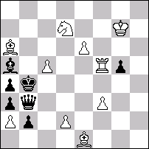
#2 (10+7)
Pawns may move one square sideways, as well as normally

1.Sb8! (2.Sc6#)
1...Qxe6/Qxa2/Qd5/Qxf3/Qc3+/Qe3
2.e2/c2/d4/d3/dxc3/dxe3#

