F-1
Section: S#
Suggested by: Uri Avner
Theme:
A S#3 is required, where two pieces – a white piece 'A' and a white or black piece 'B' (B being a line-piece) – occupy (either in the initial position or at a later stage, not necessarily at the same time) squares on the same line 'x'. Black's 1st and 2nd moves are done by the same piece 'C' which first captures 'A' and then withdraws, freeing line 'x' for 'B' for any purpose: movement, control, pin, check, mate, dual avoidance etc.
There is one restriction: unacceptable as a thematic variation is the creation of a direct black battery with 'B' as the rear piece and another piece 'D' as the front piece, to fire and mate on the 3rd move.

Examples (taken from: "Passive Annihilation in Selfmates" by Petko A. Petkov, StrateGems 27, 2004, pp118-124):

1) Waldemar Tura
1 Pr Szachy 1987
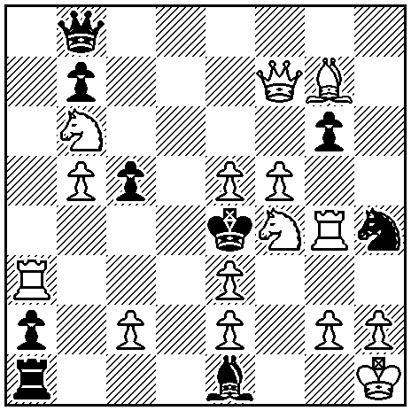
S#3
1.Sa4! (2.Se6+ Kd5 3.Sc3+ Bxc3#), 1…Qxe5 2.Sd5+! Qf4 3.Sac3+ Bxc3# (2.Sh3+?, 2.Sh5+?), 1…gxf5 2.Sh3+! fxg4 3.Sf2+ Bxf2# (2.Sd5+?, 2.Sh5+?), 1…Sxg2 2.Sh5+! Sf4 3.Sg3+ Bxg3# (2.Sh3+?, 2.Sd5+?). In the variations, Black captures three white Pawns (Pe5, Pf5, Pg2) and opens three white lines with dual avoidance.

2) Vladimir Zabunov
1 Pr Shachmatna Misal 1978
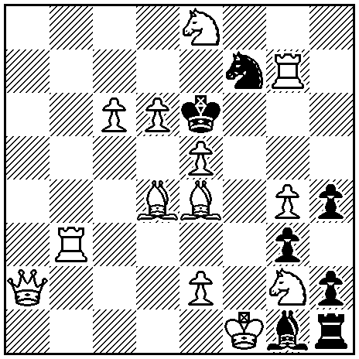
S#3
1.Ba1! (2.Rb2+ Kxe5 3.Rb4+ Bd4#), 1…Sxd6 2.Rb6+ Sc4 3.c7+ Bxb6#, 1…Sxe5 2.Re3+ Sc4 3.Bf3+ Bxe3#. Two white P-annihilations with clearance of two lines, play by the white R/Q battery and creation (with white Rook as back battery piece) of new white P/R and B/R batteries.

3) Milan R. Vukcevich
3 Pr StrateGems 2001
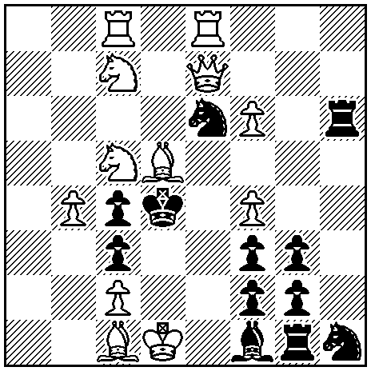
S#3
1.Red8! (2.Sb3+ cxb3 3.Sb5+ Bxb5#), 1…Se6~ 2.Qe2 and 3.Qxc4+ Bxc4#, 1…Sxc7!? 2.S5e6+ Sxe6 3.Rxc4+ Bxc4#, 1…Sxc5!? 2.S7e6+ Sxe6 3.Rxc4+ Bxc4#, 1…Sxf4!? 2.Be4+ Sd5 3.Bxh6 B~#. Black Knight correction with three secondary defences as annihilation-captures on c7, c5 and f4. Umnov theme after captures by the Knight, Knight-pinning with Zugzwang after 1…Sxf4.

4) Michael Herzberg
1 Pr Europa Rochada 1988-89
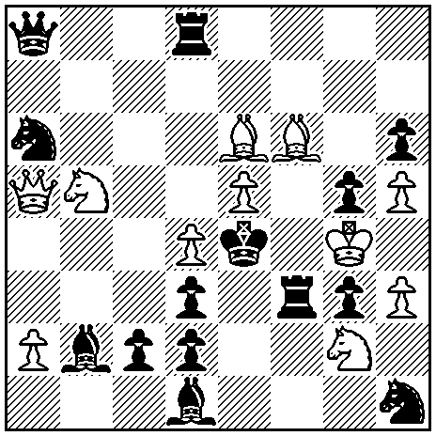
S#3*
*1…Rxd4[a] 2.Sc3+[A] Bxc3 3.Bf5+ Rxf5# (2.Sd6+?), 1…Bxd4[b] 2.Sd6+[B] Rxd6 3.Bf5+ Rxf5# (2.Sc3+?); 1.Qb6! (2.Bf5+ Kd5 3.Se3+ Rxe3#), 1…Rxd4[a] 2.Sd6+[B] Rxd6 3.Qe3+ Rxe3# (2.Sc3+?), 1…Bxd4[b] 2.Sc3+[A] Bxc3 3.Qe3+ Rxe3# (2.Sd6+?). Black self-blocks on d4 in the set and Pawn annihilation in the solution. Reciprocal change with dual avoidance, a strategy which is familiar from the orthodox threemover.

5) Waldemar Tura
2 Pr Boletim da UBP 1985
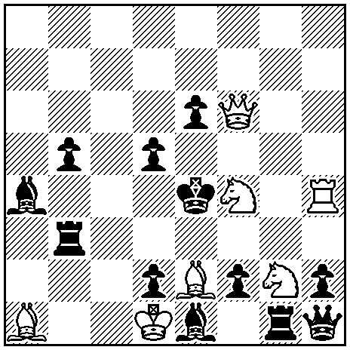
S#3
1.Bd4! (2.Qxe6+ Kxd4 3.Qe3+ Rxe3#), 1…Qxg2 2.Sxe6+! Qg4 3.Qf3+ Rxf3# (2.Sh5+? Qg4 3.Sg3+ Rxg3!), 1…Rxg2 2.Sh5+! Rg4 3.Sg3+ Rbxg3# (2.Sxe6+? Rg4 3.Qf3+ Qxf3!). (1…f1S 2.Sxe6+ Bxh4 3.Qf3+ Rxf3#, 1…e5 2.Sxd5+ Kxd5 3.Se3+ Rxe3#). Dual avoidance, combined with mutual line clearance and selfpins.

6) György Bakcsi
Die Schwalbe 1983
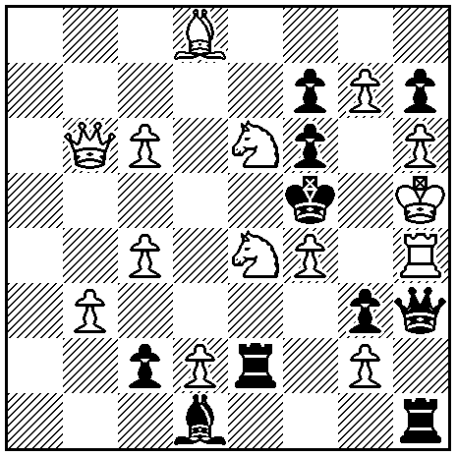
S#3
1.g8S! (2.Sg7+ Kxe4 3.Qe3+ Rxe3#), 1…Kxe4 2.Sec5+! Kd4 3.Bxf6+ Re5#; 2…Kf5 3.Se7+ Rxe7#, 1…Kxe6 2.Sec5+! Kd6 3.Be7+ Rxe7#; 2...Kf5 3.Se7+ Rxe7#, (1…fxe6 2.Se7+ Kxe4 3.Qe3+ Rxe3#). Annihilation by the black King.

7) Petko A. Petkov
ANDA 2003
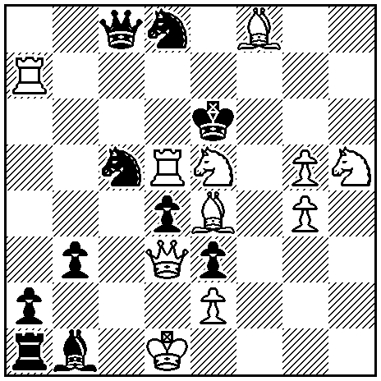
S#3
1.Ra5! (2.Bf5+ Kxd5 3.Qe4+ Bxe4#), 1…Sc5~ 2.Qa6+! ~ 3.Bf5+ Bxf5#, 1…Sxe4! 2.Rd6+ Sxd6 3.Qg6+ Bxg6#, 1…Sxd3! 2.Sf4+ Sxf4 3.Bf5+ Bxf5#. Knight correction, white line-opening after 1…Sxe4, black line-opening after 1…Sxd3 and ambush key.
F-2
Section: S#
Suggested by: Peter Gvozdják
Theme:
Selfmate in 3. In a thematic try, there is a full-length threat. In the solution, there is again a full-length threat. The threats of the try and the solution must not be identical.
Examples:

Petko A. Petkov  Schach-Aktiv 1988  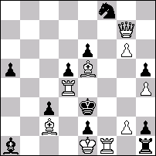  s‡3 (9+11) C+  1.Dd7? [2.Té4+ d×é4 3.Dd2+ ç×d2‡]  1…é×f1=F 2.Da4 [3.Td3+ F×d3‡]  1…é×f1=C 2.D×é6 [3.Dh3+ Cg3‡]  mais 1…Cf6!  1.Da7! [2.Tç4+ d4 3.T×ç3+ F×ç3‡]  1…é×f1=F 2.Td2+ d4 3.Té2+ F×é2‡  1…é×f1=C 2.Tg4+ d4 3.Tg3+ C×g3‡ | Hartmut Laue  The Problemist 1996  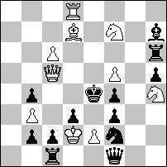  s‡3 (10+13) C+  1.f6? [2.Ff5+ F×f5 3.Dé3+ f×é3‡]  1…Tg6 2.Df5+ Rd4 3.é3+ f×é3‡  mais 1…Cd1!  1.ç7! [2.Fç6+ T×ç6 3.Dé3+ f×é3‡]  1…Fg6,Tç6 2.D(×)ç6+ Rd4 3.é3+ f×é3‡  1…Cd1 2.D×b4+ Rd5 3.é4+ f×é3 e.p.‡

Three good reasons (says Gvozdjak) why to choose this theme:
1. Different combinations. Different threats create possibility of different strategy in phases.
2. Development of the idea. It can be developed in both, tries or variations.
3. Originality. Just about 20 examples known to me.
F-3
Section: S#
Suggested by: Viktor Syzonenko
Theme:
The number of moves is arbitrary. Only those black pieces (pawns) are allowed which make at least one capture of a white piece (pawn) in any phase of the author’s plan. [The author’s plan may consist of one solution only. Or it may include also other solutions, set-play, tries.]
Explanation:
Each black chess-man on the diagram, including pawns and king, is obliged to make at least one capture of white material in the AUTHOR’S plan. In case the black king does not make any capture of white material, the AUTHOR is forbidden to use movements of the black king in his plan.
[In the first example the black king makes at least one capture and actively moves, but it (the king) can also be absolutely motionless (example 2). The rest of black materials do not have such a privilege: either capture of white material or absence in the initial position.]

Examples:

1. Viktor Syzonenko  Shakhmatna Misl, 7 2004  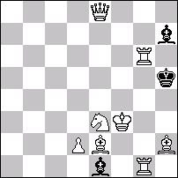  S#13 (8+3)  1.Th6++ Kxh6 2.Sf5+ Lxf5 3.Dh8+ Lh7 4.Df8+ Kh5 5.Ke3+ Kh4 6.Df4+ Kh3 7.Lg4+ Kh4 8.Lg3+ Lxg3 9.Th1+ Lh2 10.Le2+! Kh3 11.Df3+ Kh4 12.Dh5+ Kg3 13.Tg1+! Lxg1# | 2. Arno Tungler  Mystetski shakhy, 7TT 2005  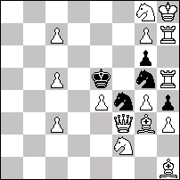  S#5 15+5=20C+  1.c8S!  1...hxg3 2.Sd3+ Sxd3 3.Dxg3+ Sf4 4.Sd6! gxh5 5.Sf7+ Sxf7#  1...gxh5 2.De4+ Sxe4 3.Txh5+ Sg5 4.Sce7 hxg3 5.Sg6+ Sxg6#  Double theme.

F-4
Section: S#
Suggested by: Ukraine
Theme:
Selfmate in three moves. At least 2 variations with moves by the white king on the 2nd or 3rd move.

Example:

Uri Avner, Yuri Bereznoy
2 Pr Phenix, 1993
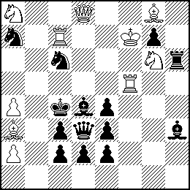
s#3 (10+14)
1.Ke6! threat 2.Sb6+ Bxb6 3.Qd5+ Qxd5#
1. … Bxf5+ 2.Kd6+ Be6 3.Se5+ Bxe5#
1. … Rxg6+ 2.Kd7+ Re6 3.Rc5+ Bxc5#
F-5
Section: S#
Suggested by: Ukraine
Theme:
Selfmate in three moves. At least 2 variations presenting the Munich Theme.

Example:
H. Laue
1 Pr Die Schwalbe, 1984
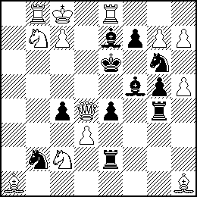
s#3 (13+11)
1.Sb4? threat 2.Qf6+ Kxf6#; 1. … Sd1!
1.g8S? threat 2.Qd5+ Kxd5#; 1. … ed3!
1.h8R! threat 2.Rh6, 3.Qe5+ Kxe5#
1. … c3 2.Sb4, 3.Qf6+ Kxf6#
1. … R4g2 2.g8S, 2.Qd5+ Kxd5#
F-6
Section: S#
Suggested by: Milan Velimirović
Theme:
Selfmate in 3 or more moves. A black piece (X) is pinned in the initial position or in some moment in the course of the solution. Then the following happens: After the Black King vacates the pin line, white decoys the unpinned piece X opening the (previously pin) line so that subsequently he can take the advantage of the BK inability of to go back.

Example:

Vukota Nikoletic
2 Pr feenschach 2001
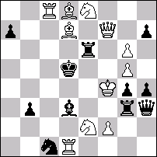
s#4
1.Ba4! ~ 2.Qd7+ Rd6 3.Qb5+ Ke6 4.Sd4+ R:d4#
1...a6 2.Sc3+ Kd4 3.Bb6+ R:b6 4.Se2+ Se2# (3...Kd4-d5??)
1...hg6 2.Sf6+ Kd6 3.Be7+ R:e7 4.Se4+ R:e4# (3...Kd6-d5??)

