D-1
Section: eg
Suggested by: Yochanan Afek
Theme:
In a position in the main line of a win or draw study where an unprotected white or black piece A is directly attacked, White or Black puts another piece B en-prise (again unprotected and directly attacked). This thematic move resulting in the two white or the two black pieces A & B hanging, must be a quiet one, i.e. not a check and/or a capture.
Examples:

1) G. Kasparian  1 Pr Magyar Sakkelet 1969  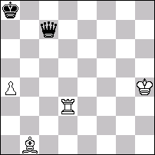  Draw  1. Kg4! Qc8+ 2.Kf3!! (2.Kh4 Qf8!) Qb7+ 3. Rd5!! (thematic!) Q:b1 4.Ra5+ Kb7 5.Rb5+ Draw. | 2) Y. Afek  3 com Schakend Nederland 1978  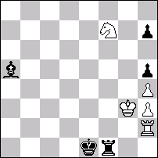  Draw  1. Se5! (1.Sd6? Bc7 2.Kg2 Rf8 3.Rh1+ Ke2 4.Se4 Rg8+) 1…Bc7 2. Rh1!! (thematic!) 2…R: h1 3.Kg2 Rf1 4.Sd3+ Ke2 5.Sc1+! Ke1 6.Sd3+ Ke2 7.Sc1+ Draw.
3) Y. Afek  3 Pr Hildebrand-80 2002  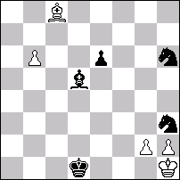  Draw  1. B: e6! (1.b7? Sg4-+) 1…Sg4!! (thematic!) 2. B: g4+ Ke1! 3. Bc8!! (3.B:h3? Kf1 4.b7 B: b7-+) 3…Kf1 4.Ba6+ Kf2 5.Bb7! Kf1 6.Ba6+ Ke1 7.Bc8! Ke2 8.Ba6+ Kf2 9.Bb7! Draw. | 4) P. Sobolevski  Pr Shachmati v SSSR 1951  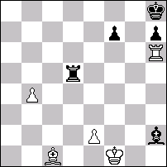  Win  1.Bb2+ Be5 2.Rd6! (thematic!) Rb5 3.Rd8+ Kg7 4.Rb8! (thematic!) Rd5 5.e4! wins.

D-2
Section: eg
Suggested by: Ilham Aliev
Theme:
Twins.
This theme is very poorly investigated - also tournaments in this theme it is possible to count as fingers.
D-3
Section: eg
Suggested by: John Roycroft
Theme:
A win or draw study in which the play centres on the survival or elimination of a pawn on the g-file (b-file). The pawn may be black or white.

Example:
John Roycroft
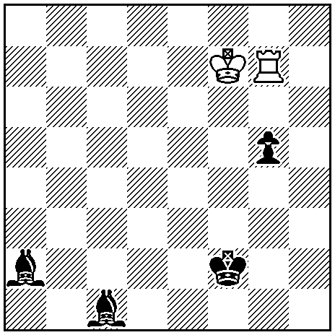
Draw (2+4)
1.Kg6 Kg3 2.Kh5 Kh3 3.Rc7/i Bd2 4.Rd7 Bf4 5.Rg7 g4 6.Rxg4 Bf7+ 7.Rg6 Kh2 8.Kg4 draw.
i) Thematic try: 3.Rxg5? Bf7+ and if 4.Rg6 Kh2 wins, or if 4.Kh6 Be8 wins, and not 4...Kh4? 5.Kg7.
D-4
Section: eg
Suggested by: Ukraine
Theme:
In a white-to-win endgame study, a black queen resulting from pawn promotion makes at least one move.

Example:
A. Pankratov
3 Pr Krasny Sever 1992
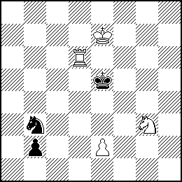
Win (4+3)
1.e4! b1Q 2.Se2! Qxe4! 3.Re6+ Kf5! 4.Sg3+ Kf4 5.Rxe4+! Kxg3 6.Re3+ K~ 7.Rxb3 wins

