B-1
Section: #3
Suggested by: Paz Einat
Theme:
Black's first move enables a pin of a black piece after a second black move by the king. The first move can be either by a piece that interferes with a White line, and is thus being pinned after the second King move as in the first example, or by opening a (anticipatory) half-pin as in the second example.

Examples:

1. Uri Avner  4 HM Hannelius-70 JT 1988  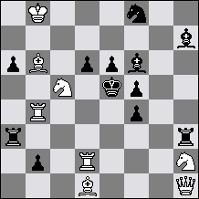  3# 8 + 12  1.Re2+? Rhe3! 2.Sf3+ Kd5  1.Qe1+? Rae3! 2.Sd3+ Kd5  Solution: 1.Kb7! (2.Sd7+ S:d7 3.Bd4#)  1...Raf3 2.Re2+! Kd5 3.Bb3# 2...Re3 3.Sd3#  1...Rhd3 2.Qe1+ Kd5 3.Bf3# 2...Re3 3.Sf3# | Here the set play is thematic:  2. Aaron Hirschenson  1 HM Visserman MT 1980  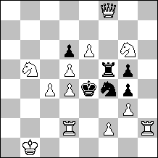  #3 12 + 6  Set:  1...S:d5 2.S:d6 + Kf3 3.Se5 #  1...R:d5 2.Sc3 + Kf3 3.Rd3 #  Solution: 1.Qa8! zugzwang.  1...S:d5 2.Sc3 + Kf3 3.Rd3 #  1...R:d5 2.S:d6 + Kf3 3.Se5 #

B-2
Section: #3
Suggested by: Peter Gvozdják
Theme:
Three units of the same colour move on the same square.

1. Milan Vukcevich  U.S. Problem Bulletin 1991  2° Prix  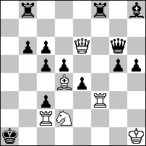  ‡3 (6+13) C+  1.Dé7! [2.Da7‡]  1…Dg7 2.Tf6! [3.F×ç3‡] ç×d4/D×f6 3.Da3/Da7‡  1…Dh7 2.Df6! [3.F×ç3,Tf1‡]  1…Df7 2.Ff6! [3.Tf1‡] é×f3/D×f6 3.Dé1/Da7‡  (1…Ta8 2.T×f8 [3.T×a8,Tf1‡] T×f8 3.Da7‡  1…Tb7 2.D×b7 [3.Da7,Da6‡] Ta8 3.D×a8,Tf1‡) | 2. Yuri Gordian & Igor Lyapunov  Shakhmaty 1983  2° Prix  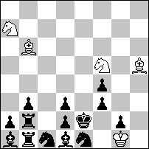  Blancs : Rg1 Fb6h5 Ca7f5  Noirs : Re2 Tb2b1 Fa1d1 Cc1e1 Pf4b3d3f3a2d2g2  ‡3 (5+14) C+  1.Fé3! blocus  1…Cç2 2.Ff2 C2~ 3.Cd4‡  1…Fç2 2.Cb5 [3.Cç3‡] d1=C 3.Cbd4‡  1…Tç2 2.F×f4 [3.Cg3‡] Fd4+ 3.C×d4‡

Three good reasons (says P.Gvozdjak) why to choose this theme:
1. Artistic quality. Three-fold repeating makes it so.
2. Great variability. Can be shown on white and/or black side.
3. Combination with other elements. Almost unlimited.
B-3
Section: #3
Suggested by: Marjan Kovacevic
Theme:
In the initial position there is a white attempt (A) which has a quiet threat (B). The attempt fails because move A contains a certain weakness (allowing a flight, unpinning, self-pinning, sacrifice, opening of a Black line, etc.).
The first move B, of at least one logical try (attempt), compensates in advance for the same thematic weakness and threatens the quiet move A. However, there is a new, single refutation.
The key-move, paradoxically, produces exactly the same kind of weakness, which White has attempted to compensate in the try. There is a single threat (or no threat at all). After a black move (defence), White performs the same quiet second move B that has appeared earlier as the first move of the thematic try.

Example:
Marjan Kovacevic
Original - Scheme
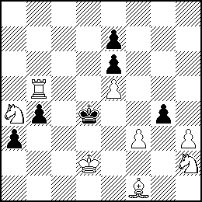
#3 vv 8+6

1.fg4? (A)~ 2.Ld3 (B) ~ 3.Sf3# 1... Ke4!
1.Ld3? (B) ~ 2.fg4 (A) ~ 3.Sf3# 1... g3!
(1... gh3 2.f4 ~ 3.Sf3#)
1.f4! ~ 2.Tb4:+ Kd5 3.Lg2#
1... gh3 2.Ld3 (B) ~ 3.Sf3#
(1... Ke4 2.Tb4:+ Kd5 3.Lg2#)
(Bold letters for thematically significant moves)
B-4
Section: #3
Suggested by: Marek Kwiatkowski
Theme:
The same black move occurs as a defense or set (first black move) as well as a second defense (second black move) after a quiet white move. Sets and tries are allowed.
Examples:

1. Mikhail Marandyuk  3rd Pr Odessa 1997  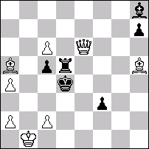  #3 ( 8 + 6 )  1.Bd2! thr 2.Bf7 thr 3.Qd5#  2...R~ 3.Qe3#  2...Re5 3.Qc4#  1...R~ 2.Be3+ Kc3 3.Qb3#  1...Re5 2.Qd6+ Ke4 3.Qd3#  2...Kc4 3.Qd3# 2...Rd5 3.Qf4#  1...Kc4 2.Qe4+ Rd4 3.Bf7#  2...Bd4 3.Qd3#  1...f2 2.c3+ Kc4 3.Be2#  2...Kd3 3.Qe2#  1...Be5 2.Qg4+ Bf4 3.Qf4# | 2. Leonid Makaronez, Leonid Ljubashevski  & Marek Kwiatkowski  IRT 2002/3  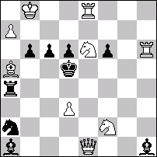  #3 ( 9 + 9 )  1...Rd4 2.Rh5+ f5 3.Rf5#,  1...Bd4 2.Qh1+ Ke5 3.Qe4#;  1.Sg4! ~ 2.Qh1+ Ke5 3.Qe4#;  1...Bg2 2.Qf2 Rd4/Bd4 3.Qf5/Qg2#,  1...Bf3 2.Qe3 Rd4/Bd4 3.Sf6/Qf3#;  1...f5 2.Qe5+, 1...Be4 2.Se3+  1...Re4 2.Bb6 Re6 3.Qe6#;  1...Rg4 2.Bb6 Rg7 3.Sf4
3. Martin Wessels  1st Pr Schach-Aktiv 2001  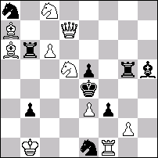  #3 ( 10 + 9 )  1.Qe6? ~ 2.Sd6# but 1...Ra6!;  1.Bc4? ~ 2.Sd6# but 1...Rg6!;  1.Rf2! ~ 2.Sc3 (f6)+ Ke3 3.Qd2#;  1...Sd3 2.Qe6 (~ Sd6#) Rc6 3.Sf6#;  1...Bg6 2.Bc4 (~ Sd6#) Rc6 3.Sc3#;  1...Rc6 2.Sd6+ Kd5 3.e4#, 2...Rd6 3.Sc3# | 4. Valentin Rudenko  2nd Hm Probleemblad 2000  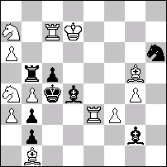  #3 ( 12 + 8 )  1.Re4? (thr 2.Sb6+) Kc3 3.Sb5#  2...Rb6 3.Rc5#  1...Kd5 2.Rc5+ Bc5 3.Sc3#  2...Rc5 3.Sb6#  1...Ra5 2.ba5 (thr 3.Rc5#) Kd5 3.Sb6#  but 1...Bf1!  1.Rd3! (thr 2.Rc5+) Bc5 3.Sb2#  2...Rc5 3.Sb6#  1...Kd5 2.Sb6+ Rb6 3.Rc5#  2...Ke5 3.Sc6#  1...Rb7 2.ab7 (thr 3.Sb6#) Kd5 3.Rc5#

B-5
Section: #3
Suggested by: Stefan Milewski
Theme:
"Gateway Theme". To realize the threat, white figure has to go between black figures. In the thematic defences these black figures close the line of her movement.

example:
S. Milewski
2-3 HM Szachy 1989
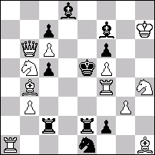
#3(12+10) C+
1.Rd1!...,2.Rd5+,Bxd5 3.Sg6#.
1...,Rcd2 2.Qxc5+,Bd5 3.Sg6#
2...,Rd5 3.Bc3#.
1...,Red2 2.Re4+,Kd5 3.Rexe1#
B-6
Section: #3
Suggested by: Gennadiy Shinkarenko
Theme:
The first moves of the try play become in solution second moves, and the first moves of the solution is the second move of the tries' variations. See this formulae:
1. A? 1...x 2. C
1. B? 1...y 2. C
1. C! 1...a 2. A
1...b 2. B (black moves x,y,a,b - are not thematical moves).

Examples:
Gennadiy Shinkarenko
1. | 2. | 3. | 4.
HM Rezvov-80 2002 | 5 Pr Ural Problemist 03 | 2HM Viszauer-80 | 1HM Moskow 2002
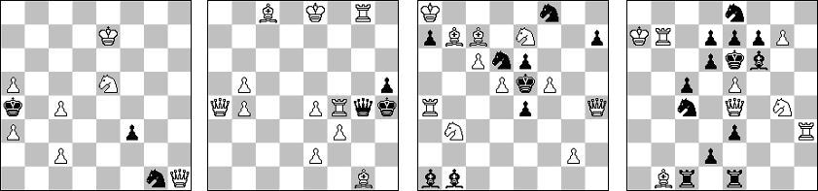
#3 (7+3) | #3 (11+3) | #3 (11+9) | #3 (8+13)

№1: 1... f2 2. Qb7 [3. Qb4#] 1... S~ 2. Qb1 [3. Qb4#]
1. Sd7? A zz 1... K:a5 a 2. Qh8 C [3. Qa8#] 1... K:a3! b
1. Sd3? B zz 1... K:a3 b 2. Qh8 C [3. Qa1#] 2... Ka2 3. Qb2# 1... K:a5! a
1. Qh8! C [2. Qb8 [3. Qb4#] 1... K:a5 a 2. Sd7 A [3. Qa8#] 1... K:a3 b 2. Sd3 B [3. Qa1#] 2... Ka2 3. Qb2#
№2: 1. Qa2? A zz 1... Kg3 b 2. e3 C [3. Qh2#] 1... Kh3! a
1. Qc2? B zz 1... Kh3 a 2. e3 C [3. Qh2#] 1... Kg3! b
1. e3! C zz 1... Kg3 b 2. Qa2 A [3. Qh2#] (2... Qg6+ 3. R:g6# 2... Q:g8+ 3. Q:g8# 1... Q:f4 2. Bf2+ Qg3 3. B:g3#)
1...Kh3 a 2.Qc2 B [3.Qh2#] (2...Qe6+ 3.B:e6# 2...Qd7+ 3.B:d7# 2...Q:c8+ 3.Q:c8#)
№3: 1... e:f5 a 2. Qg5 A [3. Q:f5#] 2... e3 3.Qg7# 1... e:d5 b 2. Ra5 B - 3. R:d5#
1. Qg5? A [2. f:e6, f6#] 1... e:d5 b 2. Sc8 C [3. B:d6# D] 1... h6!
1. Ra5? B [2. d:e6#] 1... e:f5 a 2. Sc8 C [3. B:d6# D] 1... Bc3!
1. Sc8! C [2. B:d6+ D K:d5 3. c7# 2... K:f5 3. Se7#]
1... e:d5 b 2. Qg5 A [3. B:d6# D] 2... d4 3. Ra5# B
1... e:f5 a 2. Ra5 B [3. B:d6# D] 2... f4 3. Qg5# A
№4: 1. Rb6? A [2. e:f6+ Se5 3. Q:e5#] 1... B:e5 c 2. Ba2 B [3. Q:e5#] 1... S:e5 a 2. Rh6 C - 3. Q:e5# 1... B:g7!
1.Ba2? B [2.e:f6#] 1...d:e5 b 2. Rh6 C [3.Q:e5#] 1...B:e5 c 2.Rb6 A [3.Q:e5#] 1...d5!
1. Rh6! C [2. e:d6+ Se5 3. Q:e5#] 1... S:e5 a 2. Rb6 A - 3. Q:e5# 1... d:e5 b 2. Ba2 B [3. Q:e5#] 2... d6/d5 3. R:e7#
B-7
Section: #3
Suggested by: Ukraine
Theme:
At least 2 variations presenting Black Correction after White’s 2nd move.

Example:
L. Loshinsky
1 Pr Postsjakk 1964
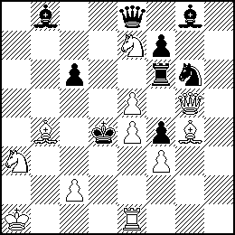
#3 (11+9)

1.Re2! threat 2.Rd2+ Ke3 3.Sc4#
1. … Sxe5 2.Be6! threat 3.Qg1#
2. …Se5~ 3.Qc5#, 2…. Sd7(!) 3.Sxc6#, 2. … Sd3(!) 3.c3#
1. … Bxe5 2.Bd7! threat 3.Qg1#
2. … Be5~ 3.Qc5#, 2…. Bd6(!) 3.Sxc6#
B-8
Section: #3
Suggested by: Ukraine
Theme:
On the 2nd move a white piece makes a non-checking move pinning a black piece which has just made a move to the square on which it is then pinned. At least 2 variations.

Example:
M. Marandyuk, V. Samilo
4 Pr 64-Shakhmatnoye Obozreniye 1985
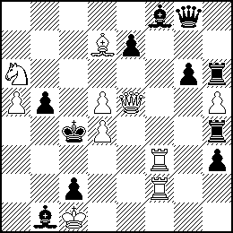
#3 (10+11)

1.Ra3! threat 2.Bxb5+ Kxb5 3.Qe2#
1. ... Qxd5 2.Be6!
2. ... Rxd4 3.Qc7# (2. ... Qxe6 3.Qc5#)
1. ... Rxd4 2.Rf4!
2. ... Qxd5 3.Qe2# (2. ... Rxf4 3.Rc3#)
(1. ... Re4 2.Qc7+ Kxd4 3.Rd2#, 2. ... Kxd5 3.Qc5#)
B-9
Section: #3
Suggested by: Ukraine
Theme:
3-move Schiffmann with half-pin creation in the course of the play.

Example:
J. Rice
The Problemist 2003
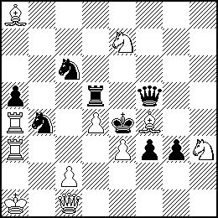
#3 (11+8)

1.Qb1! threat 2.c4+ Sc2+/Sd3 3.Qxc2/Qxd3#
1. … Rxd4 2.Bxc6+ Sxc6/Rd5/Qd5 3.c3/c3/Sg5#
1. … Sxd4 2.c3+ Sb(d)c2+/Sd3 3.Qxc2/Rxd4#
(1. … Se5 2.Rxb4 threat 3.Bxd5#, 2. … Sc4/Sd3/Qe6 3.c3/cxd3/Sg5#;
1. … f2 2.Qh1+ g2 3.Qxg2#)
B-10
Section: #3
Suggested by: Uri Avner
Theme:
White is threatening to arrive on his 2nd move at square "x." Black defends by arriving at the same square "x" on his 1st move. Pawns are not allowed as thematic pieces.

Example:

Eeltje Visserman
1 Pr Probleemblad 1974
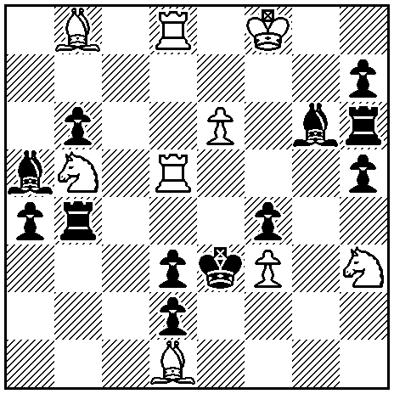
#3 (9+12)
1.Sd6! threat: 2.Se4 (3.Bxf4, Rxd3#)
1...Be4 2.Sc4+ Rxc4 3.Bxf4#
1...Re4 2.Sf5+ Bxf5 3.Rxd3#
(1...Rd4 2.Re5+ Be4/Re4 3.Sf5/Sc4#)
Thematic moves underlined.

