A-1
Section: #2
Suggested by: Bob Lincoln
Theme:
The key move closes a White line. In at least one variation Black reopens the line.

Examples:

(1)
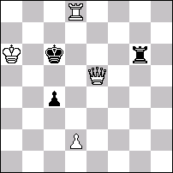
1. Qa5? (2.Qb6) Rd6! 1.d4! (2.Qc5) 1...cxd3 e. p. 2.Qc3, 1...Rg5 2.Qd6

(2)
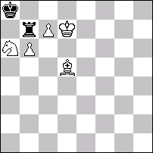
1.Kc6! 1...Ra7 2.c8=Q, 1...Rb8 2.cxb8=Q, 1...Rxc7+ 2.Kxc7, 1...Rxb6+ 2.Kxb6

Of course these are primitive, but I would hope the unpinning concept can lead to some good strategic results.
A-2
Section: #2
Suggested by: Paz Einat
Theme:
At least three black defenses produce the same type of weakness. However, each defense must have a defensive (strengthening) motif which is different from the one shown by the other defenses.

Example:

Paz Einat After C Monsfield
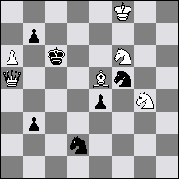
#2 ( 6 + 6 )
1.Bd6! thr. 2.Qc5#
1...b6 direct guard 2.Qd5# selfblock
1...b5 interference 2.Qc7# selfblock
1...S:d6 unguard 2.Se5# selfblock
A-3
Section: #2
Suggested by: Paz Einat
Theme:
Two “themes” that consist of black weakening effects exist. One Black defense shows one of these themes and a second Black defense shows the second. A third Black defense displays both themes and leads to a third mate. Three different mates are required. This is the minimum requirement.

Example:

Paz – Original
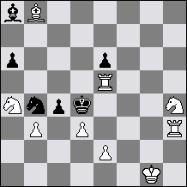
2#
1.Sg6 ! threat: 2.Ba7 #
1...Sc6 2.Rh4 # Self-interference
1...S:d3 2.e3 # Self block
1...Sd5 2.Re4 # Self-interference + Self block

Variations as follows are allowed:
1…a (weaknesses A&B)
1…b (weaknesses A&C)
1…c (weaknesses A,B&C)
A cyclical version adding 1…x (weaknesses B&C) would clearly be OK.
OR:
1…a (weaknesses A)
1…b (weaknesses B)
1…c (weaknesses C)
1…d (weaknesses A,B&C)
Weaknesses are counted only with regard to what is relevant to enable the ensuing mate! For example, if a defense causes a pin of a B piece but this pin is not relevant to the mate – it is evidently not counted.

A-4
Section: #2
Suggested by: Paz Einat
Theme: Each of two tries has two threats. In the solution, a Dombrovskis or Hannelius occurs involving only one of the threats from each try. The other two threats must appear as mates after other black defenses (in the case of condensed form these threats are represented by a single mate that must reappear after another black defense).

Pattern - Dombrovskis:  Try: 1.X? threats: 2.A,C# but: 1…a!  Try: 1.Y? threats: 2.B,D# but: 1…b!  Solution: 1.Z!  1…a 2.A#  1…b 2.B#  1…c 2.C#  1…d 2.D#  This can be condensed to  Try: 1.X? threats: 2.A,C# but: 1…a!  Try: 1.Y? threats: 2.B,C# but: 1…b!  Solution: 1.Z!  1…a 2.A#  1…b 2.B#  1…c 2.C# | Pattern - Hannelius:  Try: 1.X? threats: 2.A,C# but: 1…b!  Try: 1.Y? threats: 2.B,D# but: 1…a!  Solution: 1.Z!  1…a 2.A#  1…b 2.B#  1…c 2.C#  1…d 2.D#  This can be condensed to  Try: 1.X? threats: 2.A,C# but: 1…b!  Try: 1.Y? threats: 2.B,C# but: 1…a!  Solution: 1.Z!  1…a 2.A#  1…b 2.B#  1…c 2.C#
Examples:

Paz Einat – Original  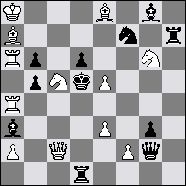  2# (12 + 11)  Try: 1.Qc3? 2.Se7(A),Sf4(C)#  but: 1...d:e5! a  Try: 1.B:b6? 2.Q:d1(B),Qb3(D)#  but: 1...d:c5! b  Solution: 1.R:b6! (2.Bc6#)  1...d:e5 a 2.Se7(A)#  1...d:c5 b 2.Q:d1(B)#  1...S:e5 2.Sf4(C)#  1...B:c5 2.Qb3(D)#  (1...Sd8 2.R:d6#) | Paz Einat – Original  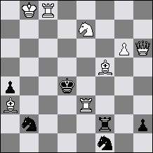  2# (8 + 6)  Try: 1.Rc2? 2.Bc5 (A) B:b2 (C)#  but: 1...Sc4 (a)!  Try: 1.Bc2? 2.Re4 (B) B:b2 (C)#  but: 1...Sd3 (b)!  Solution: 1.g7! (2.Qb6#)  1...Sc4 (a) 2.Bc5 (A)#  1...Sd3 (b) 2.Re4 (B)#  1...R:f5 (c) 2.B:b2 (C)#  (1...Rc2/S:e3 2.Qf4/Qf6#)  Condensed form
A-5
Section: #2
Suggested by: Geoff Foster
Theme:
"Add the white king".
In my opinion "add the white king" is a very promising stipulation. Imagine a problem with no white king, with an obvious key which apparently solves. There are various plausible placements of the white king to maintain the same key, but each of these fails to a pinning or checking defence, or because the white king obstructs another piece. When the white king is placed on the correct square the apparent key no longer solves, but there is some positive effect allowing a different key. This is a new theme - "key correction"!

Example:
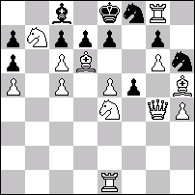
+WKg5 1.exf6 e.p.!

This was a problem by Denis Saunders, Commended, The Problemist, 1993/I. The original problem was a normal #2, but I've made it into "add the white king". This might not be a very good example, because I was thinking of a problem with tries, depending on the location of the white king (Geoff Foster).
A-6
Section: #2
Suggested by: Peter Gvozdják
Theme:
Four-phase twomover with two constant black defences leading to changed mates in all phases.

Example: Gérard Doukhan
3° Prix Revista de Sah 1979
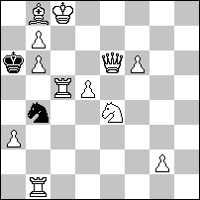
‡2 (12+2) C+

1.Cd6? blocus
1…Rxb6 2.Cé4‡
1…C~ 2.Dé2‡
mais 1…Cd3!

1.d6? blocus
1…Rxb6 2.d7‡
1…C~ 2.Dç4‡
mais 1…Cd5!

1.Fd6? blocus
1…Rxb6 2.Fb8‡
1…C~ 2.b8=C‡
mais 1…Cç6!

1.Dh3! blocus
1…Rxb6 2.Dé6‡
1…C~ 2.Dd3‡

Three good reasons (says Gvozdjak) why to choose this theme:
1. Changed mates. This is always base for a good theme.
2. Interesting mechanism. It can be discovered in most of the existent examples.
3. Variety of construction. From light-weight (example) to heavy ones.
A-7
Section: #2
Suggested by: Aaron Hirschenson
Theme:
At least 2 phases are required. In the initial position there is at least one flight for the bK, with the bK facing a direct white battery. The key threatens to activate the battery. There are changed mates between the phases.

Example:
Aaron Hirschenson
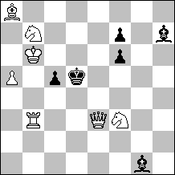
#2*

Set Play:
1…c4 2. Rb5#
1…Kc4 2. Sd6#

Solution: 1. Qe7! threat 2. Sd6#
1…c4+ 2. Sc5#
1…Kc4 2. Qxf7#
A-8
Section: #2
Suggested by: Viktor Melnichenko
Theme:
In a #2 problem with a change of function between white moves, the en passant defence must be used, i.e. when White tries to mate with his initial square Pawn by a double step move, Black defends by creating the possibility of an en passant capture. Le Grand, Hannelius, Dombrovskis and other reversal themes are possible.

Remark: in any modification of the theme definition that might occur, the only must is the en passant prevention of a mate by a white Pawn.

Examples:

(1) V. Melnichenko  & S. Shedey  HM Loshinsky MT 1983  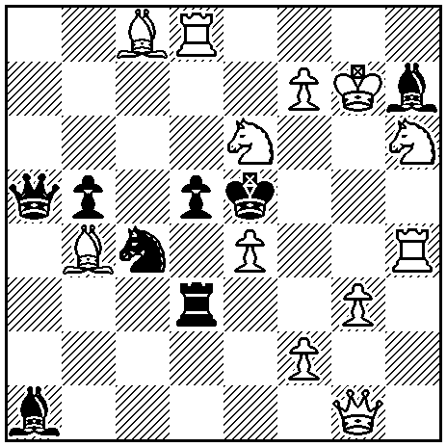  #2  1.Qg2? thr. 2.f4#(A), Sg4#(B), but 1…dxe4! (e.p. defence)  1.f3? thr. 2.Sg4#(B), 1…dxe4 2.f4#(A), but 1…Bf5!  1.Sg5! thr. 2.f4#(A), 1…dxe4 (e.p. defence) 2.Sg4#(B)  Le Grand | (2) V. Erokhin  HM Germany 1984-85  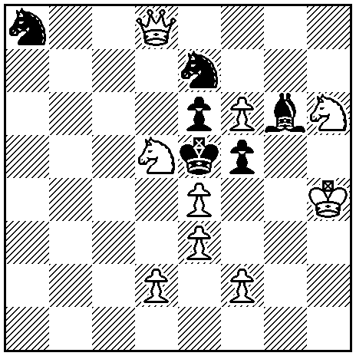  #2  1.d3? thr. 2.f4#(A), 1…fxe4 (e.p. defence) 2.d4#(B), but 1…Sxd5!(a)  1.f3? thr. 2.d4#(B), 1…fxe4 (e.p. defence) 2.f4#(A), but 1…Sc6!(b)  1.Sc3! thr. 2.Qd4#, 1… Sd5(a) 2.d4#(B), 1…Sc6(b) 2.f4#(A)  Hannelius | (3) Scheme  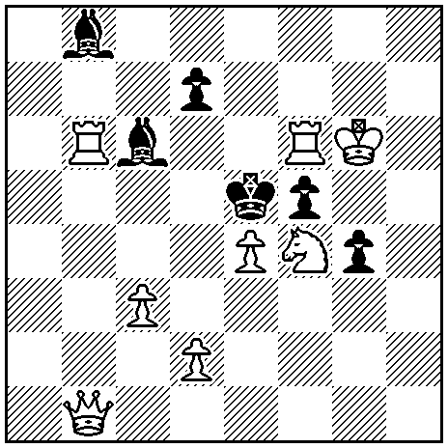  #2  1.Kg5? thr. 2.d4#(A), but 1…fxe4!(a) (e.p. defence)  1.Qd3? thr. 2.Rxf5#(B), but 1…Bxe4!(b)  1.Qe1! thr. 2.Sd3#, 1…fxe4(a) 2.d4#(A), 1…Bxe4(b) 2.Rxf5#(B)  Dombrovskis

A-9
Section: #2
Suggested by: Jacques Rotenberg
Theme:
A self-pinning try is refuted by a counter self-pinning.

Example:

Jacques Rotenberg & Jean Marc Loustau
4th Prize Die Schwalbe 1986 (v)
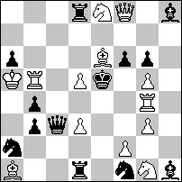
#2 (13+13)
1.Qxb4? but 1...Rxd5! (2.Qd6??)
1.Rgxb4? but 1...Bxd5! (2.Re4??)
1.Rc4! (2.f4#) 1...Bxd5 2.Re4# 1...Rxd5 2.Qd6#
A-10
Section: #2
Suggested by: Anatoly Slesarenko
Theme:
The synthesis of a classic theme and any change of move functions. In the solution at least two variations present a commonly acknowledged classic one-phased theme (Schifman, Nitvelt, Somov, Isaev, Halfpin, Gamage, Barulin, Levman, Novotny, Grimshow, black correction, promotions, pickaniny etc etc). At the same time all these variations must be a part of any change of move function matrix (Dombrovskis, Hannelius, Banny, Vladimirov, Rudenko, le Grand, Lender, reversal, antireversal , pseudo forms of all these themes etc etc).
Comments: 1) blocking, ordinary selfpin (but not halfpin, Schiffmann, Nitvelt etc), capture etc are not classic themes. 2) the play onto one square is not a classic theme.

Examples:

(1) V. Chepizhny, V.Rudenko  2 Pr Odessa-86  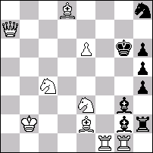  1.Tf3? – Ld3(A)x,  1…Lc7!  1.Tf4? – 2.Se5(B)x,  1…Lb7!  1.Tf7!- 2.Tg7x,  1…Lc7 2.Ld3(A)x,  1…Lb7 2.Se5(B)x  Synthesis of Halfpin and Dombrovskis. | (2) V. Rudenko, A. Slesarenko  1 Pr JT Melnichenko-65, 2004  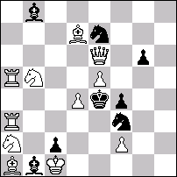  1…L:e5 2.Sd6x,  1…S:e5 2.f3x,  1…Sd5 2.D:g6x  1.Dc4? – 2.Sac3(A),Sbc3(B)x,  1…Sf~ 2.d5x,  1…S:d4! 2.D:d4x,  1…S:e5! 2.dex,  1…Sd5 2.Dd3x,  1…Sd2!  1.Dh3! – 2.D:f3x,  1…Sf~ 2.Sac3(A)x,  1…S:d4! 2.Sbc3(B)x,  1…Kd5 2.Sd6x  The synthesis of black correction and Somov with Rudenko-Dombrovskis (two classic themes, two “algebraic” themes). | (3) A. Slesarenko  4 HM Pushkin-200, 2000  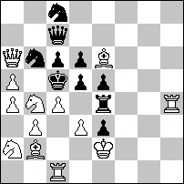  1.S:d5(A)? – 2.b4(C)x,  1…cd 2.Db5(D)x,  1…S:d5!  1.S:c6(B)? – 2.Db5(D)x,  1….D:c6 2.b4(C)x,  1…Sa7!  1.La3! – 2.Sc2x,  1…T:c4 2.S:d5(A)x,  1…S:c4 2.S:c6(B)x  The synthesis of Schiffmann and “first moves-variations” change of move function.  Note: pseudo-le Grand CD-DC is not thematic as it is not interwoven with Schiffmann defenses.

A-11
Section: #2
Suggested by: Anatoly Slesarenko
Theme:
The synthesis of a black correction and any change of move functions. In the solution at least two variations present black correction (one variation with a random move of a black piece and at lest one variation with correcting move of the same piece). At the same time the random variation and at least one correcting variation must be a part of any change of move function matrix (Dombrovskis, Hannelius, Banny, Vladimirov, Rudenko, le Grand, Lender, reversal, antireversal , pseudo forms of all these themes etc etc).

Example:

V. Rudenko, A. Slesarenko
1 Pr JT Melnichenko-65, 2004
1…L:e5 2.Sd6x,
1…S:e5 2.f3x,
1…Sd5 2.D:g6x
1.Dc4? – 2.Sac3(A),Sbc3(B)x,
1…Sf~ 2.d5x,
1…S:d4! 2.D:d4x,
1…S:e5! 2.dex,
1…Sd5 2.Dd3x,
1…Sd2!

1.Dh3! – 2.D:f3x,
1…Sf~ 2.Sac3(A)x,
1…S:d4! 2.Sbc3(B)x,
1…Kd5 2.Sd6x
The synthesis of black correction and Somov with Rudenko-Dombrovskis.
A-12
Section: #2
Suggested by: Christopher Reeves
Theme: A try (which may be a random move) creates a single threat (a). A black defence (x) is met by a white mate. Another try by the same piece creates a new single threat (b) which is defeated by the same black defence (x). In the actual play this threat is changed and black defence (x) now leads to a changed mate. The post-key single threat may be the same as the original threat (a). It is permitted for White to create zugzwang in place of a threat in one of these phases of play.
Examples:

1) A.C. Reeves
Problem 1977 –Revised Version
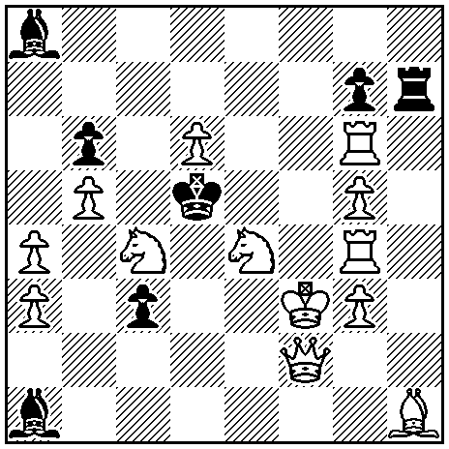
#2 (13+7)
1.Ke2? (>2.Sxc3 a)
1...Kxc4 x 2.Sd2;
But 1..Rxh1!
1.Kf4? (>2.Sxb6 b)
But 1...Kxc4 x!
1.Ke3! (>2.Qf7 not b)
1...Kxc4 2.Qa2.

2) M. Kovačević
I Pr Sredba na solidarnosta 1983/84
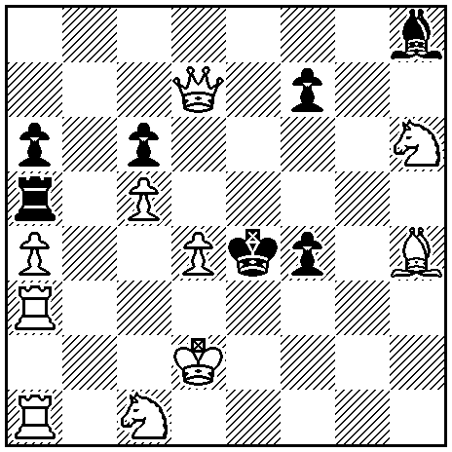
#2 (10+7)
1.Sa2? (>2.Re1 a)
1...Bxd4 x 2.Qf5;
But 1...f3!
1.Sb3? (>2.Qxc6 b)
1...f3 2.Qf5;
But 1...Bxd4 x!
1.Sd3! (>2.Sf2 not b)
1...Bxd4 x 2.Qxc6;
1...f3 2.Re1.

